Hablamos Cap.9
Español 2002
Vocabulario:
In pairs, students find ways to talk about each photo using as many vocabulary words from Chapter 9 as possible.
- 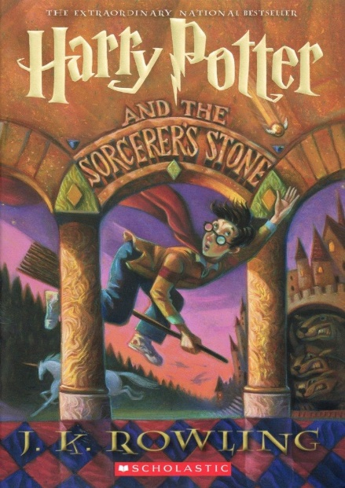
- 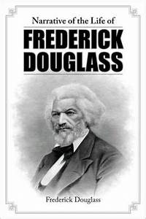
- 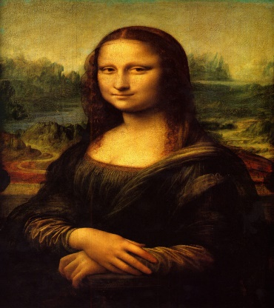
- 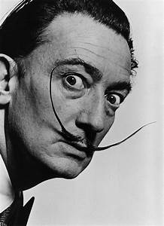

- “Sonnet 18” William Shakespeare
Shall I compare thee to a summer's day?
Thou art more lovely and more temperate.
Rough winds do shake the darling buds of May,
And summer's lease hath all too short a date.
Sometime too hot the eye of heaven shines,
And often is his gold complexion dimmed;
And every fair from fair sometime declines,
By chance, or nature's changing course, untrimmed;
But thy eternal summer shall not fade,
Nor lose possession of that fair thou ow'st,
Nor shall death brag thou wand'rest in his shade,
When in eternal lines to Time thou grow'st.
So long as men can breathe, or eyes can see,
So long lives this, and this gives life to thee.

Past Perfect Subjunctive: Thinking about the past year (or 2020), students write a few sentences about what they would have done if there hadn’t been a pandemic. Then they interview each other and share their thoughts.
Display this question:
¿Qué hubieras hecho en 2020 si no tendríamos el Covid?

Conditional perfect: Play the following short animated film. Stop it at 1:26.
https://www.youtube.com/watch?v=A6PWu3EH7Xw
Then students discuss the following questions:
- ¿Qué habría pasado si él la esperara en el ascensor?
- ¿Qué habría pasado si él ayudara a la niña coger el globo?
- ¿Qué habría pasado si él parara el carrito?
- ¿Qué habría pasado si él no ayudara a la viejita?
Then play the rest of the video so they can see what would have/or happened.

Future Perfect: Students ask the following questions of their classmates. They should interview 1 classmate per question, and the answer can be no. They should note who they spoke with for each one.
¿Después de graduarte…
_____________________ habrás continuado la educación en otra universidad?
_____________________ te habrás casado?
_____________________ habrás comprado una casa?
_____________________ habrás vivido solo/a?
_____________________ habrás tenido una carrera fabulosa?
_____________________ habrás sido famoso/a?

