Are you interested in developing and/or deepening your skills at creating student-centered collaborative activities to increase the level and variety of engagement in your classroom?
Do you currently use active learning techniques in your classes, and want to learn more about best practices for writing and editing activities that promote deep learning and collaboration for all students?
Are you looking for a support group of peers and other education leaders?
Are you willing to try new classroom techniques that surface student thinking?
If you answered “yes” to any of these questions, we invite you to participate in FOCI Series 2.
All faculty, department chairs, and deans are encouraged to participate! Series not limited to mathematics and STEM!
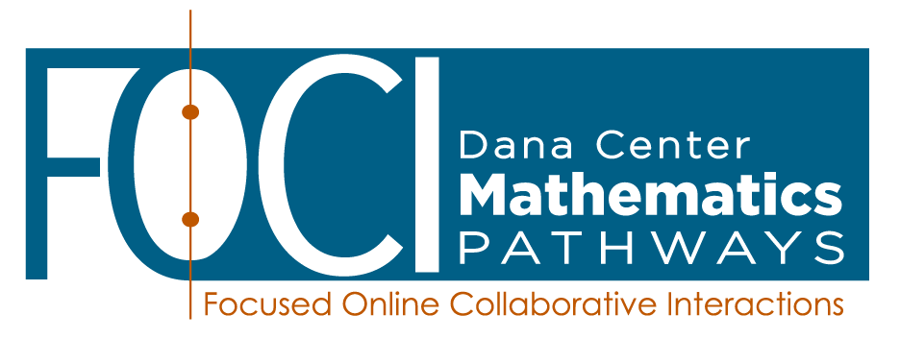
Series 2: Strengthening the Classroom Experience
Creating tasks that are worthy of collaborative effort
In this FOCI series of six sessions, you will engage in a scaffolded process of identifying characteristics of effective group-worthy tasks and implementing existing tasks. You will also design, implement, and improve your own tasks to deepen learning, particularly in classrooms with students from diverse backgrounds and preparation. You will develop facilitation instructions for activities to promote effective sharing of tasks within departments or regions. This work will include collaborating with cross-institutional peers and preparing to collaborate with others in the future.
FOCI sessions are highly interactive and take place online via Zoom in a secure virtual meeting room. There is no travel required to participate!

You’ll work with a cohort of peers in large and small groups to learn together. Facilitators from the Charles A. Dana Center will guide each session and ensure that you have all of the tools and support you need to apply your knowledge effectively in the classroom.

Dates and times:
Thursdays, 3:00 – 5:00pm Eastern

February 18 Febrauary 25 March 11 March 25 April 8 April 21

Register here https://forms.gle/ntJfcfWfHPvWk5LG7 by February 11, 2021
Dana Center handles all registration.

What am I committing to?
Actively participating in the full series of 6 sessions (12 total hours) | - Each session is 2 hours long. During each session, we will use authentic situations to explore, struggle with, and make sense of pedagogical and content challenges. Session delivery uses the video and audio features of Zoom. This technology enables us to converse “face-to-face” in real time in large and small groups, without the expense and hassle of traveling to a central location.
Preparing for each session and trying new ideas in your own classroom after each session | - Prior to each session, you are expected to do a limited amount of preparation work, often a short reading, video viewing, document analysis, and/or personal reflection. After each session, you commit to trying a technique or approach we discussed during the session.
Contributing to the large and small group discussions; supporting your peers on this learning journey | - Contribute in the large and small group discussions, bringing your own perspectives and prior experiences into the conversations. Collegially engage in conversations and application activities focused on deepening student understanding through effective student discourse and collaboration.

What support will I get from the Dana Center?
FOCI materials | - You will receive high-quality, well-researched, and thoughtful materials for the entire series. All session materials (readings, reflections, handouts, and PowerPoints) will be provided. You will also have access to recordings of the sessions so that you can review the content on your own.
Support from trained facilitators | - Dana Center curriculum and professional learning specialists will lead the sessions. These individuals are available to answer questions and provide support during and between the sessions. They can address content and application questions as well as technology issues (e.g., the Zoom platform).
Certificate of Completion | - You will receive a certificate of completion at the end of the series that may be submitted with tenure/promotion materials for your department. The topics and number of hours of professional learning you completed will be listed on the certificate.

Do I need any previous knowledge of active and collaborative learning to participate?
This series is designed for those who have already completed FOCI Series 1: Deepening Student Understanding, who have attended a Dana Center curriculum or pedagogy workshop, or who have facilitated active and collaborative learning lessons. The session is designed to help teachers improve their activity development and authoring skills. A sample of learning outcomes for each session in the series is provided below.

Series 2: Strengthening the Classroom Experience
Creating tasks that are worthy of collaborative effort

- Session 1: What Is a Group-Worthy Task?
- Develop norms for participation in the series.
- Explore the definition and characteristics of group-worthy tasks.
- Analyze the benefits of using group-worthy tasks.
- Create an introductory active-learning activity to be implemented before the next session.
- Session 2: How Do You Know if a Task is Group-Worthy?
  - Discuss the challenges, benefits, and continuous improvement of the activity implemented between sessions 1 and 2.
  - Practice identifying activities that are group-worthy.
  - Identify low-floor, high-ceiling characteristics of a task.
- Session 3: Strategies for Creating Group-Worthy Tasks
- Discuss strategies for modifying activities to make them more group-worthy.
- Identify the essential characteristics of group-worthy tasks, and those which are merely desirable.
- Select a topic and real-world context for a group-worthy task.
- Session 4: Implementation Planning for a Group-Worthy Task
- Identify the conceptual connections of the task.
- Explore key implementation considerations for group-worthy tasks.
- Collaborate to identify logistical considerations for their tasks.
- Consider strategies for modifying implementation in the moment when an activity does not go as planned.
- Session 5: Group-Worthy Task Revision and Improvement Cycle
- Engage in a focus group protocol for evaluating tasks for their group worthiness.
- Identify key components of facilitation instructions for group-worthy tasks that will be used by another instructor.
- Discuss strategies for reinforcing classroom norms midway through the semester.
- Session 6: Collaborating with Colleagues to Use Group-Worthy Tasks
- Develop a continuous improvement cycle for group-worthy tasks.
- Discuss the greatest challenges encountered through the process of creating group-worthy tasks, and brainstorm possible solutions.
- Explore additional resources for professional learning related to facilitating and creating group-worthy tasks.

