Are you interested in building your understanding of the latest research in psychology and learning science?
Do you need fresh ideas and research-based strategies to support students in sustaining their effort through struggles or setbacks?
Are you looking for a support group of peers and other education leaders?
Are you willing to try new classroom techniques that promote students’ productive persistence and learning mindsets, and that improve overall classroom climate and culture?
If you answered “yes” to any of these questions, we invite you to participate in FOCI Series 3.
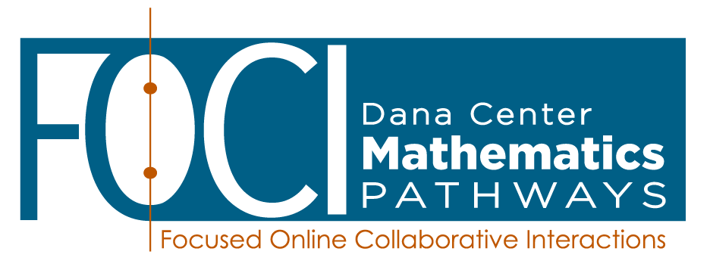
Series 3: Empowering Students as Learners
Fostering engagement and persistence through psychosocial strategies and learning science
This FOCI series consists of six sessions that examine the most compelling research-based ideas and strategies from psychology and the learning sciences that address the needs of college students from diverse backgrounds and preparation. Experience collaborative activities, relevant readings, videos, and research summaries. Personalize your learning by planning for and enacting modest changes in your classrooms (including remote learning settings) and in professional learning communities that have the potential for transformative change in students’ learning mindsets, persistence, and the overall learning environment.
FOCI sessions are highly interactive and take place online via Zoom in a secure virtual meeting room. There is no travel required to participate!

You’ll work with a cohort of peers in large and small groups to learn together. Facilitators from the Charles A. Dana Center will guide each session and ensure that you have all of the tools and support you need to apply your knowledge effectively in the classroom.

To allow ample time to complete the deep work required for this series, there will always be a few weeks between sessions. Participants should commit to attending all six sessions and completing the between-session work over the course of the series.

Dates and Time
Tuesdays, 3:00 – 5:00pm Eastern

February 16 February 23 March 2 March 23 March 30 April 13

Register here https://forms.gle/RbSRoKvtkPb8NvDv5 by February 9, 2021
Dana Center handles all registration.

What am I committing to?
Actively participating in the full series of 6 sessions (12 total hours) | - Each session is 2 hours long. During each session, we will use authentic situations to explore, struggle with, and make sense of psychosocial strategies and learning science. Session delivery uses the video and audio features of Zoom. This technology enables us to converse “face-to-face” in real time, in large and small groups, without the expense and hassle of traveling to a central location.
Preparing for each session and trying new ideas in your own classroom after each session | - Prior to each session, you are expected to do a limited amount of preparation work, often a short reading, video viewing, document analysis, and/or personal reflection. After each session, you commit to trying a technique or approach we discussed during the session.
Contributing to the large and small group discussions; supporting your peers | - Contribute in the large and small group discussions, bringing your own perspectives and prior experiences into the conversations. Collegially engage in conversations and application activities focused on deepening student understanding through effective student discourse and collaboration.

What support will I get from the Dana Center?
FOCI materials | - You will receive high-quality, well-researched, and thoughtful materials for the entire series. All session materials (readings, reflections, handouts, and PowerPoints) will be provided. You will also have access to recordings of the sessions so that you can review the content on your own.
Support from trained facilitators | - Dana Center curriculum and professional learning specialists will lead the sessions. These individuals are available to answer questions and provide support during and between the sessions. They can address content and application questions as well as technology issues (e.g., the Zoom platform).
Certificate of Completion | - You will receive a certificate of completion at the end of the series that may be submitted with tenure or promotional materials for your department. The topics and number of hours of professional learning you completed will be listed on the certificate.

Do I need any previous knowledge of active and collaborative learning to participate?
No previous knowledge is required! This series will provide an introduction to student-centered learning, effective student discourse, and collaboration. A sample of learning outcomes for each session in the series is provided below.

Series 3: Empowering Students as Learners
Fostering engagement and persistence
through psychosocial strategies and learning science

- Session 1: Introduction to Psychosocial Factors
  - Establish a safe, participant-centered learning environment for the cohort.
  - Set goals for participation and growth during this professional learning series.
  - Investigate what we mean by psychosocial factors and learning science.
  - Explore introductory information about learning mindsets.
- Session 2: Growth Mindset and the Neuroscience of Learning
  - Continue to investigate the academic impact of students’ self-beliefs.
  - Deepen understanding of growth mindset and related faculty strategies that have the power to transform learning environments.
  - Explore key ideas and strategies from the neuroscience of learning mindsets and connect that learning with classroom strategies.
- Session 3: Motivational Factors, Autonomy, and Purpose
  - Explore key dimensions of motivation.
  - Determine key strategies to support student motivation.
- Session 4: Belonging in a Learning Community
  - Discuss key research on the importance of belonging and related faculty strategies.
  - Investigate impediments to belonging.
  - Understand how a growth mindset culture promotes belonging and relatedness.
- Session 5: Productive Persistence
  - Explore the research supporting the development of students’ productive persistence and effective effort.
  - Connect productive persistence to learning mindsets.
  - Explore high-leverage strategies for students’ productive persistence and information retention.
- Session 6: Applying Psychosocial Factors in Syllabi and Course Design
  - Discuss and determine how to implement the key ideas and strategies introduced in this series into your course structure, syllabus, assessment routines, etc.
  - Identify next steps for planning and enactment of strategies learned in the series.

