Are you an educator committed to equitable outcomes for all students, yet finding that the equity gaps are not closing for your students or your institution?
Do you need fresh ideas and research-based strategies that lead to equitable instructional practices and student outcomes?
Working toward equity requires courage and commitment. Are you looking for a group of peers and other education leaders who will support one another in taking action?
If you answered “yes” to any of these questions, we invite you to participate in Series 5.
All disciplines welcome! Series not limited to mathematics faculty!

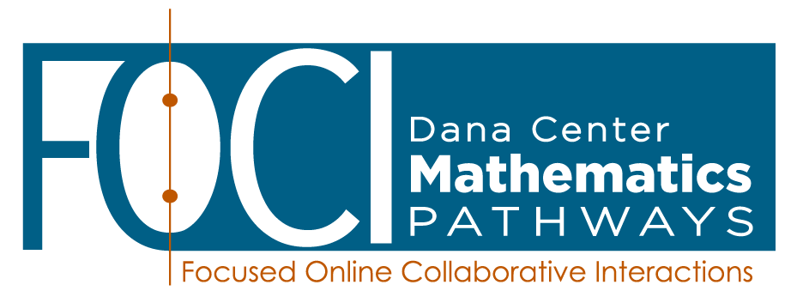
FOCI Series 5: Driving Equitable Student Outcomes:
Implementing equity-minded teaching and learning
In this series of six sessions, you will engage with the research-based ideas and strategies that address equity gaps while meeting the needs of college students from diverse backgrounds and preparation. With fellow faculty, department chairs, and deans, experience collaborative activities, relevant readings, videos, and research summaries. Personalize learning by planning for and enacting modest changes in your classrooms (including remote learning settings) and professional learning communities that have the potential for transformative change in learning environments and student outcomes.
Series sessions are highly interactive and take place online via Zoom video conferencing technology – so there is no travel required to participate!
You’ll work with a cohort of peers in large and small groups to learn together. Facilitators from the Charles A. Dana Center will guide each session and ensure that you have all of the tools and support you need to apply your knowledge effectively in the classroom.
To allow time to complete the deep work required for this series, there will always be at least one week between sessions. Participants should commit to attending all six sessions and completing the between-session work over the course of the series.

Dates and times:
Tuesdays, 4:00 – 6:00 pm Eastern

February 16 February 23 March 2 March 23 March 30 April 13

See page 3 for session descriptions. Attendance in all six sessions is highly recommended.
Register here https://forms.gle/iyjy9DvSGfh3AK5A7 by Noon on February 9, 2021
Dana Center handles all registration.

What am I committing to?
Actively participating in the full series of 6 sessions (12 total hours) | - In each 2-hour session, we will use authentic situations to explore, struggle with, and make sense of equity-minded teaching and learning.  - Session delivery uses the video and audio features of Zoom. This technology enables us to converse “face-to-face” in real time in large and small groups without the expense and hassle of traveling to a central location.
Preparing for each session and trying new ideas in your own classroom after each session | - Prior to each session, you are expected to do a limited amount of preparation work, often a short reading, video viewing, document analysis, and/or personal reflection.  - After each session, you commit to trying a technique or approach we discussed during the session.
Contributing to the large and small group discussions; supporting your peers on this learning journey | - Contribute in the large and small group discussions, over Zoom or Canvas discussion boards, bringing your own perspectives and prior experiences into the conversations.  - Collegially engage in conversations and application activities focused on deepening student understanding through effective student discourse and collaboration.

What support will I get from the Dana Center?
FOCI materials | - You will receive high-quality, well-researched, and thoughtful materials for the entire series. All session materials (readings, reflections, handouts, and PowerPoints) will be provided electronically.  - You will also have access to recordings of the sessions so that you can review the content on your own.
Support from trained facilitators | - Dana Center curriculum and professional learning specialists will lead the sessions. These individuals are available to answer questions and provide support during and between the sessions. They can address content and application questions as well as technology issues (e.g., the Zoom platform).
Certificate of Completion | - You will receive a certificate of completion at the end of the series that may be submitted with tenure or promotional materials for your department. The topics and number of hours of professional learning you completed will be listed on the certificate.

Do I need any previous knowledge of equitable teaching and learning to participate?
No previous knowledge is required! This series will provide an introduction to equity-minded teaching and learning practices and routines. A sample of learning outcomes for each session in the series is provided below.

FOCI Series: Driving Equitable Student Outcomes:
Implementing equity-minded teaching and learning
- Session 1: Introduction to Equity Topics in Postsecondary Education
Participants will:
  - Establish a safe, participant-centered learning environment for the cohort.
  - Set goals for participation and growth during this professional learning series.
  - Engage in collective inquiry around the meaning of equity.
- Session 2: Equity-mindedness
Participants will:
  - Explore a framework for taking needed actions toward equitable outcomes.
  - Understand some of the primary obstacles blocking the path toward racial equity.
- Session 3: Neuroscience and Implicit Bias
Participants will:
  - Explore the neuroscience of bias.
  - Discuss how an understanding of bias can support faculty in closing equity gaps.
  - Investigate ways to understand, address, and overcome our own biases and work toward equity-mindedness.
- Session 4: Psychosocial Factors Related to Equity
Participants will:
  - Explore introductory information about psychosocial factors in learning.
  - Connect psychosocial factors to equity-mindedness and equitable teaching practices.
- Session 5: Culturally Responsive and Sustaining Practices
Participants will:
  - Investigate cultural frameworks in teaching and learning.
  - Explore and discuss how cultural practices impact teaching and learning.
  - Take steps toward incorporating culturally responsive and sustaining teaching and learning practices.
- Session 6: Applying Equitable Teaching Practices in Syllabi and Course Design
Participants will:
  - Discuss and determine how to implement the key ideas and strategies introduced in this series into your course structure, syllabus, assessment routines, etc.
  - Identify next steps for planning and enactment of strategies learned in the series.

