Entering a Facilities Work Request in the QWare work order system
- Click the link to go to the log in page.
  - https://az.quecentre.com/gahighlands/login.aspx
  - 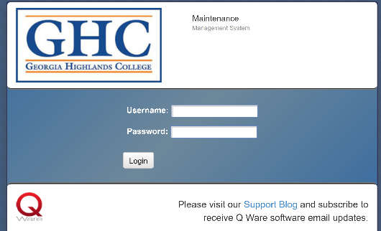
- Log in using your single sign on credentials.
  - Note: “@highlands.edu” should not be part of your username.
  - 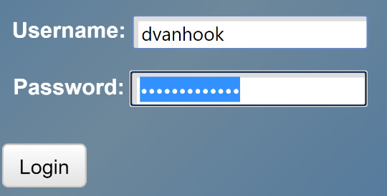
- Use the drop-down boxes to select the Campus, Building, Floor and Room Number where the issue is located.
  - 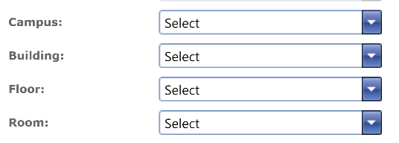
- Add additional location information in the location box
- Enter information about requested work in the Description box.
  - 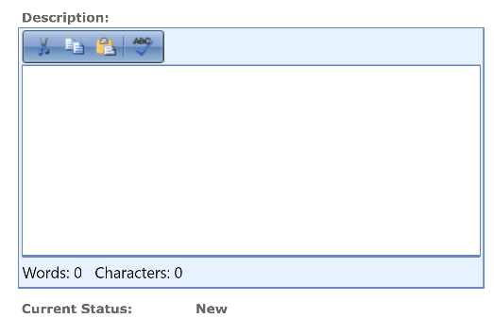
- Click Update to complete the request.
  - 