Happy Cinco de Mayo!
Brought to You by the GHC Diversity Committee
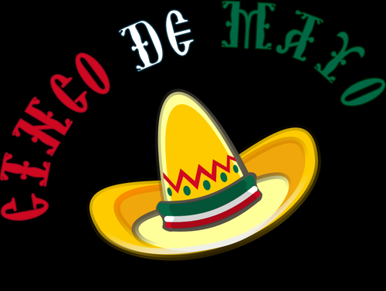
Did you know that Cinco de Mayo, or the 5th of May, is not the celebration of Mexican independence? It actually commemorates the Battle of Puebla, a small town in east-central Mexico, during the Franco-Mexican War in 1862 in which the outnumbered and under supplied Mexican army beat the forces of the French who wanted to own Mexico!

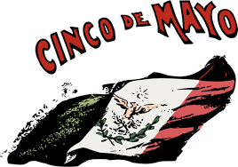
General Ignacio Zaragoza who led the Mexicans in this battle was born in a Mexican village which is now a city in the U. S. state of Texas. “It is said that in 1867, just five years after the victory, a group of Mexicans residing in Texas began to celebrate the date with songs and poetry, thus becoming a tradition of celebration and colors across the state. Later, this tradition would spread throughout the United States among Mexican communities.” (#BetterTogether).
Want to know more about Mexican culture and heritage? Watch this video!
Here's a fascinating video about the history of Cinco de Mayo!
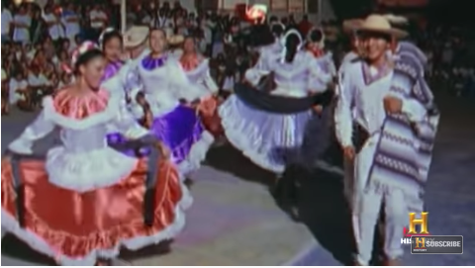

You can also check out these eBooks from the GHC Library!
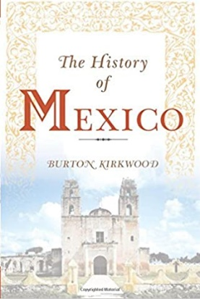
The history of Mexico
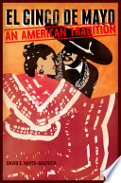
El Cinco de Mayo An American Tradition.
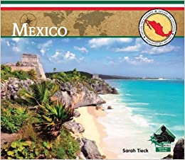
Mexico.

Even though we’re social distancing you can celebrate with food! Here are some links to recipes of traditional foods!
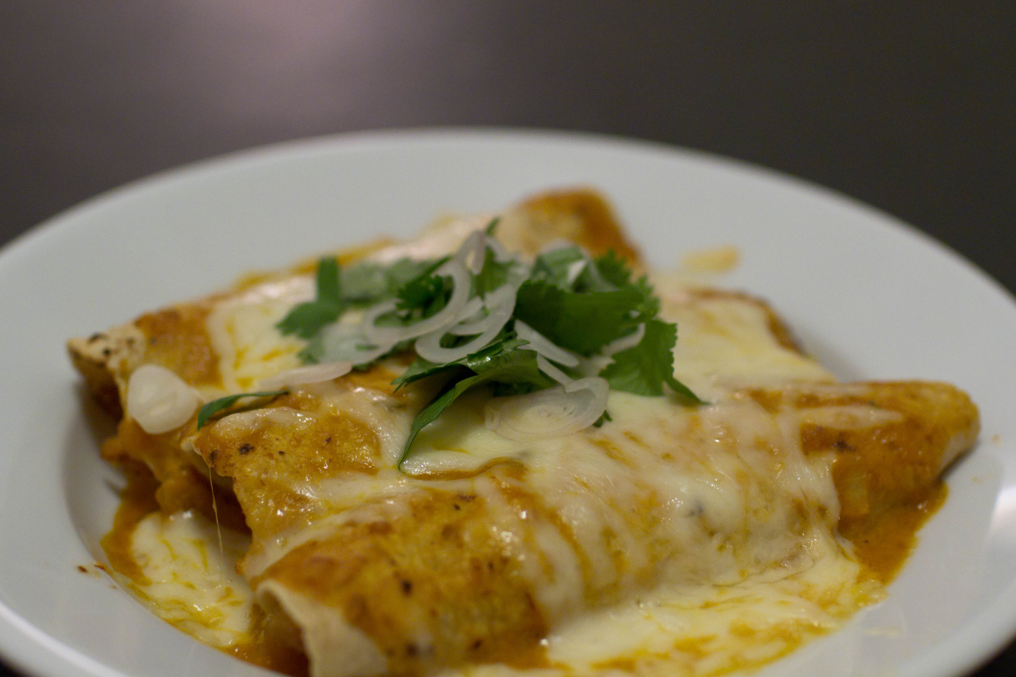

25 Easy Pantry Recipes to Make During the Quarantine

5 Mexican-Inspired Recipes You Can Make With Pantry Staples on Hand

Mexican Lasagna (Made from Pantry Ingredients!)

And, what’s a celebration without music? Here are some links to mariachi music!
Recuerdame

El Pasajero

Happy Mexican Mariachi Latin Music
