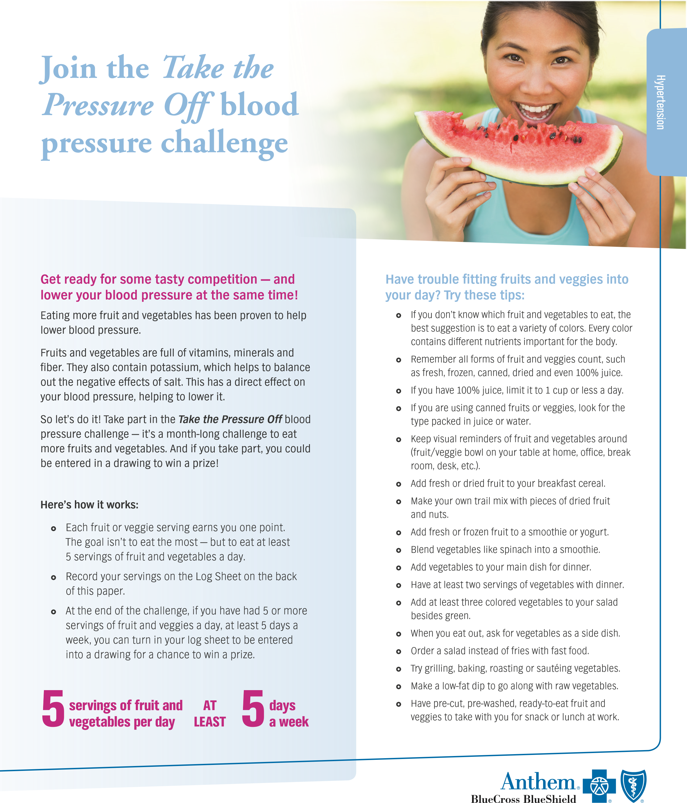
Anthem Blue Cross and Blue Shield is the trade name of: In Colorado: Rocky Mountain Hospital and Medical Service, Inc. HMO products underwritten by HMO Colorado, Inc. In Connecticut: Anthem Health Plans, Inc. In
Take the Pressure Off
blood pressure challenge
Name
________________________________________________________
Phone #
______________________________________________________
Email address
__________________________________________________
Track and record your number of
fruit and vegetable servings for
each day. Your goal is to have
at least 5 servings of fruits and
veggies per day, 5 days a week
for 4 weeks.
WEEKS
MONDAY
TUESDAY
WEDNESDAY
THURSDAY
FRIDAY
SATURDAY
SUNDAY
WEEK 1
WEEK 2
WEEK 3
WEEK 4

