Updating People Admin to look at the new site requires users to clear their Cache.

Click on open menu in top right hand corner

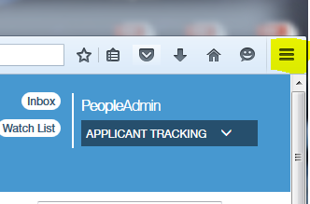

Click on Options

Click on Privacy

Click on “clear your recent history”

Make sure your Cache box is checked and click on clear now

After this you will need to refresh your screen  or log out and log back in.

