Health & Fitness 2015 Bucket List
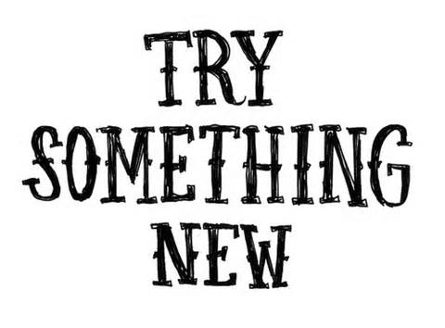

TRY:
____________________________
____________________________
____________________________
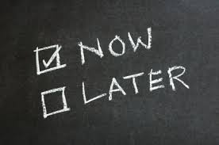
DO:
____________________________
____________________________
____________________________
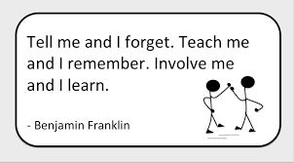
LEARN:
____________________________
____________________________
CELEBRATE MY SUCCESSES BY:
_______________________________

