To View Time-Off Requests in eTime:

Sign into eTime as an employee. You will see this screen, click on **“home.”**

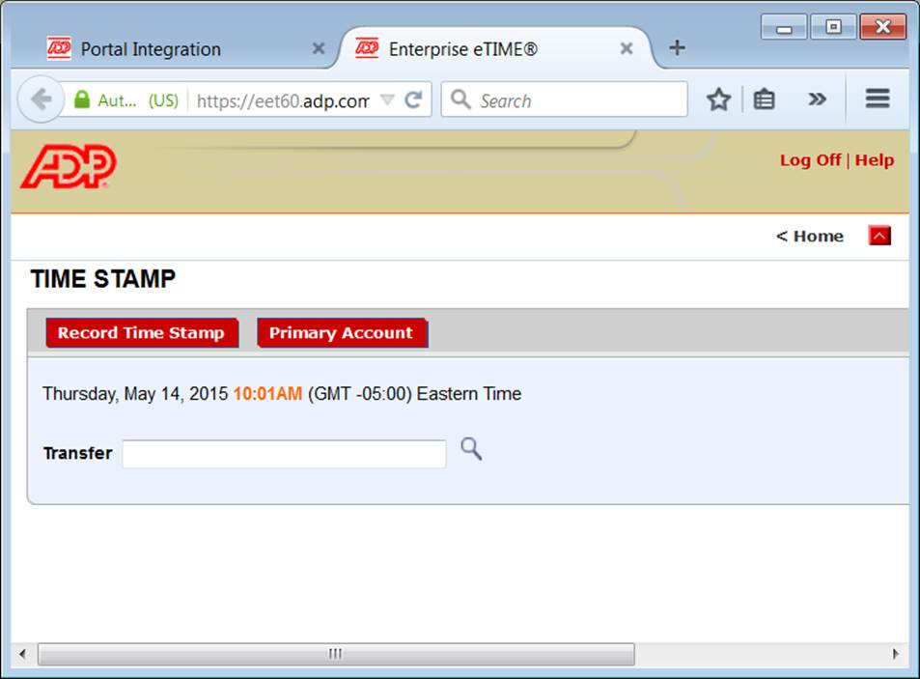

Click on **“Inbox”.**

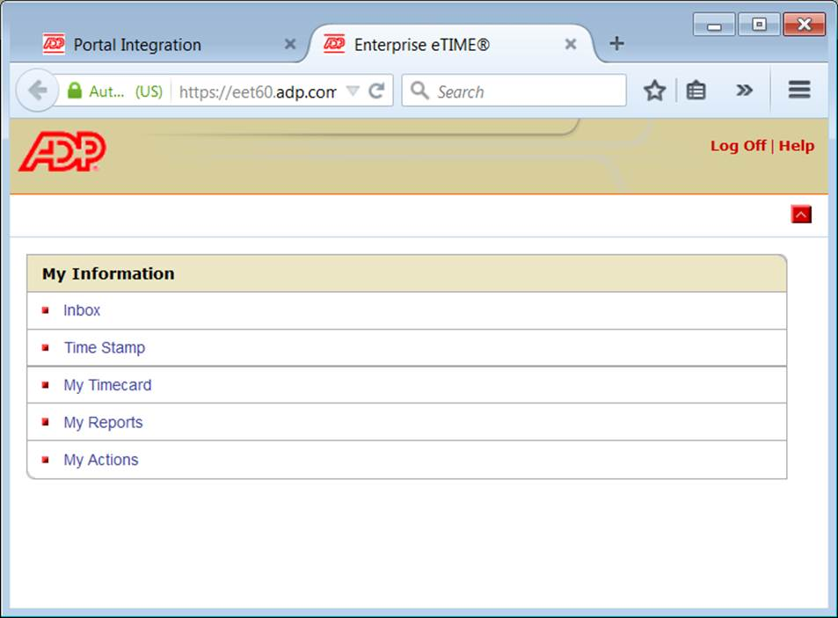

Click on **“Messages”**. You will then see all your requests for time-off, and manager responses indicating approval/denial.

