Georgia Highlands College
you could be saving up to 15% on the monthly service charge of qualified wireless plans
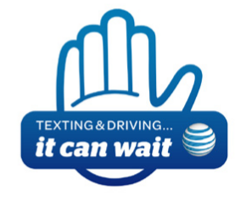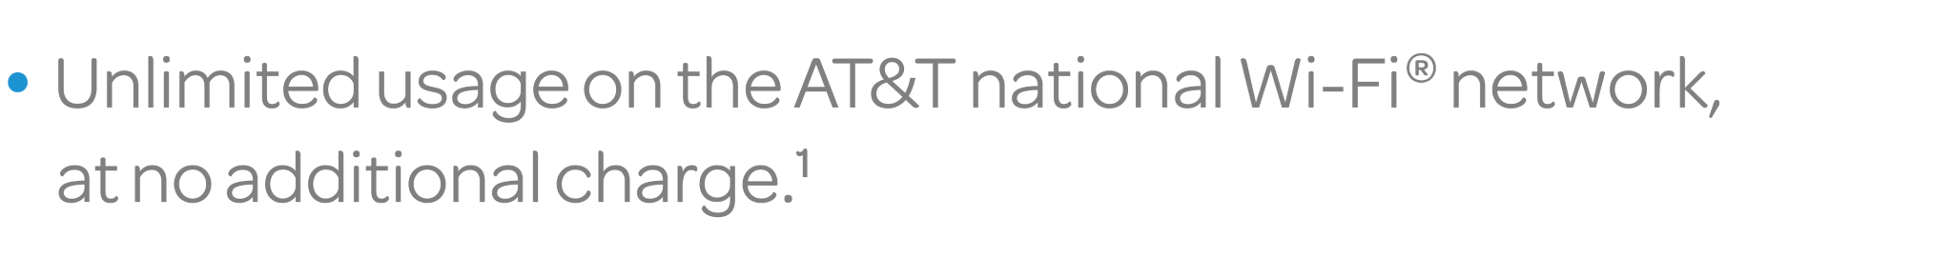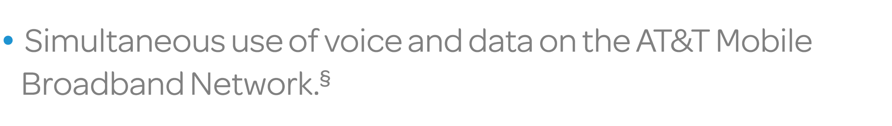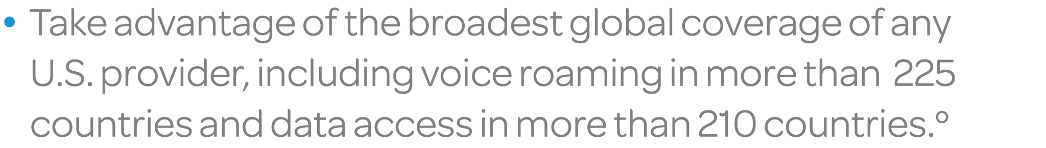
Murdoch Ruth
706-936-0434
AT&T Small Business Specialist
405 Turner McCall Blvd
Rome, Ga 30165

In addition to the AT&T Sponsorship Program
discount, you’ll also enjoy these benefits:

To purchase online, visit http://www.att.com/getIRU
Mention FAN: 3696536
Sponsorship Program discounts: Monthly service discounts are available to qualified employees, students and other authorized individuals associated with eligible sponsoring organizations, such as companies and colleges/universities with a qualified business agreement (“Business Agreement”). Individuals must provide proof of eligibility (valid employee badge/student ID card, paystub or other approved validation method) and subscribe to service as Individual Responsibility Users (IRUs), taking personal liability for their accounts. Discounts are subject to the Business Agreement and may be interrupted, changed and/or discontinued without notice to you. A minimum number of employees, minimum monthly service charge for qualified plans, additional AT&T services or other requirements may apply for eligibility. Under some Business Agreements, the discount can vary monthly depending on your organization’s aggregate volume of qualified charges. Discounts apply only to the monthly service charge of qualified plans (unless otherwise provided in your organization’s Business Agreement). Discounts are not available with any unlimited voice plans. For Family Talk plans, discount will only apply to the primary line. For Mobile Share plans, discount applies only to the monthly service charge for the data allotment of eligible plans, not to the additional monthly device charge(s). Additional plan and other restrictions apply. Discounts may not be combined. Offer subject to change. If you have a question about available discounts and/or your eligibility, contact your organization’s telecom manager or contact us at att.com/getIRU. All other marks contained herein are the property of their respective owners. Service provided by AT&T Mobility.
© 20152014 AT&T Intellectual Property. All rights reserved. AT&T and the AT&T logo are trademarks of AT&T Intellectual Property.
¹ Wi-Fi enabled devices required. Access includes Wi-Fi Basic. Other restrictions apply. See attwifi.com for details and locations.
- Mobile broadband not available in all areas.
- AT&T Mobile Share Value Plans (with Unlimited Domestic Talk and Text) Smartphone required. Up to ten (10) devices per plan. Additional monthly charge per device. Unlimitedtalk and text for phones only. If you are using a shared data plan without a Smartphone(s) on the account or you do not have all required elements of the plan, AT&T reserves the right to place the non-complying device(s) on an appropriate plan(s). If you exceed the amount of data in your plan during your billing period, an additional 1GB is automatically provided as specified in your rate plan. Overage charges are billed to the primary line. All data allowances, including overages, must be used in the billing period in which the allowance is provided or they will be forfeited. Authorized users on the account may temporarily suspend data access for each device using the Shared Data Plan. Data access will be restored at the beginning of the next billing cycle. Monthly charges, however, will continue to apply. Tethering and mobile hot spot use is permitted with up to five (5) simultaneous devices. Access to corporate email, intranet and apps available for $15/mo. per device. Additional monthly charge per device not eligible for discounts. Domestic use only. Activation fee may apply. Additional deposits and other restrictions may apply.
º International Roaming: Availability, quality of coverage and services while roaming are not guaranteed. International roaming rates apply outside the U.S., Puerto Rico and U.S.V.I. Visit att.com/worldpackages to view rates and available discount plans.

