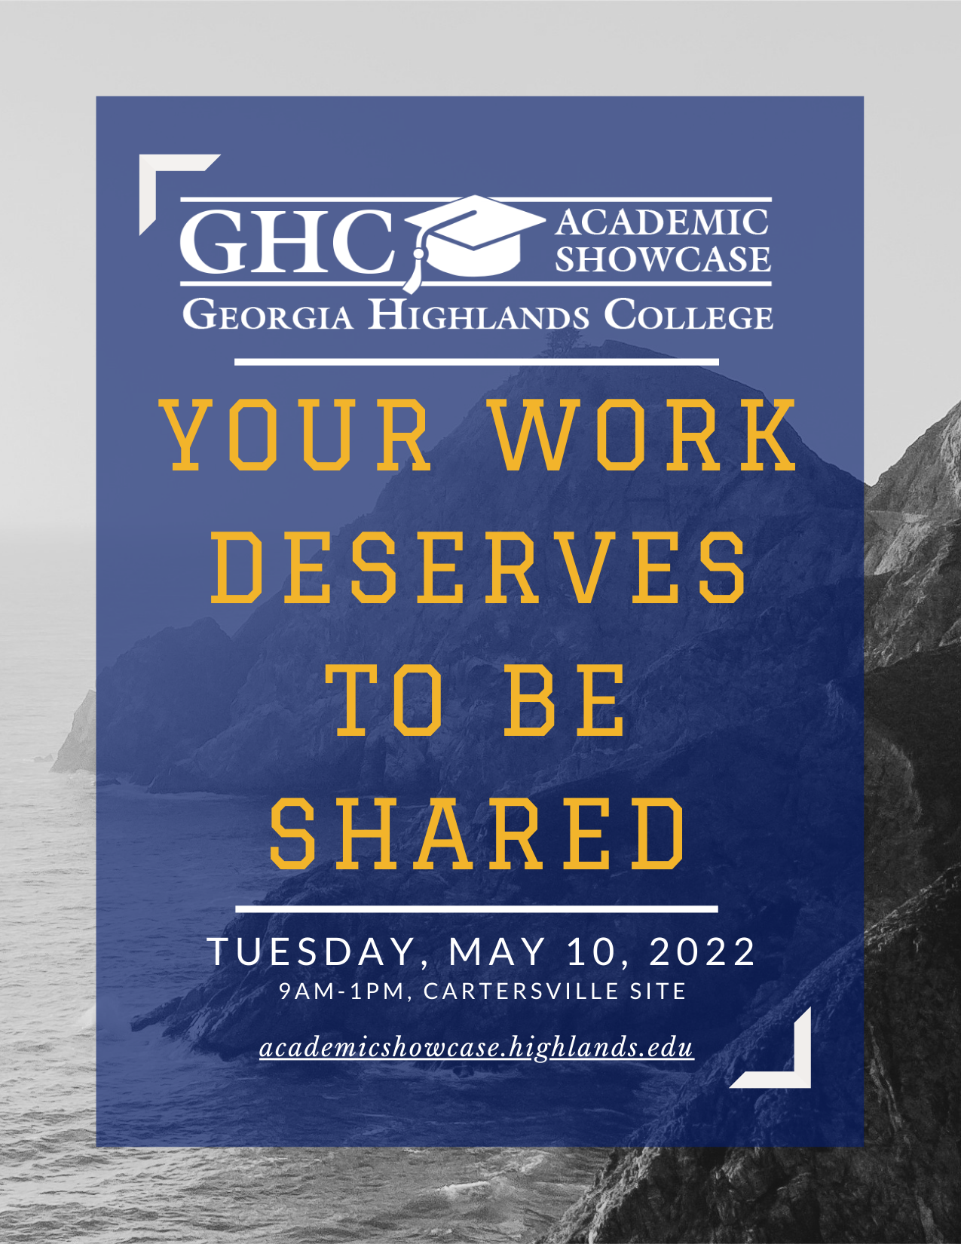

Special Thanks

Academic Showcase Committee
Josie Baudier
Jesse Bishop
Layla Cecil
Sarah Coakley
Caroline Evergreen
Julius Fleschner
Michelle Lockett
Clifton Puckett
Rachel Rupprecht
Krissy Shanahan
Erin Shufro

Cartersville Campus
Leslie Johnson
Karen Yerkes
Facilities Team

IT Support
Adam Bowman

Program Printing
Ken Davis

Welcome to Georgia Highlands College’s Inaugural Academic Showcase!

Schedule
9:00 – 9:10 Welcome, Ballroom
Academic Building B
Dr. Sarah Coakley, Interim Provost

9:20 – 10:15 Oral Presentations
Academic Building A, 3rd Floor

10:25 – 11:35 Posters, Gymnasium
& Exhibits, Ballroom
Academic Building B

11:00 – 12:10 Lunch, Café
Academic Building B
12:10 – 12:30 Keynote, Ballroom
Academic Building B
Captain Orry Young, GHC Alumnus

12:30 – 1:00 Award Ceremony, Ballroom
Academic Building B
(Campus map on back)

Presentations Academic Building A, 3rd Floor

9:20-10:00

HIPs: Writing & Research A-313
Danny Bellinger English Composition 1101 HIPs Course
I am working with a Faculty Learning Community to develop a Writing-Intensive English Composition 1101 HIPS course. The course design has five High-Impact Practices as key elements: performance expectations set at appropriately high levels; experiences with diversity; frequent, timely, and constructive feedback; periodic, structured opportunities to reflect and integrate learning; and public demonstration of competence. The students will read narrative articles and memoirs and will be able to write four expository essays using a narrative approach.

Ryan O’Connor Developing a Scientific Writing Introduction in Principles of Chemistry I
While reading and writing scientific processes is a critical skill to those continuing in the field, the first-year STEM laboratory course is frequently a student's first encounter with this style of writing. Therefore, there is a need to introduce scientific reading and writing and include elements of broader scientific communication to prepare students for future classes and/or CURE opportunities. In conjunction with the HIPS FLC and NFA, I developed an addition to the Principles of Chemistry I lab which aims to augment the standard regimen to include a scientific writing portion as a long-term High Impact Practice (HIP) spanning the semester. In this assignment, students are asked to complete one section of a formal report during each of the early lab activities and to provide some reflection on their progress. After each major section has been concluded, the formal report is written on a late-semester lab and submitted for guided peer review by classmates. In this presentation, I will discuss the layout of this HIP, results and student work in its first implementation in Spring 2022, and lessons learned for future optimization.

Charles Grimm Scaffolding and Transfer: Gauging Student Transfer in FYC
This presentation proposes a short qualitative survey study of FYC students’ ability to transfer knowledge from scaffolded lesson planning to a writing assessment. The presenter will discuss the data gathered from a pilot study before describing a larger study to determine the level of transfer in writing courses at a rural two-year college.

HIPs: Research A-321
Brandy Rogers, Barcoding Life: Scientific Discovery and
Jared Ponder, Student Impact in a CURE Biology Lab John Thomas Tapp,
& Trinity Young
The International Barcode of Life Project (iBOL) is a research alliance whose ultimate goal is to build a database of molecular barcodes in order to identify and catalog every multicellular species on the planet. Tardigrades, also known as water bears, are microscopic invertebrate animals known for their incredible abilities to withstand extreme environmental conditions, including intense heat or cold, desiccation, oxygen deprivation, and levels of radiation considered lethal to most organisms. Of the approximately 1300 known species of tardigrades, only 296 have been added to the Barcode of Life Database (BOLD) to date. In this CURE, our goal is to collect tardigrades from Bartow, Paulding, and Floyd counties, isolate their DNA, and use PCR amplification of the COI gene to generate sequence data for DNA barcoding. Through the successful completion of this student-led research, we will contribute to the growing database of DNA barcodes, as well as to the knowledge pertaining to successful location of tardigrade specimens in local ecosystems. Here, we present our methods and results, as well as report on the value of CURE labs for students. Through guided experimental design and implementation, students obtain valuable hands-on experience addressing novel questions, as well as benefit from the opportunity to make meaningful contributions to scientific knowledge. The students who participated in this project reported an increase in academic motivation and confidence greater than what they would have expected from performing a traditional series of biology lab activities with known or expected outcomes.

Merry Clark How to Change Student Perception of
& April Cole Laboratory Activities
In undergraduate biology laboratory courses, students are expected to apply the principles of science and communicate understanding in an inquiry-based way. We are researching laboratory exercises required in these courses, and student (mis)understanding of basic lab exercises. We will provide elements of laboratory exercises that do/do not “work”; from a student's perspective and discuss how our project evolved into the creation of a complete laboratory manual.

Kim Subacz Introducing CURE to Anatomy & Physiology II
In the Fall of 2021, Anatomy & Physiology II (APII) students designed a lab protocol featuring the physiology of systems in the human body. Students researched, designed, and performed (if possible) the protocol as a group. This CURE added to the lab exercises the students already perform that are very heavily anatomy based with little to no physiology. Students were surveyed pre/post CURE to determine their knowledge base and any changes. This project embraces the 5 components of a CURE: scientific practices, collaboration, iteration, discovery, and broadly relevant or important work. The students received training in scientific research from a GHC librarian. The students used this knowledge in a series of small credit activities. They created a proposal, a rough draft, and then a final draft of their new lab protocol. As a final activity each group member participated in an in-class presentation of their new lab protocol. Overall, the CURE project was very successful in the 16-week semester APII course. The students submitted positive feedback in their surveys, and we had multiple lab protocols submitted.

HIPs: Service-Learning A-322
Kimberly Roberts Hey, those nurses are HIP! Service Learning in RN-to-BSN Leadership Education
This presentation describes an asynchronous service-learning initiative that was implemented in the online RN-BSN program. High impact practices (HIPS) in nursing courses involve critical reflection and meaningful community service. They also serve to improve academic growth as well as increase student success. The service-learning project increased student success by improving the visibility of the BSN students in a leadership capacity in their work environments.

Denie Burks Transitioning from Student to Learner: How Being Uncomfortable Leads to Learning
The presentation will discuss the proposed research presented to juniors during the first semester of their junior year of the Bachelor of Business Administration program. This project combines all students enrolled in Operations Management which includes students from both the Floyd Health Care Management and the Cartersville Logistics and Supply Chain Management programs. During week #2 of the semester students are introduced to a local transportation organization along with several leading community leaders to research, discuss and plan ways to best provide cooperative and collaborative ways to provide affordable and reliable transportation to community residents. The transportation organization aligns with local agencies, educational institutions, health care facilities, manufacturing, and other businesses in an attempt to provide employees and students with reliable access to and from their daily destinations. Throughout the semester students provide ongoing updates with reports and presentations. Students select the area of the project where she/he feels they would like to research. The students also decide each person's role within their area of interest. They then communicate weekly with their assigned community leader, who acts as a mentor throughout the entire semester. At the end of the semester, the students present their final research data and make suggestions to the transportation company.

Danielle Steele Little Free Library: Service-Learning Collaboration
During the Spring semester, my ENGL 1102 class completed a Diversity Equity Inclusion Inventory of the popular titles in the Cartersville Campus GHC library. Based on this information, the class worked together to create a service-learning project where we built a Little Free Library on the Cartersville Campus and stocked it with books by a diverse group of authors not represented in our current library collection on campus. This class also had a variety of guest speakers who helped us to understand topics in literacy and diversity.

Change A-324
Giselle Tucker Your Voice, Your Vote: The impact of Georgia’s new voting laws and its effect on voter turnout
With the passage of Georgia Senate Bill 202 (a.k.a. the “Election Integrity Act of 2021”) through the legislature, research was conducted to see the impact these laws may have on voter turnout. Since January of 2021, as many as 18 states have enacted laws that many analysts believe will serve to harm the integrity of what is in essence, a constitutional right. These enacted and proposed laws include vote-by-mail restrictions, restrictions on early voting, and broader authority for purges of voter rolls. An often-cited reason for these bills and laws is voter fraud, yet voter fraud is rare and has not been widespread or unequivocally proven. Research was conducted by analyzing Section 5 of the Voting Rights Act of 1965, Section 4(b) of the Shelby County v Holder (2013) decision, and the effect Georgia's Senate Bill 202 may have in the upcoming gubernatorial race. The research discussed assesses the impact these policies have historically had on the electoral process. By comparing these outcomes before and after the passage of these major policy or legal outcomes, utilizing non-partisan data from both sides of the ideological spectrum, our research aims to predict whether these new restrictions serve to impact voter turnout.

Maurice Wilson Overcoming Implicit Biases in the College Mathematics Classroom
We all hold implicit biases about people that influence our behavior and interactions in ways we don’t even realize. When professors’ hidden attitudes and beliefs about students are based on race, ethnicity, and/or gender, they may unknowingly communicate negative messages to their black, brown, and female students about their abilities to tackle the math topics. This presentation will offer suggestions on how to recognize those biases and ways to overcome those biases in the classroom.

Allen Dutch HIPs in Internship Classes
& Kimberly Lyons
Instructor for Comm 2999 Internship class will give a brief explanation of the HIPS elements built into the class this year during the Faculty Learning Community for High Impact Practices. Student Kimberly Lyons will present results of her internship project and her experiences during her internship with Delos Custom Rug Company working as the Social Media and Marketing Intern Spring of 2022.

Being and Becoming A-326
Katie Weatherford Everybody Loves Moral Philosophy Professors: How “The Good Place” Uses Humor to Educate
“The Good Place‚” is a show on NBC about the afterlife. This show is able to use a mostly outlandish premise to convey complex principles about ethical and moral philosophy. “The Good Place” does a truly fantastic job of this. This speech focuses on two of the main characters in this show, Eleanor Shellstrop and Chidi Anagonye, and will remain spoiler-free. Eleanor is a self-proclaimed “Arizona dirtbag” who dies and goes to the good place. There she meets Chidi Anagonye, an ethical and moral philosophy professor who agonizes over every single decision he has ever and will ever make. Eleanor confesses to Chidi on their first day together that she does not belong. This kickstarts her attempts to become a better person through learning philosophy with Chidi. The show is able to help the average person learn about these complicated theories of ethical and moral philosophy, without even realizing it. The central theme of this show, according to the creator, Michael Schur, is the question of what we owe to each other. This may sound familiar; it is the title of a book by philosopher T.M. Scanlon. Of course, he also wanted to explore many different philosophers through the lens that your bonds with other people create a more meaningful life. While this speech focuses on this show in particular, educators will be able to use some of the show’s tactics in their classrooms.

Samantha Lewis Ride the Wave: How to be a Successful Student
As a soon-to-be graduate of Georgia Highlands College (GHC), the presenter will share her experiences in utilizing the resources available to students across all campuses. The presenter has spent every semester from summer 2019 to spring 2022 enrolled in GHC classes, and she took full advantage of those offered online and face-to-face. The student was three months into Spring 2020 when the COVID-19 front hit GHC. Amid being forced into online learning, the tutorial center was vital to her successes. The presenter began her journey of resources at that time. She reached out to Student Support Services (SSS) where she found a counselor, and she has been seeing the same person for more than a year. The presenter believes it is important to make sure that students on all campuses are aware of what SSS and other programs offer to GHC students. During her time at GHC, the presenter became familiar with the tutorial center, the writing center, SSS, the Undergraduate Research Group, the Media Innovation Center (MIC), the library, the video room, the Honors Program. and countless other resources at GHC. The presenter wants to share with other students how to be successful at GHC.

Crystal Nichols Character Study of Juan Soler as an existential hero in the film “Death of a Cyclist”
This presentation will examine the character of Juan Soler in the film “Death of a Cyclist” as an existential hero. At the beginning of the film the two main characters, Juan and Maria, must make a choice which will affect not only their relationship but the rest of their lives. I will utilize theory from Jean Paul Sartre's work “Existentialism and Human Emotion” and his philosophy on existentialism and choice. Juan Soler is a complex character who must make choices based on what Sartre calls the “facticity” of life. Life can be messy, but we must make choices. I will look at definitions of existentialism and how they relate to the film. I will also discuss the many elements of “film noir” contained in this film. In conclusion, by accepting his responsibility Juan comes full circle and becomes a hero as foreshadowed in the film.

Innovation A-328
Labeeba Testing the Acid Content in Various
Shafique Carbonated Beverages
The most opportune way to quench humongous thirst on a hot, sunny day is through “soft drinks.” The market nowadays offers a wide assortment of sodas. Chemists classify them into two broad categories: clear and dark. The sodas that fall under the clear category have critic acid H₃C₆H₅O₇ (aq) in them to contribute to their sour “tart” taste. On the other side, caramelized dark beverages have phosphoric acid H₃PO₄ (aq) induced in them to provide their flavors. With the help of the common acid-base titration method, I intend on finding the acid concentration present in a few of the most popular beverages. In light of the fact that most of the beverages are colored a pH meter will be used to determine the equivalence point. The base the sodas will be titrated against is NaOH (aq) with potassium hydrogen phthalate. For this project, I have selected eight beverages (two regular and two zero-sugar versions of the same soda), four from each category (Dark sodas: Coca-Cola, Diet Coca-Cola, Dr. Pepper, Zero Sugar Dr. Pepper; Light sodas: Sprite, Sprite Zero Sugar, 7-up, 7-up Zero Sugar). In addition to the titration of the sodas with standardized NaOH (aq) solution, club soda will be titrated using the exact same procedures as a controlled group. All the liquids will be degassed overnight to remove carbon dioxide from them. Besides stock solution of citric acid and phosphoric acid will be titrated to determine K_{a1} and K_{a2}, and K_{a3}.

Jordyn Coffin Devastation and Innovation Following the Great Chicago Fire of 1871
Late in the evening of October 8, 1871, a fire began on Chicago’s west side and spread quickly throughout the city, fanned by Chicago’s notorious winds. The fire lasted an agonizing 3 days, outsmarting firefighters at every turn and leaving a trail of destruction and heartache in its wake. By the end of the day on October 10, 1871, three hundred people had lost their lives and one-third of the city found themselves homeless. This tragedy brought the city to its knees, but out of the ashes came a complete overhaul of the fire service and an explosion of architectural innovation.

Exhibits & Posters

Academic Building B

10:25-11:35

Music, Ballroom 10:25-10:45
Robert Adams, HIP Course Enhancement: Planning,
Meggan Brant, & Advertising, and Executing a
Madison Crouch Community Concert Event 10:25
Students in Robert Adams’s hybrid MUSC 1100 course acted as a liaison between our GHC music ensemble, The Highlanders, and the Cartersville Downtown Development Authority to present a concert for the Cartersville community in Friendship Plaza on Monday, April 25. All students in the course worked collaboratively to organize and promote the event, promote GHC’s music department, and assist with set-up and tear-down for the musical ensembles.

The Highlanders in Concert 10:30-10:45
The Highlanders is a GHC student ensemble of 15 instrumentalists and singers: Ammad Caesar, Arian Jolly, Cassie Haygood, Dalton Umphrey, Dana Christ, Ian Schirmer, Jamie Kline, Jane Parsons, Jeremiah Madden, Jerry Anderson, Katie Weatherford, Lee Smith, Madison Crouch, Nicholas Johnson, & Sophia Soto. Led by Sam Baltzer, the group performs a variety of songs including pop, jazz, classical, Broadway, and Celtic dance tunes.

Exhibits, Foyer 10:45-11:35
Thailea Brinkmann The Bachelorette group video
This satirical video was based on the Greek mythology of the “Beauty Contest” between the goddesses Hera, Athena, and Aphrodite. It uses the dating game interview process to make fun of current dating practices and also addresses gender issues, but is a humorous look at today's world of dating.

Claudia Miles The Brain
A 3D model of the brain constructed from Styrofoam and painted to differentiate each part of the brain.

Lyzette Schott Family Communication Book for Kids and their Grown-Ups
I wrote this book as an Honors Project for my Communications class in which I set out with the intent of creating a simple children’s book. My plan was to teach kids a couple complicated college-level communication skills in a very simplified way. My professor, Dr. Stuglin and I came up with a basic concept and away I went. I had no idea at first glance that this book would take such a dramatic turn to include both kids and their grown-ups and that in the end, I would be teaching concepts to the grown-ups more than anything, using their own kids as assistants!

Anna Hough, “Life Goes On” Game
Charlotte McGinnis,
Michelle Pineda Tinoco,
& Grace Silva Parra
This satire project is a board game based on Kafka's Metamorphosis.

Gabrielle Hawthorne, “Lockdown” Game
Ryan Parker, Jack
Baldwin, & Meet Patel
This group satire project is a board game about Covid lockdowns. It is based on Mary Shelley's Frankenstein.

Albert Cooper A Massive Tragedy
It is a piece of music that I composed that carries many themes through the notes and techniques used in the composition.

Kayla Miller Reverse Poem
The topic of my poem is a description of what the love of a mother is like. It is an elegy for the lives lost at the Kabul airport in 2021 and our other service members.

Jenna Patterson Storm Clouds Over Lake
This is a digital painting that I created using photoshop that is based on an actual photograph taken by me.

Posters, Gym 10:25-11:35

Faculty & Staff

Banhi Nandi Bacteria: The Only Culture GHC Has

Justin Polizzi Biochemistry as a Writing-Intensive Course

Paula Stover, Community Involvement: A High
Debbie Amason, Impact Practice in Associate Degree
Misty Smith, Programs
Kelly Wright,
Shea Walker,
Nicole Tolbert, &
Marta Sanderson

Shea Walker, Creating an Evidence-Based Practice
Lisa Jellum, Experience Through Public Knowledge
& Allen Dutch Presentations (A High-Impact Practice)

Tara Suswal Effects of High Impact Practices on Student Engagement in Elementary Statistics Courses

Michelle Abbott Getting Students to Read: Using Perusall to Increase Engagement with Assigned Readings

Lucinda HIPs Undergraduate Research
Montgomery Implementation

Brittany Ozmore, GHC Video Recording Studio
Josie Baudier,
Betsy Fleming, &
Adam Bowman

Jonathan Howard Vitamin D Receptor Expression during Recovery following Severe Skeletal Muscle Injury

Students

Workplace Proposals
Shawn McDaniels Backdoor Replacement

Karen Vaca Bahama Breeze

Alexandria Harn Cracker Barrel Technology Innovation

Mayra Bravo Daycare Center

Anya Riley Employee Breakroom Areas

Jacob Carroll Faulty Equipment at Autobell

BJ Roper Fundraising Needs for Booster Club

Sophie Williams More Sustainable Lighting

Stockton Norod New Walkie Talkie System

Jolene Hayden Occurring OSHA Accidents due to Equipment Repairs
Kaitlyn Williams Security Cameras

Khady Diaw Shaw Industries Carpet

Aniston Hofer Tanning Salon

Nahum Trenti Tool Renewal

Reese Elrod Walk-in MD

Isaiah Ray Wasted Cans at the Budweiser Brewery

College and Career Advising
Vanessa Johnson, Dual-Enrolled and General Studies
Megan Hardin
Karlee Urlaub,
Anna Rich, &
Katie Traynor

Nicholas Engineering and Computer Careers
Constantine,
Cesar Hernandez,
Ryan Lovingood,
& Nate Seavey

Cole Leshin, Film/English/History
Myla Mingioni,
& Reilly Black

R.J. Holmes, General Studies
Luke Foster, &
Mason Curtis

Kaylin Taylor, Healthcare
Allie Gravitt, &
Bridgett Jenkins

Shavvon Psychology and Biology
Carmichael &
Karim Mohammed

Literature
Charity Towe, The Beat Generation
Jennifer York,
Chelsea Simons,
Taylor Burns, &
Michael Cohen

Shannon Ellis Charlotte Perkins Gilman: Short Fiction

Zach Murray Flannery O’Connor: Georgia Author of Short Stories

Kyjuan McClendon The Harlem Renaissance
Vanessa Juarez Pelico,
Cayland Rucker,
Gordon Elzey, &
Jeremiah Anderson

Chris Meyers John Steinbeck: Short Fiction

Ana Reynoso Mary Hood: Georgia Author of Short Stories

David Chester, Southern Women Writers
Evan Hammonds,
Isaiah Calhoun,
Ava Bierkamp &
Juan Herrera

Carrie Kindt, Stream of Consciousness
Michael Page,
Aleena Diomende,
& Taylor Cooper

Ryan Causey, Western Writers
Kamryn Dean,
Evan Arvanitis,
Logan Bennett, &
Marena Cescutti

Biology
Sydney Bryson Agricultural Runoff Monitoring for Lake Allatoona

Lauren Black Comparing the Nitrate and E. Coli Concentrations Between the East and West Sides of Lake Allatoona

Deilan Estrada Databasing Retention Pond Bacterial Species using 16s rRNA Analysis

Crystal Lee The Effects of Damming Rivers

Cheyenne Bailey Retention Ponds are a Bacterial Ground for Populations that can be Manipulated into Antibiosis

Multi-Disciplinary
Samantha Lewis Georgia Highlands College Leadership Series

Aidan Spanglish Fabrics Inventory Database
Schmeckpeper,
Hunter Crisp, &
Austin White

Michael Roberts, Minecraft Education Addition
Guillermo Vazquez,
Heidy Mendez, &
Miriam Lister

Lunch, Cafe 11:00-12:10

Keynote, Ballroom 12:10-12:30
GHC: An Exceptional Foundation for a Rewarding Life
Captain Orry Young served as president of Phi Theta Kappa, Alpha Psi Omicron Chapter while a student at Georgia Highlands College. Following his graduation from GHC in 2011, he transferred to UGA on an ROTC scholarship. During his seven years of active-duty service in military intelligence, he saw three combat tours in Afghanistan and Syria. After earning his MBA from Emory next month, he will pursue a career in Marketing and Strategy at Microsoft in Atlanta.

Award Ceremony, Ballroom 12:30-1:00

Cartersville Instructional Site
