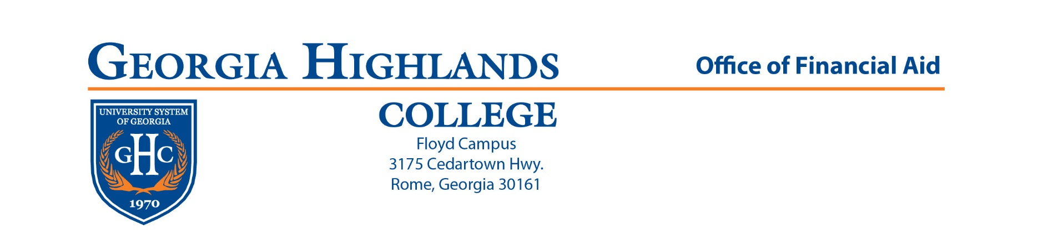

Greetings,
This letter is to advise students, who requested transient status to another institution from GHC, of the necessary steps in the transient financial aid process.
For federal aid consideration (Pell/Student Loans):
___The student should consult the Office of Financial Aid at GHC to submit a Consortium Agreement which will be sent to the host institution. The Consortium Agreement can be found online at www.highlands.edu, under Financial Aid Forms.
___After the drop/add period at GHC, the consortium agreement will be sent to the Office of Financial Aid at the host institution so they can confirm the student's schedule and return the form to GHC.

___Students are expected to pay their total tuition and fees to the host institution by the fee payment deadlines and expect reimbursement from GHC for any federal aid during normal refunding timeframes set by the Business Office.
For state merit award consideration (Hope/Zell):
___The student should consult the GHC Office of Financial Aid to submit a Hope/Zell Transient Request form. The Hope/Zell Transient Request form can be found online at www.highlands.edu, under Financial Aid Forms. Subject to approval, a Hope/Zell Transient Certificate will be submitted to the host institution via the Hope/Surfer website.
___The host institution will process the Hope/Zell Transient Certificate as long as the student has been accepted to the host institution with a schedule in place for the applicable semester. Hope/Zell is awarded up to 15 credit hours (these 15 credits are a total of any credits taken at the home and host institutions).
___ Hope/Zell Miller Scholarships do not cover the full amount of tuition and fees. Transient students are expected to pay any tuition and fees due at the host institution by the fee payment deadlines.
Please let us know if you have any questions.

We wish you much success,
The Office of Financial Aid
Georgia Highlands College
finaid@highlands.edu
FAX: 706-295-6341 or 6731

