COMM 1100 Human Communication
WORKBOOK C
for use with the Essential Communication text

"Truth is, I'll never know all there is to know about you just as you will never know all there is to know about me. Humans are by nature too complicated to be understood fully. So, we can choose either to approach our fellow human beings with suspicion or to approach them with an open mind, a dash of optimism and a great deal of candor."
-Tom Hanks

NAME: __________________________________________________________________

Instructions
DO NOT LOSE THIS WORKBOOK

A. Read the assigned chapter before class.
B. Complete the workbook entry before class.
C. Bring workbook to class to be checked for completion in the first 10 minutes.
D. Use the workbook during class to facilitate class discussion.
E. Use the workbook to prepare for assignments and study for unit exams.
Scoring
-15 points per entry for completion prior to arriving in class (6 entries)

WB: Unit C, Entry 1 - Read chapter seven before class and answer the following items in your own words. Explain your answers. Provide examples. Bring your workbook to our next class.
Define interpersonal communication.
What is the difference between content messages and relational messages?
Explain how a relational message might convey meaning about affinity, respect, immediacy, and control.
Define metacommunication and explain the three key things to know about it.
Define self-disclosure.
Draw and label Altman and Taylor’s Social Penetration Model.

What does this model suggest we do to improve the quality of our relationships?

Draw and label Luft & Harrington’s Johari Window.

What does this model suggest we do to improve the quality of our relationships?

What eight questions should we ask before engaging in self-disclosure? Why does each matter?

How is online interpersonal communication different from face to face interpersonal communication?

What do you like most about communicating online? What do you like least?

What is a communication climate?
Explain the difference between confirming and disconfirming messages.

What are four ways to avoid damaging your relationships?

What is a spiral? What is the difference between a positive, negative, and cyclical spiral?

Take the assessment on page 106. What is the Forecast for your communication climate?

You will complete this page during class. Do not complete it in advance.
Personality in Practice
Define the relevant terms in the Meyers-Briggs Personality (MBTI) model.
Extrovert
Introvert
Sensor
Intuitive
Thinker
Feeler
Judger
Perceiver
What type are you?
What types will you have good relationships with?
What types will be difficult for you to build relationships with?

WB: Unit C, Entry 2 - Read chapter eight before class and answer the following items in your own words. Explain your answers. Provide examples. Bring your workbook to our next class.
Explain the differences between relationships with friends and relationships with family.
Why do we form friendships? (Seven common reasons). For each of the seven, identify a friend you have or have had that may have been because of that reason.

Define social exchange theory.

What is the difference between an intangible reward and a tangible reward? Give an example of each.

What is a relationship cost? Provide an example.

Your Example | Friendship Dimension  (Explain each) | Your Example
My friends from the restaurant I worked at in Michigan | Short Term vs Long Term  Short term friends change as life does, they are tied to a specific job, school, city, etc. Long term friends stay friends through new jobs, new cities, changes in family, etc. | My friend Ben, who I’ve kept close to over 18 years and multiple moves.
 | Low Disclosure vs. High Disclosure
 | Doing-Oriented vs. Being-Oriented
 | Low-Obligation vs. High-Obligation
 | Frequent Contact vs. Occasional Contact

What are the Eight Communication Strategies for being a good friend?

Rate yourself 1 (worst) to 10 (best) at each of the 8 strategies above.
What is the contact hypothesis and why does it matter to gender and friendship?

What are five common differences between the ways friends communicate online or in person?

Communication between parents and their children also has special features. Was communication with your parents focused on conversation or conformity? What does that mean? How did it impact you?

Were your parents generally authoritarian, authoritative, or permissive? What does that mean? How did it impact you?

Communication between siblings also has special features. What kinds of sibling relationships did you have or do you have now? (If you don’t have siblings, talk about one of your friends that does have them). What does that mean? How did it impact you (them)?

What can we do to strengthen family ties?

You will complete this page during class. Do not complete it in advance.
Communicating with Friends in Practice

Relationship between A: and B:
 | A | B
Why did this relationship form (7 common reasons)?
What rewards and costs does each person gain?
Is this relationships short or long term?
Low or high disclosure?
Doing or Being oriented?
Low or High Obligation?
Frequent or Occasional Contact?
If you had to guess, what is each person’s MBTI?
(entry 1)
Is the relationship in a positive, negative, or cyclical spiral? (entry 1)
Provide evidence to support your claims in the table above. (I think this person is in this stage because in the episode last season they said ….)
WB: Unit C, Entry 3 - Read chapter nine before class and answer the following items in your own words. Explain your answers. Provide examples. Bring your workbook to our next class.

What is intimacy in romantic relationships?
Draw and label Knapp’s Relational Development Model.

Explain each stage of Knapp’s Relational Development Model.
Stage | Characteristics
Pick one of current friendships or romantic relationships. What relationship stage is that relationship in? What makes you think that the relationship is in that relationship stage?

What are three ways that communication influences romantic potential?

What do we know about gender and intimacy?

What are love languages? Give examples of what kinds of behaviors might fit in each language.

Take the assessment on page 129. What is your love language? Do you agree with this result?
Think of someone you dated or had a romantic interest in. What was their love language? How did you (how do you) know?

Relationship Dialectic Theory describes a dialectical model. What is the dialectical model?

Explain the sometimes conflicting drive (dialectical tension) between openness and privacy. Provide an example.

Explain the sometimes conflicting drive (dialectical tension) between connection and autonomy. Provide an example.

Explain the sometimes conflicting drive (dialectical tension) between predictability and novelty. Provide an example.

Explain the Strategies for Managing Dialectical Tensions? Identify the one that you use the most often. Identify the one that you think is the most effective and healthy way to balance a dialectic. (i.e. Which one do you use, and which one should you use?)

Explain the differences between altruistic lies, evasions (including the distinction between equivocation and hinting), and self-serving lies (including the distinction between omission and fabrication).

How do partners typically express conflict? Come up with an example for each of the five styles of expression in conflict.
Term | Definition | Example

How can we protect ourselves from abusive partners?

What conflict patterns typically destroy relationships?

Think of an example of a recent conflict between you and a romantic partner or romantic interest. Which conflict patterns did you use? Which did they use?

Save space here to learn about Thomas & Kilmann’s Conflict Styles Model in class.

What are the eight steps for win-win problem solving explained in the chapter?

You will complete this page during class. Do not complete it in advance.
Romantic Relationship Communication in Practice

Relationship between A: and B:
 | A | B
What relationship stage does each think they’re in?
What MBTI personality do they have? (entry 1)
Are they open or closed (dialectic)?
Are they connected or autonomous (dialectic)?
Are they predictable or novel (dialectic)?
How do they typically express conflict?
How do the characters approach conflict? (style)
Map out dialogue for how they could handle this conflict using eight steps of win-win problem solving.
Provide evidence to support your claims in the table above. (I think this person is in this stage because in the episode last season they said ….)
WB: Unit C, Entry 4 - Read chapter ten before class and answer the following items in your own words. Explain your answers. Provide examples. Bring your workbook to our next class.

Define networking.
What five steps does the chapter provide for creating and benefiting from a personal network? For each, rate your current attempt/ability to use this strategy from 1 (I don’t do this well and never do it) to 10 (I do this well and do it often).

What five strategies can we use to build a career-enhancing network? For each, rate your current attempt/ability to use this strategy from 1 (I don’t do this well and never do it) to 10 (I do this well and do it often).

When applying for a job, what five steps should we follow?

Take stock of your current online identity, including the variations between the versions of you available to the world on each profile. Follow the example in italics.
Platform | Name this version of you | How private/ public is this version of you? | What do you share often here? | What do you never share here?
Facebook | Friends &  Family Me | Somewhat private. Mostly friends and fam | Daily life photos, vacation photos, political news, memes | Provocative or NSFW content, extensive cussing, because of some family

How can we better manage an online identity?

What is a selection interview?

How can we prepare for an interview?

What kinds of questions are illegal to ask in a job interview in the United States?

What is a bona fide occupational qualification?
What should we do if asked an illegal question during an interview?

What suggestions for participating in a job interview will help us succeed during the interview itself?

Provide some examples from page 151, and also from searching around online, of good questions that an interviewee can ask the interviewer at the end of an interview.

What do we have to do differently when interviewing by phone or video?

Review the Common Interview Questions on page 147. Write an answer for each below (and also answer the additional common questions I’ve included), as if you were being asked that question during a real job interview next week.

Tell me something about yourself.

What makes you think you’re qualified to work for this company?

What accomplishments have given you the most satisfaction?

Why do you want to work for us?

Where do you see yourself in 5 years?

What major challenges have you faced, and how have you dealt with them?

What are your greatest strengths?

What are your salary requirements?

Why did you leave your last job?

What are your greatest weaknesses?

Do you work better with others or alone?
How has your personal background influenced what you are today?
Tell me about a problem or issue you faced at work and how you dealt with it.
Given that we have other qualified candidates, why should we hire you?

Gather information as if you were putting together a resume. What would you include?
Type | Definition | My resume would have
Education | HS/College Degrees. Years expected or completed for graduation. GPA. Major coursework. | 2017 – Douglas High School Graduate  3.6 GPA, 15th in class  Honors Trigonometry & Chemistry
Experience
Honors
Skills
Activities
You will complete this page during class. Do not complete it in advance.
Landing a Job in Practice
Tell me something about yourself.

What makes you think you’re qualified to work for this company?

What accomplishments have given you the most satisfaction?

Why do you want to work for us?

Where do you see yourself in 5 years?

What major challenges have you faced, and how have you dealt with them?

What are your greatest strengths?

What are your salary requirements?

Why did you leave your last job?

What are your greatest weaknesses?

Do you work better with others or alone?
How has your personal background influenced what you are today?
Tell me about a problem or issue you faced at work and how you dealt with it.
Given that we have other qualified candidates, why should we hire you?

INTERVIEW RUBRIC
If you miss your chance to conduct an interview/be interviewed, you will be unable to make up the points.

Job details: You are applying for a position working for Georgia Highlands College that will require basic computer skills, communication skills, organization, and a quick learner. The job involves recruiting activities for the college. This is a part time job that will allow you to work during hours you are not in classes. The company has agreed to cover your tuition at GHC plus pay you a salary if you get the job.

Conducting an Interview – 30 points
You will prepare a series of questions for a 5 minute interview (at least 15 questions, likely more). These should include several from the standard questions (p. 147) and some of your own creation (be creative!). During the interview, you should attempt to ask at least one probing question. You are representing your company and must demonstrate that responsibility in your interviewing manner.

Demonstrates Preparation  List of at least 15 questions ready | 0 2 4 6 8
Questioning probing, closed & open, hypothetical Qs | 0 1 3 5 7
Role Management  Listens rather than talks | 0 1 3 5 7
Represents company well manages nonverbal (incl. artifacts); demonstrates taking the situation seriously | 0 2 4 6 8

Being Interviewed – 70 points
You will prepare to answer questions in a 5 minute interview. You should be ready to concisely answer the standard questions (p. 147) and also think about how you might deal with other unexpected questions. During the interview, you should be mindful of the strategies we discussed in class and ask at least one question of your interviewer (p. 151). You are actively trying to do well in this interview and get the job so must demonstrate that challenge in your interviewing manner.

Demonstrates Preparation  Answers to standard Qs prepared. Knowledge of company demonstrated | 0 2 4 6 8 10
Role Management  Answers questions as asked; answer length and detail is appropriate; back questions at the end of the interview | 0 2 4 6 8 10
Represents self well  manages nonverbal (incl. artifacts); demonstrates taking situation seriously | 0 2 4 6 8 10
Answering  Demonstrates humility & interest;  sells self; is not critical; evidence of considering answer connotations | 0----------40
Misc. Comments:
WB: Unit C, Entry 5 - Read chapter eleven before class and answer the following items in your own words. Explain your answers. Provide examples. Bring your workbook to our next class.
What are five reasons why good communicators flourish in the professional world?

Define social intelligence.

Explain and provide an example for each of the blunders to avoid at work. Which blunders have you made out of the list?
Blunder | Explanation | Example
How can we communicate more professionally online? Which is most important?

What are common characteristics of good leaders?

Explain the Trait Theory of Leadership.
Explain the Situational Theory of Leadership. (Save space to add situational styles in class)
Explain the Transformational Theory of Leadership.

Draw and label the Managerial Grid.

Complete the assessment on page 164 and explain your result (your leadership style) here.
What are some strategies for working with a difficult boss?

How can we leave a job without burning bridges?

What is power in the workplace?

Type of Power | Explanation | How do we gain/develop this kind of power?
Legitimate
Expert
Connection
Reward
Coercive
Referent
What characteristics are embodied in small group interaction?

Explain the difference between rules and norms in small groups, including by social, procedural, and task.
Explain the difference between formal and informal roles in small groups.
Draw and label the Model of Roles in Small Groups. Which task role, social role, and dysfunctional role have you adopted most often? (Pick one of each)

Define cohesiveness and explain how groups can enhance cohesiveness.
Why do groups produce higher quality solutions in most cases?
Explain the stages in decision making groups and why each is important.
How do we encourage equal participation in small groups?
How do we avoid information underload and overload in small groups?
Define groupthink. How do avoid the pressure to conform in small groups?
How do we make the most of diversity in small groups?

Explain the nine steps of Dewey’s Reflective Thinking Method.

You will complete this page during class. Do not complete it in advance.
Group Problem Solving in Practice

You will complete this page during class. Do not complete it in advance.
Group Assignment
What are the major decision-making strategies? Put a star next to the one your group will use.
Strategy | Definition

Norms or Rules in use
My informal or formal Roles in this group
Our group’s
leader
Our leader’s
leadership style

What I know about the problem
Possible Solutions
Details on Our Solution
WB: Unit C, Entry 6 – Refer back to chapter ten and eleven as needed before class and answer the following items in your own words. Explain your answers. Provide examples. Bring your workbook to our next class.

During in-class discussion of entry 4, we discussed how to answer each of these questions better. Rewrite your answers here, using what we discussed in class as a guide for how to answer better.
Tell me something about yourself.

What makes you think you’re qualified to work for this company?

What accomplishments have given you the most satisfaction?

Why do you want to work for us?

Where do you see yourself in 5 years?

What major challenges have you faced, and how have you dealt with them?

What are your greatest strengths?

What are your salary requirements?

Why did you leave your last job?

What are your greatest weaknesses?

Do you work better with others or alone?
How has your personal background influenced what you are today?
Tell me about a problem or issue you faced at work and how you dealt with it.
Given that we have other qualified candidates, why should we hire you?
Come up with five additional common interview questions to ask during an interview. Write them below leaving space for your answers. Next, answer each as if you were asked them during an interview. (Try a Google search for “common interview questions” and skip any that appear in the list on page 32 of the Workbook).

Come up with five unexpected questions to ask during an interview. These are sometimes funny, sometimes wild, and generally hard to predict or prepare for in advance. For example: What superpower would you like to have? What song lyric describes your work ethic? What is your spirit animal? After you come up with five unexpected questions like my examples, Write them below leaving space for your answers. Next, answer each as if you were asked them during an interview. (Try a Google search for “weird interview questions” to give you ideas for questions).

Compile a clean list of 20 interview questions you can ask a fellow student during the interview assignment. These can be your choice of any of the common interview questions included in the workbook, the common questions you found for page 33, and the unexpected interview questions you found for page 33.

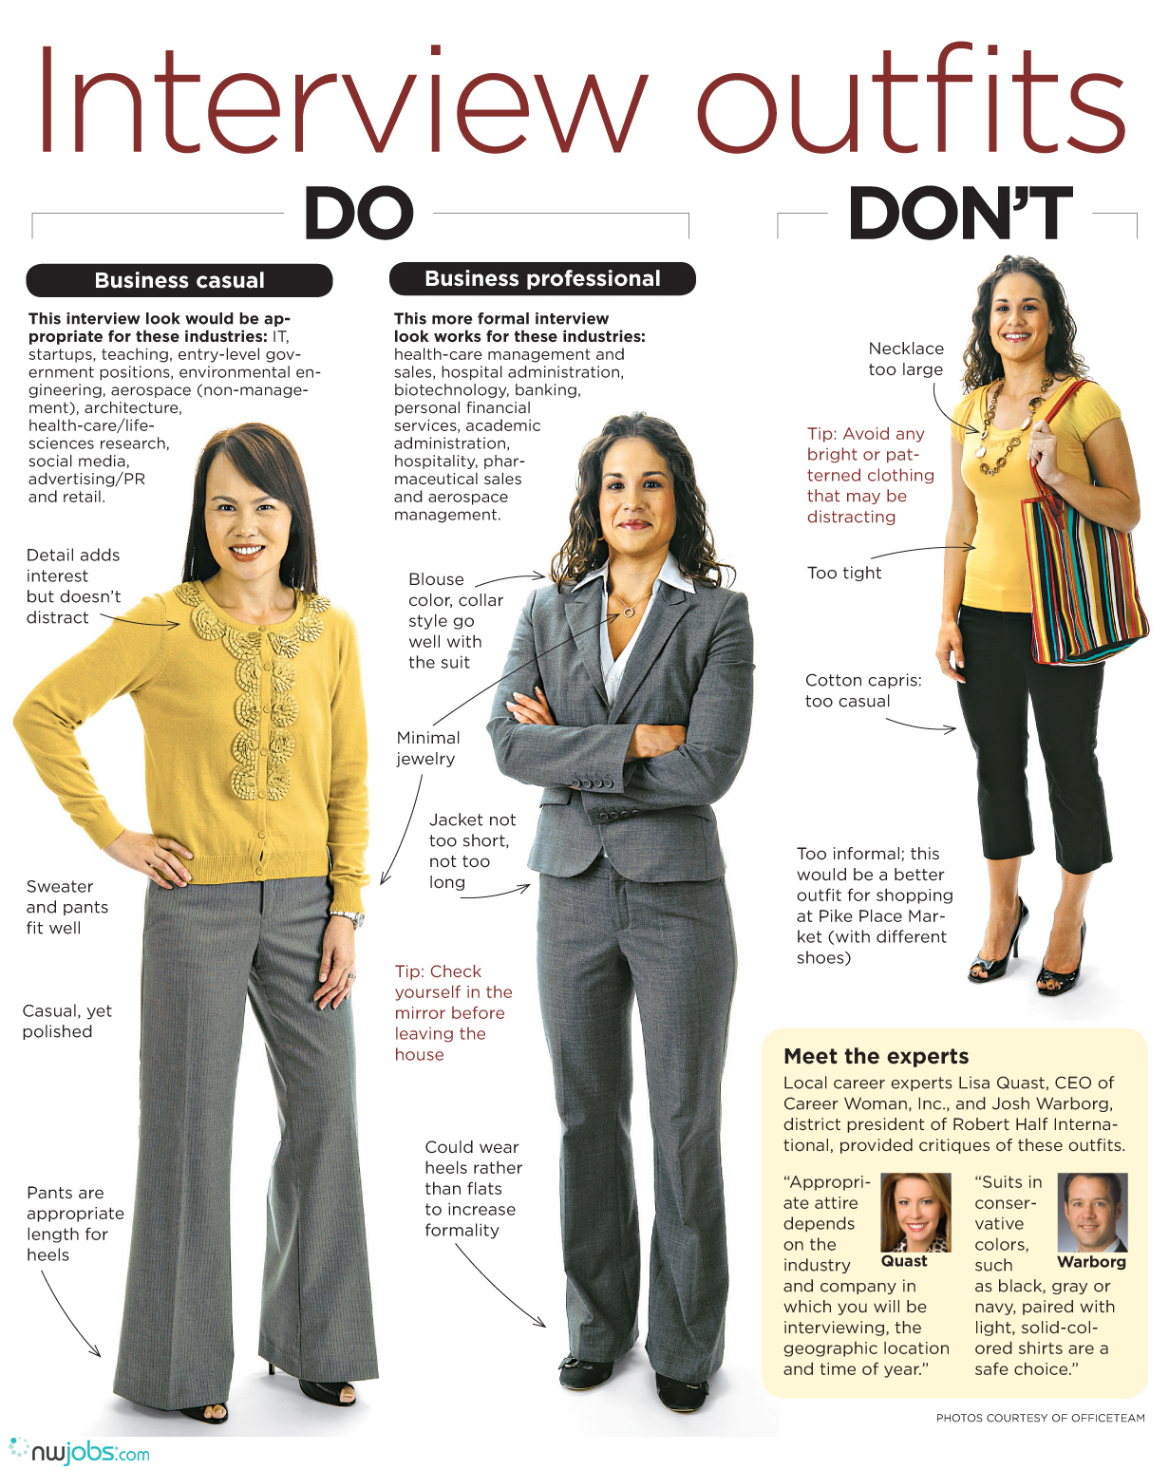

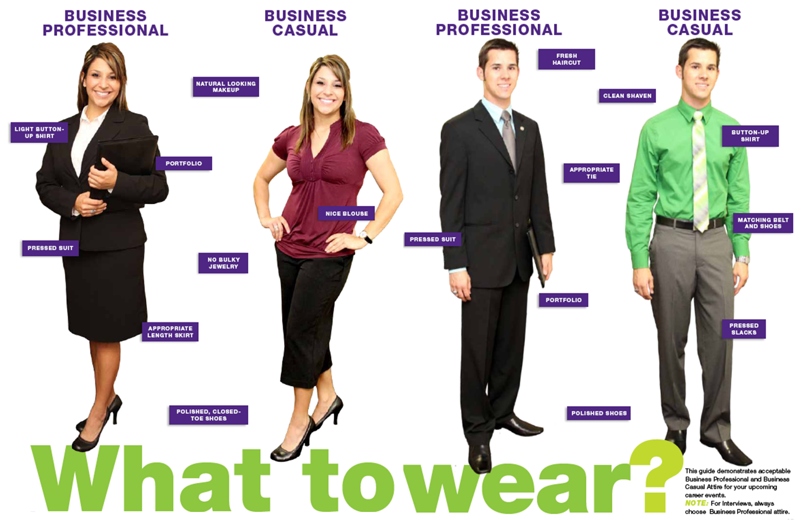
Supplement the reading with online searches to determine what you should wear to an interview. What do you have that is business professional? (Not business casual). What colors are best? What jewelry is acceptable? What shoes will you wear?

You will complete this page during class. Do not complete it in advance.
Interviewing in Practice

Study Guide for Exam Three
- Exam Three is worth 100 points out of 1000 in the course (10% of course grade).
- You will not be allowed to use notes, the workbook, or the textbook during the exam.
- You do not need a scantron but may decide to bring blank sheets of paper to write on.
Exam Details
---------------------------------------------------------------------------------------------------------------------

Section A: 12 multiple choice questions worth 1 point each
Study tip: focus on vocabulary and 'lists,' such as the kinds of value steps.
Sample questions:
The gatekeeper, critic, and direction giver are examples of which group roles category?
a. Task Roles b. Social Roles c. Dysfunctional Roles
Which of the following is not part of the standard answer structure for behavioral interview questions?
a. Reference b. Situation/Example c. Connect to this job d. Results of my actions
---------------------------------------------------------------------------------------------------------------------
Section B: 4 models worth a total of 38 points. You will draw the model and label it.
Study tip: redo any section in the workbook that said "Draw and label..." without notes.
Sample question:
Draw and label the steps in the Relationship Stage Model (13 points)
---------------------------------------------------------------------------------------------------------------------
Section C: 10 short answer questions worth 5 points each, 50 points total.
Study tip: review anything in the workbook that said "Explain and give an example for..."
Sample question:
Pick a conflict you are experiencing with a friend/family member/partner. Using the steps for win-win problem solving, walk through how you would resolve this conflict.
---------------------------------------------------------------------------------------------------------------------

