GHHU 2901
Persuasion in Advertising

PART FOUR
WORKBOOK

“I am convinced that the act of thinking logically cannot possibly be natural to the human mind. If it were, then mathematics would be everybody's easiest course at school and our species would not have taken several millennia to figure out the scientific method.”
― Neil deGrasse Tyson

NAME: __________________________________________________________________

Instructions
DO NOT LOSE THIS WORKBOOK

A. Complete the workbook entry before class.
This will include creating a ‘storyboard’ for each class period. These are worth points!
B. Use the workbook during class to facilitate class discussion.
C. The workbook includes all major assignment rubrics.

Patriotism in Advertising Workbook Entry 1 – Read the included materials, find appropriate examples, and complete storyboard assignment 12 due for points next class.
Pathos, by M.T. Wroblewski, Small Business Chronicle Online, 2018

Few concepts have survived the test of time quite like Aristotle's “modes for persuasion” – the notion that a persuasive appeal needs three elements to be successful: ethos, logos and pathos. Ethos is an appeal to ethics and character, meaning that an audience must believe the speaker is ethical, credible and trustworthy. Logos is the appeal to logic; pathos is an appeal to emotion.
Two thousand years after Aristotle developed this “rhetorical triangle,” rhetoric teachers still rely on it to teach college students how to craft effective persuasive arguments. And advertisers still invoke ethos, logos and pathos, knowing they must achieve a delicate balance of the three elements. The appeals also form the basis for how marketing experts, and groups that bestow industry awards, deem an effective “good” or “great” – in other words, effective at persuasion.
Since the earliest days of television – when products were placed in the hands of and promoted by well-known people for the first time – business owners have known that one of the best ways to inject ethos in their messages is to rely on celebrities to deliver the messages for them.
Pathos is the emotional appeal, and involves special tactics to create an emotional state or emotional response for the audience.
--------------------------------------------------------------------------------------------------------------------
In this workbook, we’ll explore three persuasive techniques used in advertising that are all special sub-types of pathos from Aristotle’s rhetorical triangle:
- Patriotism
- Fear
- Avante Garde / Bandwagon
Patriotic Ads and The Economics of Patriotism by Shayna Robinson; July 1, 2016

By including patriotic themes in their advertising, American businesses associate their products with one of the most emotive and enduring brands of all time: the USA.

Great advertising relies upon effective design and language to forge bonds between a brand and its customers. By integrating patriotic imagery into their ads, American brands create a connection for consumers between their product and all the commonly cited virtues of the good old US of A — freedom, determination, and originality among them. Referencing American iconography typically suggests a brand’s honor and integrity, and helps stoke consumers’ loyalty to that brand by touting qualities that consumers can feel good about supporting. While there are certain brands — often those in the beer and automobile industries — that always emphasize the American-ness of their products, patriotic ads become particularly prevalent during major American holidays, from July 4th to Super Bowl Sunday.

Patriotism might seem like an easy way to make a few sales around patriotic events and holidays, but in reality, it’s hard to fake national pride. Simply being manufactured in the United States is not enough for a product to earn its (red and white) stripes; brands must consciously cultivate a patriotic image among consumers.

According to Brand Keys 2015 top 50 most patriotic brands, Jeep is the most strongly associated with America at 98%, and Levi Strauss, maker of the iconic 501 blue jeans, rounds out the top five at 94%. Developed specifically for the military in World War II and still used by the armed forces today, Jeep has retained its association with true American values — despite being owned by the multinational Italian-based Fiat Chrysler corporation, and manufactured on four continents.

Brands that have played an integral role in American history are also perceived as being patriotic: Coca-Cola and Disney polled highly at 97% and 96%, respectively. Most of the top ranked brands boast longstanding ties to the American industry: Campbell’s Soup, founded in 1869, stands at 77%; Louisville Slugger, founded in 1855, stands at 88%; and Jack Daniels, founded in 1875, commands a 93% patriotism rating. One brand, however, stands out: Facebook, founded in 2003, shares the number 18 slot with L.L. Bean, beating out the NFL, MLB, and even McDonald’s.

Done right, patriotic advertising fosters a strong consumer association between a product and the best of America. However, it’s not a foolproof strategy; consumers are rightfully irate when brands attempt to capitalize on national tragedies to make a sale. After 9/11, patriotic brands faced a catch-22: proceeding without acknowledgement of the event often came off as insensitive or cynical, while several “well-meaning” attempts at respectful observance backfired.

Even more problematic are brands’ attempts to repurpose iconic patriotic imagery. In 2015, Under Armour was forced to pull a T-shirt featuring a distasteful reference to the Battle of Iwo Jima. Americans take their national iconography seriously — while this can work to a brand’s advantage, it can also be a double-edged sword.

While wise advertisers don’t invoke these tropes lightly, the 4th of July is widely viewed as an acceptable occasion to wear your love for your country on your sleeve, even in advertising. Patriotic movies often drop around or on July 4th itself; take Saving Private Ryan, American Sniper and Independence Day, for instance. Memorial Day is another occasion for patriotism, but is more strongly associated with sales and promotions — particularly those that pay tribute to the armed forces. In 2015, Red Lobster joined this trend, offering veterans a free appetizer with orders over $10 for the holiday weekend.

Meanwhile, Budweiser benefits from their all-American branding year round, but especially this summer: Anheuser-Busch announced that their flagship product will be rebranded as “America” from May 23rd until the November election, hoping to capitalize on the patriotism of election season. Spokesperson Ricardo Marques explained: “Budweiser has always strived to embody America in a bottle, and we’re honored to salute this great nation where our beer has been passionately brewed for the past 140 years.”

It’s no accident, however, that this rebrand coincides with the beer industry’s most profitable holiday. Across the country on the 4th of July, people celebrate with their families and communities: this year, over 158 million Americans are projected to attend a cookout or barbecue, spending an estimated $6.8 billion on food. Despite its convenient timing, this rebrand is nonetheless a bold move: the fact that Budweiser is (at least temporarily) abandoning their name indicates that they are confident relying upon their brand recognition alone.

The Fourth presents a great opportunity to reflect upon our own individual concepts of “America.” While not everyone would immediately associate the beer formerly known as “Budweiser” with the USA, the fact that well-known brands are deeply embedded in the American experience and our daily lives is undeniable. Displaying a sense of national pride coupled with respectful adherence to tradition can often be a winning combination for beloved — and lesser known — brands.

Patriotic Advertising: Not Always a Good Fit by Brett Robinson. Published on June 29, 2017. Ad Age.

It's the time of year where brands across North America blitz consumers with patriotic ads, social media content, shelf-talkers and package design. The rationale behind this messaging approach boils down one or more of the following assumptions:

Consumers will like and/or buy our brand more if we tap into national pride;
This is something we've always done, our competitors do it and therefore we should
continue to do it as well;
I'm patriotic, therefore consumers I'm trying to connect with are patriotic.

While playing up your brand's patriotic credentials may be the right thing to do to drive brand affinity and sales with your brand's core audience, love of country is far from universal -- and is extremely complex besides.

Consider the case of the lucrative segment of educated, culturally diverse and socially progressive millennials in major cities across North America. Surveys from Pew Research and the Canadian Broadcasting Corporation have shown that North Americans under age 34 are generally less patriotic than their older peers. This coincides with the fact that millennials are generally more culturally diverse (and proud of their ethno-cultural background), better educated, more open-minded and less trusting of federal institutions. Pew's research also suggests that educated social progressives also tend to be less patriotic than less-educated conservatives.

Millennials are also far less likely to routinely take part in media-aided national experiences compared to previous generations. The national consciousness fostered in older North Americans was induced by 20th century mass media. In the 1960s, everyone in the nation was sitting around the same fire.

Today, the media landscape has morphed into a series of fragmented, nonlinear digital information networks. Increasingly, more of us (especially those under 34) live in a series of global and local digital communities bonded by attributes like lifestyle interests, age, language, religion, values, neighborhoods and cities. As a result, identities, preferences and shared experiences have become more diversified than ever.

Considerations before jumping
Marketers also need to category- and brand-fit before they jump into the patriotic messaging bandwagon.

Consider the food and beverage category, as University of Toronto sociologists explore in their book "Foodies: Democracy and Distinction." The foodie movement has led to a dramatic shift in food and drink preferences across North America, they found. One impact is that "local" has become a signifier of food quality. Local rarely means national in a North American context because the geography is too large and ecologically diverse. Local is about specific neighborhoods, cities and regions.

A great illustration of this is the fast-growing craft beer category. Multiple academic studies have shown consumers to actively seek out hyper local signifiers and imagery in brands, rather than national pride messages. I would hypothesize that even the most patriotic craft beer consumer would choose a beer that represents their city over a beer that represents the nation.

So where does this leave marketers who are considering some kind of patriotic marketing activation in their calendar? Very simply, you should do everything possible to find out what really matters to your audience before your brand starts waving the flag.

If you don't have the luxury of time and budget for research, perform small live social media tests of other types of place-based brand associations (global, local love, and sports team, for example). You might just find that it makes more sense for your brand to be the champion of "Earth Love" rather than "Love of Country."

You might also want to consider taking a year off putting out ritualistic Independence Day ads and content. That might just be what your brand needs to stand out from the crowd.
--------------------------------------------------------------------------------------------------------------------

What do you think about patriotism in advertising? Is it ethical? Is it effective?

______________________________________________________________________________
______________________________________________________________________________
______________________________________________________________________________
______________________________________________________________________________
______________________________________________________________________________
______________________________________________________________________________
______________________________________________________________________________
______________________________________________________________________________
______________________________________________________________________________
______________________________________________________________________________

Patriotic Advertising didn’t start during the World Wars, but if often becomes more commonplace and more accepted during times of national distress (war, terror attack, etc)
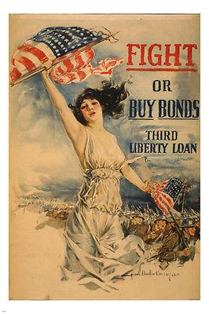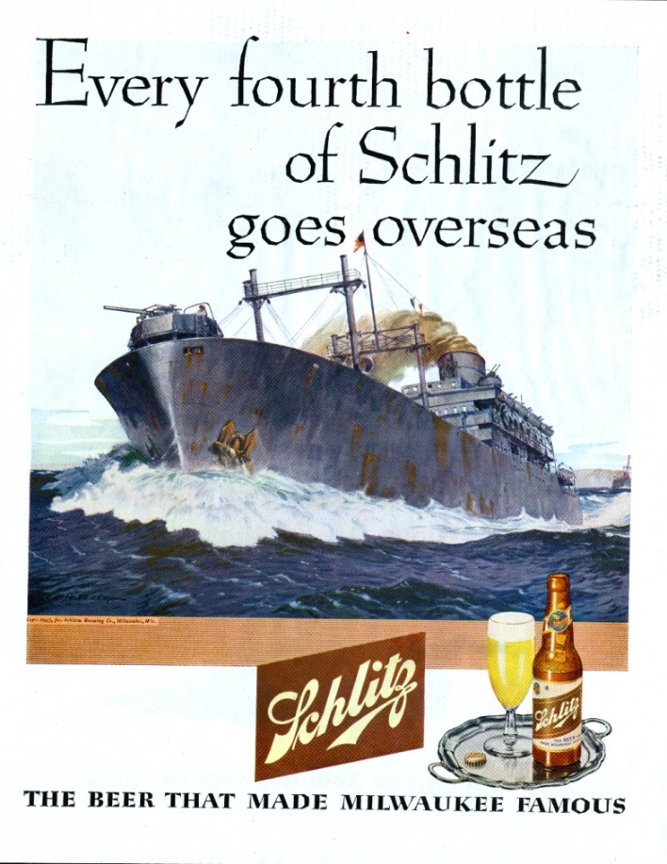
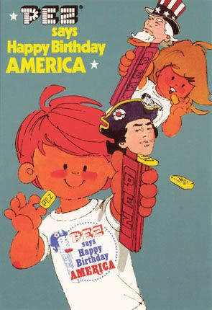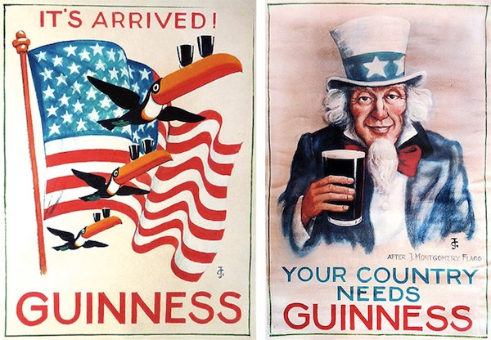
WHY do you think these kinds of ads are more common and more accepted during times of national distress? ______________________________________________________________
_____________________________________________________________________________
_____________________________________________________________________________
_____________________________________________________________________________

Tim Nudd – July 2012 AdWeek
On the face of it, patriotism would seem to be an easy sell for American advertisers. In fact, it's not. Flag-waving spots can so easily come off as cheesy and/or opportunistic. It's rare to see a patriotic commercial that feels legitimately poignant—or at least not flagrantly exploitative. Plus, of course, there are the political implications. As Chrysler learned during this past Super Bowl, you can't love America without half of America questioning your motives.
Ad | Does this ad ‘work’ for you? Would Nudd call it poor use of patriotism?
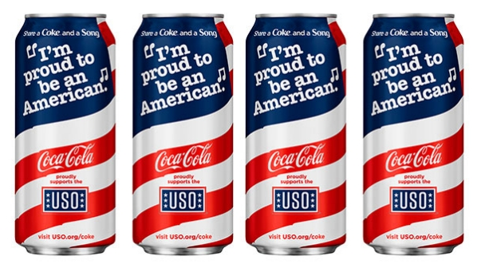 | Coca-Cola
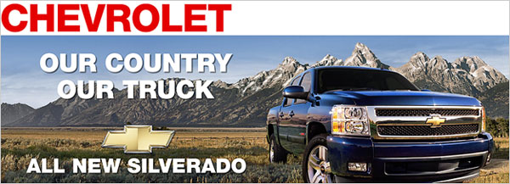 | Chevy Silverado
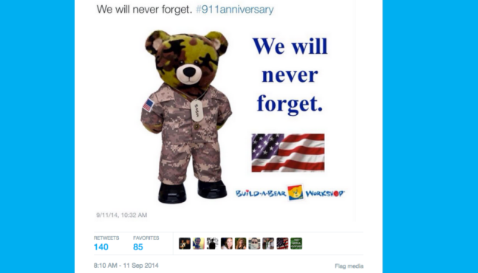 | Build-a-Bear Workshop
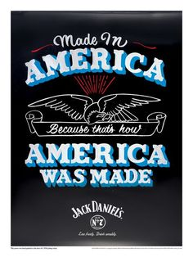 | Jack Daniel’s Whiskey
Come up with some examples of recent ads that used patriotism.
Product | Describe Ad | Emotionally Stirring or Opportunistic?
Example: Pepsi | Soldier shown drinking Pepsi | Opportunistic for me. I don’t understand why Pepsi goes hand in hand with support for the military or war.

Storyboard assignment #12. Follow the prompts below to complete the assignment and share it next class for points.

Identify a food or beverage (any kind): ____________________________________
Come up with a concept for a 30 second advertisement storyboard for this product that features patriotism as a means of emotional persuasion. Use the storyboard spaces and lines to describe individual scenes and dialogue in your ad. Use the space/number of scenes necessary for the ad you imagine. Don’t work about artistic quality – stick figures are OK. See example on Workbook 1 page 6.
Scene 1 | Scene 2 | Scene 3

Scene 4 | Scene 5 | Scene 6
Fear in Advertising Workbook Entry 2 – Read the included materials, find appropriate examples, and complete storyboard assignment 13 due for points next class.

Fear Appeals: Persuade When They’re Afraid; August 16, 2016; Social Psychology Online

There’s been a lot of talk about fear in the current election. In particular, many people [1] have explained Donald Trump’s success thus far to his keen ability to play on people’s fears. But it’s not even just appealing to pre-existing fears. Some have even suggested that he has been actively instilling fears where they may not have already existed. What’s the deal with fear appeals? Could creating fear in a population really be good for business? Sorry, I mean “politics.”

You might think that arousing fear in people can open them to influence. Plenty of ad campaigns have tried to terrify people as a way of convincing them to quit smoking, say “no” to drugs, and buy life insurance. So it must work, right? People are doing it!

Psychologists have been wondering about the persuasive power of fear, too, and they’ve run some studies that provide some compelling insights about fear and persuasion. First, let’s look at the first glimpse we had into the psychology of fear-based persuasion. Then we’ll look at the more complicated picture that later studies revealed. Basically, fear appeals aren’t a reliable persuasive strategy all on its own, but when it’s combined with a few other ingredients, it becomes a powerful influencer.

One of the first studies on fear and persuasion, published in the 50s, looked at whether students were convinced by a message about oral hygiene. The researchers developed three different messages aimed at getting people to take care of their teeth.

One message was pretty mild–it was just a fact-based lecture about teeth. Another message invoked a bit of fear, telling people about the dangers that come from neglecting oral hygiene. The final message laid it on thick, emphasizing the dangers of poor oral hygiene like tooth decay and gum disease and making claims like “this could happen to you!”[2]

In total, 200 high school students read one of these message (some of them actually read an essay on a different topic, just as a comparison). A week later, they followed up with these students to see if they’d improved their oral hygiene. Were they brushing their teeth better now? Surprisingly, the group that got “just the facts” improved the most! The group that got the most fear-inducing message barely changed their behavior at all! The moderate version of the message was somewhat effective, but not as effective as the simpler factual message.[3]

The lesson here seems to be that fear is not that persuasive on its own. The terrifying message about all the diseases that come from failing to appropriately brush your teeth did little to improve people’s brushing habits.

So scaring people to death may not be the perfect strategy, but why? Well, it might be that we feel stuck when we feel afraid. Just scaring people puts them into a panic, distracting them from your key message. In general, this is a bad thing, but it might also set people up to be more persuaded when the message makes one other thing clear: a solution.

Fear is persuasive when it’s combined with a clear way to address that fear. By making people feel afraid, they are likely to latch onto a solution that provides a clear and effective route to addressing whatever it is that’s making them afraid.

Take one early study that gave college students information about the importance of getting a tetanus shot. One version of the message simply described a case history of someone with tetanus using non-emotional language and only a couple drawings of facial expressions. The scarier version, though, described the case history in vivid detail and provided color photos of bedridden patients with gaping wounds, urinary catheters, and nasal tubes.

All of these messages noted the importance of getting a tetanus shot, but the important thing is that only half of the message recipients also received detailed instructions for where and how to get their shots at their college’s health center. The other half of people probably knew this information–it just wasn’t handed to them as part of the message.

The results showed that the scarier message was more persuasive, but only if it also provided a clear plan for getting the tetanus shot. In other words, the fear was motivating for people, but it only led to real change if people understood exactly what they should do next. This has been shown over and over again across many studies, and it’s worth noting that fear-inducing messages don’t backfire if a clear solution isn’t provided–they just don’t work as well.

The research on fear appeals and persuasion is a vast sea of studies at this point. Last year, several psychologists published a big meta-analysis that combined the results of hundreds of studies to get an even more accurate picture of fear’s persuasive power. This analysis considered responses from over 27,000 people, so it gives us a good idea of whether fear can be an important influencer.

Even though the early study on oral hygiene made it seem like fear was a worthless tactic, the results of all the studies since then clearly show that fear appeals are persuasive. They affect people’s opinions and their behaviors.

This new meta-analysis reveals some other interesting tidbits, though. We already saw that fear appeals are more effective when the message provides a clear and effective course of action. This new analysis showed a few other things that make fear appeals more persuasive.

For instance, fear appeals are more persuasive when they recommend a one-time behavior (vs. repeated behaviors). Fear appeals are also more effective when they convey higher amounts of fear and when they’re directed at mostly female audiences.

So, okay, is fear the way to win an election? Well, maybe. For some people, Trump not only reminds them of their fears about the future of America but also stands as that clear and effective solution. For other people, though, it seems pretty obvious that Trump isn’t a clear and effective solution to much of anything. So even if you might be afraid of things like terrorism, that fear alone won’t motivate you to cast a vote for Mr. Trump because you don’t see how he represents a clear, viable solution.
What do you think about using fear to persuade in advertising? Is it ethical? Is it effective? Why does or doesn’t it usually work?
______________________________________________________________________________
______________________________________________________________________________
______________________________________________________________________________
______________________________________________________________________________
______________________________________________________________________________
______________________________________________________________________________
______________________________________________________________________________
______________________________________________________________________________
______________________________________________________________________________
______________________________________________________________________________
Have you ever bought anything based on feeling fear? Was there an ad associated with this product that helped you feel that fear and ultimately led to the purchase?
______________________________________________________________________________
______________________________________________________________________________
______________________________________________________________________________
______________________________________________________________________________
______________________________________________________________________________
______________________________________________________________________________
Come up with some examples of recent ads that used fear to persuade.
Product | Describe Ad | Suggested Solution | Was it persuasive to you? Why?
Example:  Nest Camera | Burglar breaking into home during daylight | Purchase Nest cameras with phone alters | The situation is scary, but my dog seems a more effective deterrent than a camera
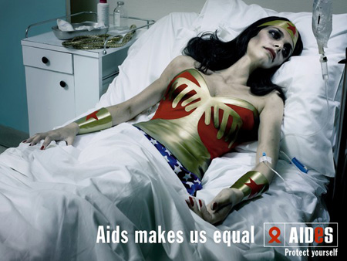
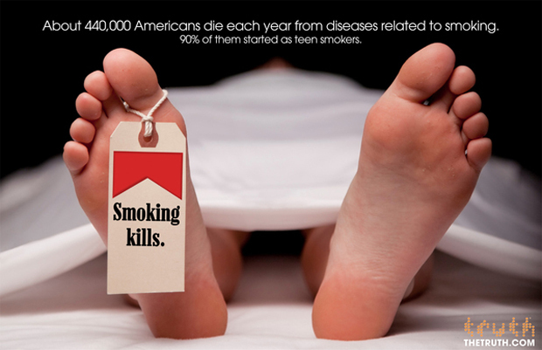
Are these effective? Persuasive? Why?
__________________________________
__________________________________
__________________________________
__________________________________
__________________________________
__________________________________
__________________________________
__________________________________
__________________________________
__________________________________
__________________________________
__________________________________
__________________________________
__________________________________
__________________________________
__________________________________
__________________________________
__________________________________
__________________________________
__________________________________
__________________________________
__________________________________
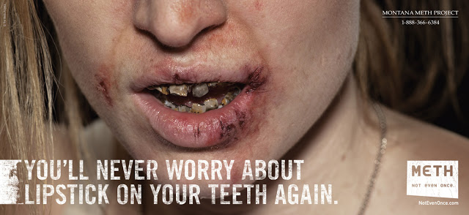
__________________________________
__________________________________
__________________________________
__________________________________
__________________________________
__________________________________
__________________________________
__________________________________
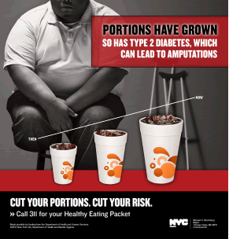
__________________________________
__________________________________
__________________________________
__________________________________
__________________________________
__________________________________
__________________________________
__________________________________
__________________________________
__________________________________
__________________________________
__________________________________
__________________________________

Storyboard assignment #13. Follow the prompts below to complete the assignment and share it next class for points.

Identify a product (any kind): ____________________________________
Come up with a concept for a 30 second advertisement storyboard for this product that features fear as a means of emotional persuasion. Use the storyboard spaces and lines to describe individual scenes and dialogue in your ad. Use the space/number of scenes necessary for the ad you imagine. Don’t work about artistic quality – stick figures are OK. See example on Workbook 1 page 6.
Scene 1 | Scene 2 | Scene 3

Scene 4 | Scene 5 | Scene 6

Avant-Garde / Bandwagon in Advertising Workbook Entry 3 – Read the included materials, find appropriate examples, and complete storyboard assignment 14 due for points next class.
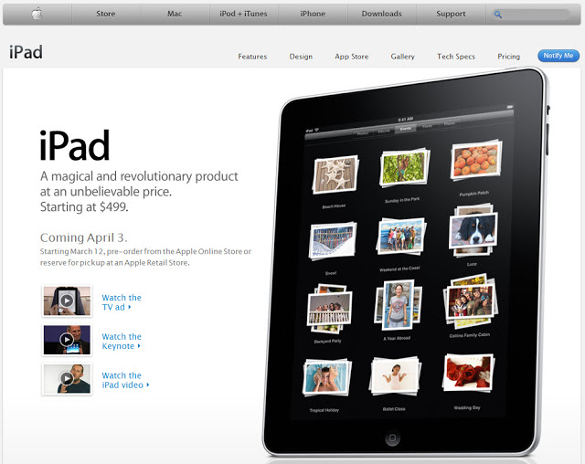
Avant-Garde by Online Design Teacher 2018
Avant Garde is a French phrase used to refer to people or works that are experimental or innovative, particularly with respect to art and culture. In graphic design advertising it is the suggestion that using this product puts the user ahead of the times. Phrases like "revolutionary" or "cutting edge" are often used too but overall a general sense of the product/service being futuristic is the key aspect. Apple are the masters of this technique with all their recent product launches using this technique.

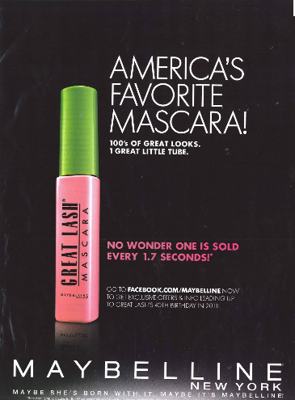
Bandwagon Appeal by Visual Communication Guy 2018
The Bandwagon Appeal attempts to persuade people by making them feel that a product or idea is popular and that everyone else is doing it. The idea of the Bandwagon Appeal is to make people feel like they’re missing out or falling behind if they don’t join the crowd and be a part of the trend. The Bandwagon Appeal is especially effective when your target audience desires to be popular, to be a part of a group, to feel included, or to generally feel cool. It’s also a good approach when your target audience may not be good at making decisions or they’re nervous to try something new. The Bandwagon appeal is effective in the following situations:

-when there is an emerging trend in society (say, for example, eating organic food);
-something is increasing in notoriety (like, say, when the Clemson Tigers won the college football national championship);
-it’s hard for your audience to know which product is best;
-a product or service is relatively new or unfamiliar;
-or you know that your target audience is looking to find a product, service, or idea that they can belong to.
So, while Avant-Garde creates an emotional appeal that is a longing for being the first-adopter, Bandwagon creates an emotional appeal that is a fear of being the last-adopter. Which do you think is a more effective means of persuasion?
______________________________________________________________________________
______________________________________________________________________________
______________________________________________________________________________
______________________________________________________________________________
______________________________________________________________________________
______________________________________________________________________________
______________________________________________________________________________
______________________________________________________________________________
______________________________________________________________________________
______________________________________________________________________________

Do Americans generally want to be the first, which risks buying into a poor product, or just anything but last, choosing products crowds have already said are high quality?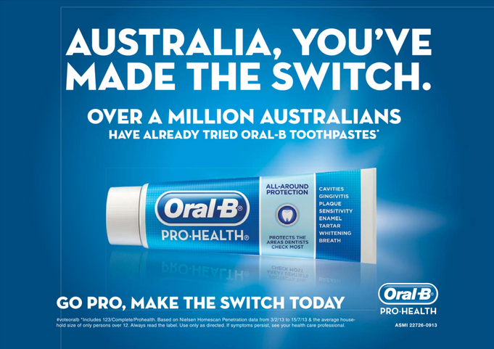
Come up with some examples of recent ads that claimed the product was avant-garde.
Product | Describe Ad | What is A-G in it? | Was it persuasive to you? Why?
Example: High-end headphones | Kid on noisy train, doesn’t notice because jams | Claim that tech is revolutionary and product is brand new to market | Yes, because I hate noisy trains and like to be a first- or early-tech adopter

Come up with some examples of recent ads that made a bandwagon claim.
Product | Describe Ad | What is B-W in it? | Was it persuasive to you? Why?
Example: High-end headphones | Kid sadly looking at everyone enjoying headphones | Claim is that everyone already has one, and you are missing out | No, because I hate noisy trains and like to be a first- or early-tech adopter. I already have good headphones.

Storyboard assignment #14. Follow the prompts below to complete the assignment and share it next class for points.

Identify a mobile technology device (any kind): ____________________________________
Come up with a concept for a 30 second advertisement storyboard for this product that features a bandwagon claim or an avant-garde claim. Use the storyboard spaces and lines to describe individual scenes and dialogue in your ad. Use the space/number of scenes necessary for the ad you imagine. Don’t work about artistic quality – stick figures are OK. See example on Workbook 1 page 6.
Scene 1 | Scene 2 | Scene 3

Scene 4 | Scene 5 | Scene 6

Polished Ad Presentation (fixed image) & Analysis Assignment
For this assignment, you will be completing two major objectives:
- Create a Digital Sign advertisement that meets MarCom specifications (50pts)
  - Choose a DIFFERENT GHC entity to advertise for. This can be a GHC department, a GHC event, a GHC program of study, a GHC club, etc.
  - Research that entity and determine what you are trying to persuade people to do. Are you trying to get people to attend a specific event? To join a club? To meet with a specific office by a certain deadline?
  - Craft an ad concept using any or all persuasive techniques discussed in class so far. You must at least include use of one of the pathos appeals in this workbook. I expect that you will use several individual strategies, not just one.
  - Make a 16x9 PowerPoint slide (single fixed image) that contains all relevant information and makes a clear attempt to persuade using the strategies discussed in class. In order to set the slide size to 16x9, click on the ‘Design’ tab in PowerPoint and select 16x9 from the ‘Slide Size’ dropdown menu on the right.
  - Submit the PowerPoint slide to me by email (sstuglin@highlands.edu ) the midnight before the class in which it is due.
  - 25 pts for quality of persuasive attempts: effectiveness, creativeness
  - 25 pts for quality of image: polish, professionalism
- Write an analysis of the persuasive strategies at work in your advertisement (25pts)
  - Identify no less than three and no more than five persuasive strategies discussed in class that you incorporated into the advertisement.
  - For each strategy, write one paragraph
    - What is the strategy and how does it work?
    - Give an example from class of that strategy at work
    - How did you incorporate this strategy into your ad?
    - Why did you choose this strategy over others?
  - At minimum, the analysis should be three solid paragraphs
  - Type the analysis, single spaced, 12-point font, with your name on the top.
  - PRINT the document the evening before it is due. Printer issues right before class are not an acceptable excuse for not having this assignment ready to turn in
  - 20 points for quality of description of strategies
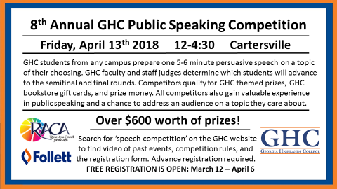
  - 5 points for college appropriate spelling, grammar, punctuation

Example of a Digital Sign made for the 2018 Speech Competition

COMPLETE FINAL PROJECT!

Final Moving Ad Presentation (30-second video) & Analysis Assignment; with a Partner
For this assignment, you will be completing two major objectives:
- Create a Digital Sign advertisement that meets MarCom specifications (100pts)
  - Choose a DIFFERENT GHC entity to advertise for. This can be a GHC department, a GHC event, a GHC program of study, a GHC club, etc.
  - Research that entity and determine what you are trying to persuade people to do. Are you trying to get people to attend a specific event? To join a club? To meet with a specific office by a certain deadline?
  - Craft an ad concept using any or all persuasive techniques discussed in class so far. I expect that you will use several individual strategies, not just one.
  - Plan out a storyboard of scenes with your partner.
  - Arrange to record the scenes (using a smartphone or other camera) and edit them together using free or more advanced software to create a 30 second commercial.
  - Upload the video file to Youtube, set the video to public, test the link, and send me the link (sstuglin@highlands.edu) by the midnight before the class in which it is due.
  - 50 pts for quality of persuasive attempts: effectiveness, creativeness
  - 50 pts for quality of image: polish, professionalism
- Write an analysis of the persuasive strategies at work in your advertisement (35pts)
  - Identify no less than three and no more than five persuasive strategies discussed in class that you incorporated into the advertisement.
  - For each strategy, write one paragraph
    - What is the strategy and how does it work?
    - Give an example from class of that strategy at work
    - How did you incorporate this strategy into your ad?
    - Why did you choose this strategy over others?
  - At minimum, the analysis should be three solid paragraphs
  - Type the analysis, single spaced, 12-point font, with both partners’ names.
  - PRINT the document the evening before it is due. Printer issues right before class are not an acceptable excuse for not having this assignment ready to turn in
  - 25 points for quality of description of strategies
  - 10 points for college appropriate spelling, grammar, punctuation

