GHHU 2901
Persuasion in Advertising

PART THREE
WORKBOOK

“I am convinced that the act of thinking logically cannot possibly be natural to the human mind. If it were, then mathematics would be everybody's easiest course at school and our species would not have taken several millennia to figure out the scientific method.”
― Neil deGrasse Tyson

NAME: __________________________________________________________________

Instructions
DO NOT LOSE THIS WORKBOOK

A. Complete the workbook entry before class.
This will include creating a ‘storyboard’ for each class period. These are worth points!
B. Use the workbook during class to facilitate class discussion.
C. The workbook includes all major assignment rubrics.

Problem-Resolution in Advertising Workbook Entry 1 – Read the included materials, find appropriate examples, and complete storyboard assignment 9 due for points next class.
Logos, by M.T. Wroblewski, Small Business Chronicle Online, 2018

Few concepts have survived the test of time quite like Aristotle's “modes for persuasion” – the notion that a persuasive appeal needs three elements to be successful: ethos, logos and pathos. Ethos is an appeal to ethics and character, meaning that an audience must believe the speaker is ethical, credible and trustworthy. Logos is the appeal to logic; pathos is an appeal to emotion.
Two thousand years after Aristotle developed this “rhetorical triangle,” rhetoric teachers still rely on it to teach college students how to craft effective persuasive arguments. And advertisers still invoke ethos, logos and pathos, knowing they must achieve a delicate balance of the three elements. The appeals also form the basis for how marketing experts, and groups that bestow industry awards, deem an effective “good” or “great” – in other words, effective at persuasion.
Since the earliest days of television – when products were placed in the hands of and promoted by well-known people for the first time – business owners have known that one of the best ways to inject ethos in their messages is to rely on celebrities to deliver the messages for them.
Logos is the persuasive strategy of presenting a simple, logical, straight-forward claim to the audience and allowing them to see the good sense in that argument.
--------------------------------------------------------------------------------------------------------------------
In this workbook, we’ll explore four persuasive techniques used in advertising that are all special sub-types of logos from Aristotle’s rhetorical triangle:
- Problem-Resolution
- Comparison by Less Bad
- Comparison by Unique Selling Proposition

Problem-Resolution (or Problem-Solution, Problem-Cause-Solution) is a fundamental organization form that, by its very structure, makes a persuasive claim. When you select a problem and a solution to present in an essay, speech, or other form of media, you are making several persuasive points:
- This is the problem. This problem matters more than other problems.
- This is the cause of the problem. The problem was not caused by anything else.
- This is the solution. This solution will effectively resolve the problem I identified.
In order to persuade the audience, we have to support each of these claims. If we can do so, the audience is sufficiently distracted from other problems, agrees that your cause is the cause, and may support the solution you advocate. In short, you persuade them to agree with the end result of problem-solution: to take the action you want them to take.
In advertising, this structure identifies a problem that people have, demonstrates how that problem is caused by a flaw in existing products or the lack of a product that addresses the problem, and then presents a new product that solves the problem when other products cannot. The end result, if done effectively, is to sell the new product.

Consider the following Situation-Problem-Solution-Evaluation structure, which works similarly to the basic Problem-Solution structure.
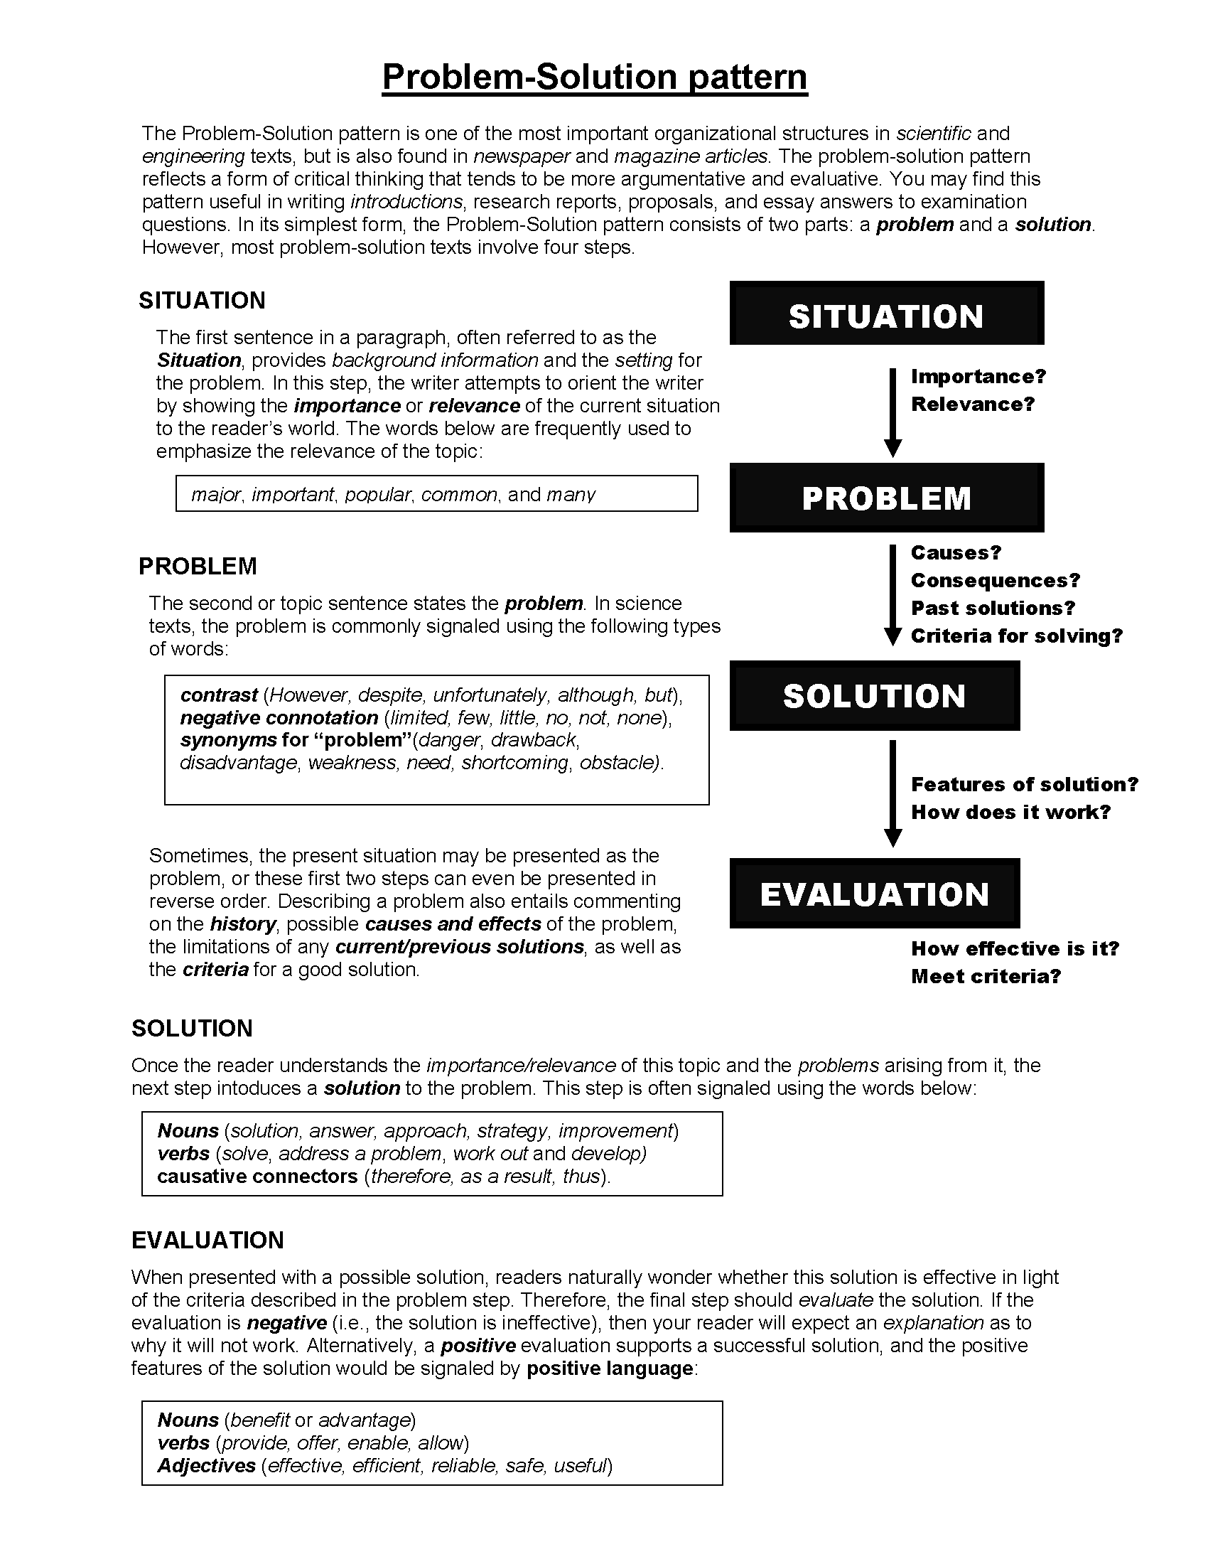

Ad | What is the Problem, Cause, & Solution?
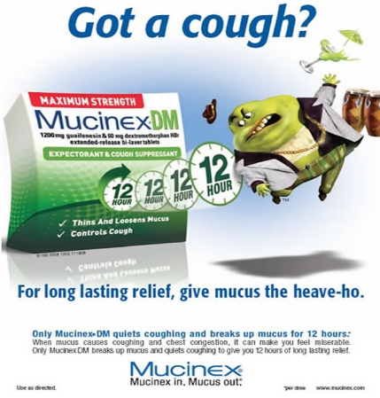
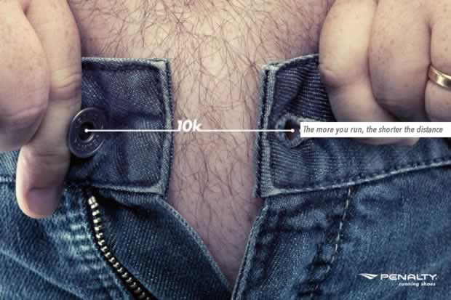
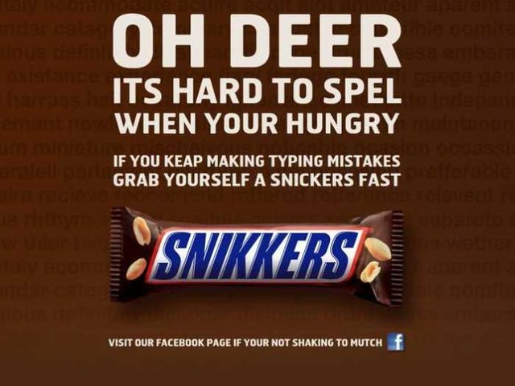
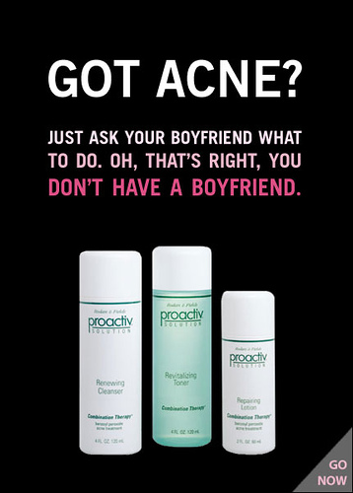

What problem are you solving? by Ana Andjelic Campaign Live Online, 2015

To innovate beyond its boundaries, the ad industry must stop putting solutions before questions.

Joshua Bell is a famous violin player. He fills concert halls, and people pay hundreds of dollars to hear him play on his Stradivarius violin.

In 2007, the Washington Post did a social experiment. It asked Mr. Bell to play at the Metro subways station in Washington, D.C. The Post wondered how people would respond to hearing a renowned musician playing in a different context. Out of about a thousand people who passed by Bell that day, only seven stopped to listen, despite Bell playing the exact same music he plays on stage. For his 45 minute performance of six Bach pieces, Bell earned $32 in tips, including a $20 tip from someone who recognized him.

Outside his normal context, despite the beauty of his music, listeners barely noticed Bell’s existence. In the new frame of a busy subway station, passers-by didn’t see Bell as a renowned musician. They saw him just as another hard-hit chap wanting to earn a buck.

Now, if we don’t have a moment to stop and listen to one of the best musicians in the world play one of the best pieces of music ever written, how many other things are we missing just by framing them wrongly?

Humans create frames for what we see, hear and experience. Those frames both inform and limit the way we think.

To fully understand and adopt the potential of something new, like digital strategy or experience design, we first need to change our perspective on how we solve problems. How much do we miss by framing the clients’ problems we encounter in one specific way?

If I asked you to build a bridge for me, you’d go off and build a bridge. Or, you can ask me why I need a bridge. I’d tell you then that I need it to get to the other side of a river. This response opens up the frame of possible solutions. There are clearly many ways to get across a river besides building a bridge. We can make a tunnel, or install a ferry service, get catapulted over or fly in a balloon.

The problem with advertising agencies is that they are building bridges in response to clients asking them to cross the river.

We define the business we are in as advertising. This automatically limits the frames we use for problem solving. The frames boil down to a brand or communications challenge. We ask how to make our communications more creative or how to make a bigger media buy or how to become (even) friendlier with the client.

We don’t ask is why is this a problem and what can we do to solve it.

The first reason we need to start asking this question is that today we operate in a much more competitive environment. Companies that don’t constantly reframe their business risk becoming obsolete.

Just look at Kodak. Kodak defined its business as making cameras and film. When digital cameras made film photography obsolete, the company stumbled because it wasn’t able to open up its frame early enough to see its business including this new technology.

Then look at Uber. This controversial startup defines its business as software infrastructure for shipping and logistics. Traditionally, one can say that Uber is a taxi company. (If so, it would be the world’s most valuable taxi company without vehicles!) But Uber is also a delivery company, a convenience store and a software company. It describes itself as a global urban infrastructure. By avoiding the traditional definition of its business, Uber allows itself to compete in many more markets than it would have competed as a mere taxi company. It competes with FedEx, with convenience stores, with concierge and nanny services, and with urban transportation options.

The second reason we need to start asking the "why" question is that the range of solutions that advertising offers is not competitive any more. Advertising has a bad habit of starting off a project with a solution instead of a problem. If the request is, "Increase revenue by X," we usually don’t ask "why" as a catalyst for exploring deeper ideas. Instead, we open our toolbox and take out awareness or customer acquisition or repeat purchases.

But the question of "why" can lead us to realize that our client may be selling an obsolete product, or it may lead us to wonder why our younger audience is more attracted to our competitors’ products.

A good example of putting a problem first is the UK’s Tesco supermarket chain. It set a goal to increase market share substantially and it needed to find a creative way of doing do. Now, Tesco could have offered discounts or made a TV spot or did a promotion via direct marketing.

Instead, Tesco looked at its customers and realized how busy their lives were. To increase its market share, the company accepted that it needed to be where its customers are. Instead of spending millions of dollars in advertising to drive customers to its stores, Tesco entirely reframed the customer shopping experience. In a now-famous move, the food chain took photos of food aisles and put life-size images in subway stations to be scanned by commuters. The sales followed.

Don’t limit yourself by knowing what you want to do up front. By approaching the problem with a fixed solution in mind, all you can do is look for evidence that supports it. Instead, you need to know what problem you want to solve. When you focus on the problem, it frees you constantly to improve your solution.

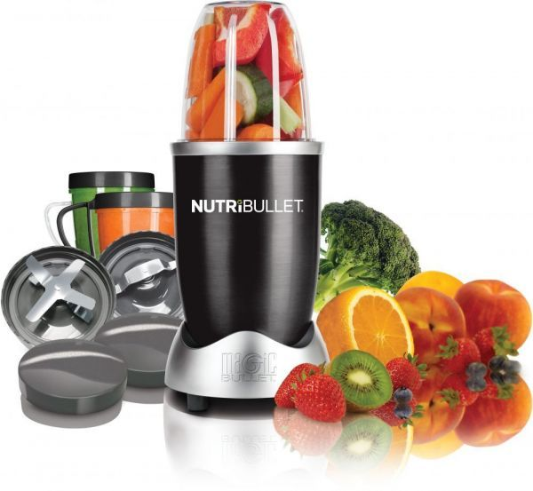
What kinds of problems might this food processor solve? How would you show them in an ad?
__________________________________
__________________________________
__________________________________
__________________________________
__________________________________
__________________________________
__________________________________
__________________________________
__________________________________
__________________________________
__________________________________
__________________________________
__________________________________

Come up with some examples of recent ads that used endorsement.

Product | Problem | Solution
Example: Car Battery | Car shown not starting in snowy cold weather | Super Battery can “start in -20 degrees!”
Storyboard assignment #9. Follow the prompts below to complete the assignment and share it next class for points.

Identify a household product use (any kind): ____________________________________
Come up with a concept for a 30 second advertisement storyboard for this product that features a problem-solution or problem-cause-solution structure in order to demonstrate that the audience needs the given product. Use the storyboard spaces and lines to describe individual scenes and dialogue in your ad. Use the space/number of scenes necessary for the ad you imagine. Don’t work about artistic quality – stick figures are OK. See example on Workbook 1 page 6.
Scene 1 | Scene 2 | Scene 3

Scene 4 | Scene 5 | Scene 6

Comparison (Less Bad) in Advertising Workbook Entry 2 – Read included materials, find appropriate examples, and complete storyboard assignment 10 due for points next class.

John Calfee’s Argument in Defense of Advertising, hosted by Philosophia at UNC Greensboro
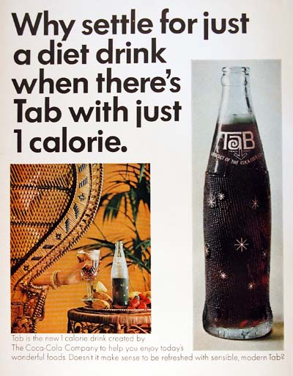
In his paper, "How Advertising Informs to Our Benefit," John E. Calfee argues that one of the great benefits of advertising is the information that it provides the consumer. However, providing the public with information is not necessarily a good thing, especially if the information is not completely true or it causes people to behave in ways that are harmful to their wellbeing.
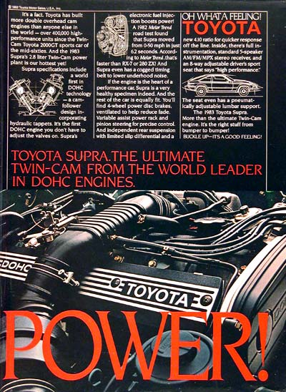
Calfee begins his argument by pointing out what advertisers are trying to do and how people typically respond to advertisers. Calfee says, "The typical ad tries to induce a consumer to do one particular thing—usually, buy a product—instead of a thousand other things… Decades of data and centuries of intuition reveal that all consumers everywhere are deeply suspicious of what advertisers say and why they say it." It is Calfee's view that because consumers know advertisers are just trying to sell them something, advertisers must convince them by using informative facts about their product that make that product more appealing than any other product on the market of the same type. For example, when you see a car commercial you know that the advertisers are trying to get you to like their car. You are suspicious of the commercial. You see the fine print at the bottom of the screen, and you might wonder if the car is really that cheap, or maybe that fine print gives a list of exceptions like, "subject to credit approval," or "value of car model shown is twice what you can really afford."
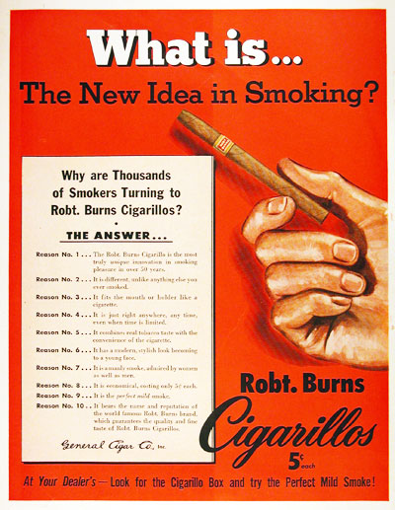
Calfee thinks that because we are suspicious in these ways, and advertisers know it, advertisers are forced to get real facts about their products to show that they are worth purchasing.. So a car commercial might point out that it is has more horsepower than the leading competitor, or the commercial might explain how the car handles better in bad weather, which makes it safer than other cars. These types of facts give us, the consumers, more information about automobiles. Before anti–lock brakes and airbags were advertised, most people didn't know the safety benefits of having them. People actually learned via commercials what it was important to have on a car for safety. Calfee argues that this sort of important information only gets to people through commercials. When a company can make a lot of money by teaching you that bran helps prevent colon cancer, like Kellogg did in 1984, you better believe that Kellogg is going to make the effort to teach you. And since Kellogg has a lot more money to advertise than the National Cancer Institute (NCI), Kellogg is really the only way this information can be spread to as many people as possible.
According to Calfee, when the Kellogg company did this two important things happened, but only one is really important here. The first, less important point, is that Kellogg's claim caused the Food and Drug Administration (FDA) to take notice. According to the FDA, a claim that All–Bran could help prevent cancer was a claim that only a drug could make, and if All–Bran was going to be marketed as a drug, then it needed to pass extensive drug testing. Ultimately, the Federal Trade Commission put a stop to this by saying what a good thing it was that Kellogg's ads were non–deceptive and helpful information for people. The second important thing that came out of Kellogg's advertising campaign was a slew of health claims by all advertisers. Prior to the Kellogg's advertising campaign, many health benefits of foods were not researched. But because Kellogg's advertising campaign was so successful, it demonstrated to other advertisers that people wanted their food to be healthy, which in turn caused those advertisers to do more research on their products. From this came a lot of health food related information that was made freely available to the public. Information about cholesterol started to appear on packaging, because it was linked with heart disease. Prior to this advertising, most people had no idea what was good for them to eat.
Calfee thinks that since there are many cases like the Kellogg's case where the public is quickly given important information that betters our lives, advertising is a good thing. However, he recognizes that this is not always what happens. If people are so easily influenced by advertising information, then what stops advertisers from making false claims? In part, these claims can be illegal. However, there are other ways that bogus or incomplete science could be used to back a particular claim to sell a product, which are not illegal. Airbags were marketed for quite some time as a very safe thing to have in your car, but unfortunately, not all the information was available, which showed that airbags can be very dangerous to smaller people like children. So information appears to be a double edged sword, it is very important to have, but a little bit can be very dangerous, especially when it comes to selling a product.
Calfee thinks that these problems with partial information work themselves out in the long run. When a company, like a pharmaceutical company, advertises a drugs wonderful affects without fully disclosing the extent of side effects, the truth will eventually come out. And the fact that the pharmaceutical company did not tell the whole truth in the first place will cause people to distrust their future commercials. However, this has two possible problems with it that Calfee does not address. The first is that in the meantime many people may be harmed if not killed because of the lack of information. Recently a pharmaceutical company was forced to remove a drug from the market because too many deaths occurred. This was a drug that was heavily advertised as a wonderful drug for arthritis, and because of the lack of information, people died. Eventually the drug was removed from the market and the commercials ceased, but this reactionary model of things working themselves out allows for many people to be harmed in the meantime. Not enough information can be a terrible thing, and fixing it later may be too late.
The other problem is that Calfee is making a claim that may not actually be true. Do you remember the name of the pharmaceutical company I'm talking about? If you do not, then the fact that the information came out later did not really harm that company's credibility, since many people do not pay attention to these things. Calfee thinks that issues like these will be taken care of through competition with competing companies. He argues that when a company's product does harm, competitors will pick up on this, and advertise their products as not having that harmful side effect. Calfee calls this “less–bad advertising.” He says, "Sellers are less likely to stretch the truth, whether it involves prices or subtleties about safety and performance, when they know they may arouse a merciless response from injured competitors" (113). Before, however, we get into a discussion of less–bad advertising note that this strategy is still reactionary, so people are still going to be harmed in the meantime. And in the case of this pharmaceutical company, there were no less bad advertisements. If advertising is doing us good overall, then it will need to be the case that not many people are harmed from bad commercials.
Less bad advertising occurs only when there is competition, and it relies on a famous old dilemma called the prisoners' dilemma. Essentially, less bad advertising occurs when one company sees a problem with another company’s product and points out the fact that they do not have that problem. Calfee uses the example of cigarette companies in the early part of the twentieth century. In these advertisements, smaller cigarette manufacturers would claim that their cigarettes did not make you cough, sting your throat, or make your throat dry. By pointing out these problems with smoking and claiming that their cigarettes did not have this problem, companies like Camel were essentially saying “our product is not as bad as the other leading brands.” Essentially, cigarette companies were admitting that cigarettes were bad in many ways in their commercials for cigarettes! But because they were saying that their product was not as bad as the next manufacturer, they could steal customers away from one another. In fact, Calfee points out that when early medical reports of the 1950s began to link cancer with smoking, advertisers used that fact to sell more cigarettes.
Over time, however, these sorts of commercials can harm the industry as a whole, because while they are effective at taking market share away from one company, they are ineffective at encouraging new smokers. Calfee points out: “Thus advertising traveled full circle. Devised to bolster brands, it denigrated the product so much that overall market demand actually declines. Everyone understood what was happening, but the fear ads continued because they helped the brands that used them.”
This sort of problem is more common than you might think, and it even has a name: the prisoners' dilemma. In a prisoners' dilemma you have two choices, but the results of your choice depend on the choices someone else makes. In the classic case, two prisoners are faced with the choice between (a) either confessing to a crime that they committed together, or (b) not saying anything at all about what they did. If one prisoner confesses and the other prisoner does not, then the prisoner who confesses gets very little time in jail while the one who kept quiet gets a whole lot of time in jail. If both prisoners keep quiet they will both only get a little time in jail, but more than they would if one talked and the other did not. If both prisoners talk, then they will both get a lot of time in jail, but not as much as they would have had one talked and the other kept quiet.
Here is a chart that explains the options and outcomes:
 | Prisoner 2 confesses | Prisoner 2 stays quiet
Prisoner 1 confesses | Prisoner 1: 8 years of jail  Prisoner 2: 8 years of jail | Prisoner 1: 1 years of jail  Prisoner 2: 10 years of jail
Prisoner 1 stays quiet | Prisoner 1: 10 years of jail  Prisoner 2: 1 years of jail | Prisoner 1: 3 years of jail  Prisoner 2: 3 years of jail
The problem for the prisoners is that they cannot communicate with one another, and they each want what's best for them. So imagine you are in this situation, what would you do? Assume you are trying to get as few years in jail as possible. Ideally, to get the fewest years possible you would confess and hope that the other prisoner did not confess. But if the other prisoner is thinking that way too, then they'll probably confess also, which will give both of you 6 years. If you both stay quiet, then you both make out pretty good with only 3 years. But if you plan on staying quiet, then the other prisoner might be doing what's best for themselves, which is to rat you out, leaving you with 10 years. Ultimately, the people who do the best in this situation are the interrogators, because they can get information from you by playing you against one another.
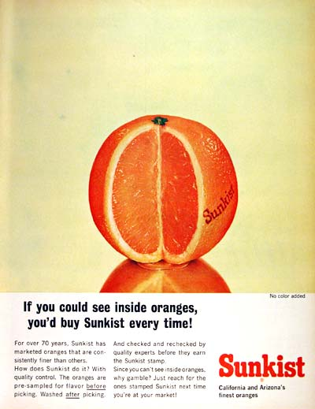
How is this problem just like that of the advertising industry when it comes to less bad advertisements? Advertisers can either run less-bad advertisements or not. If they do not run them but a competitor does, then they lose market share and the competitor benefits. If they both run less bad advertisements, then both companies lose out because consumers become afraid of the products and stop buying either of them. If they both refuse to run less-bad advertising, they do pretty well, but let's assume that they do not do as well as they would have if one had run the advertisements and the other had not. The chart will look basically the same, and the people who benefit most, according to Calfee, are the consumers. This is because the companies are competing and will try to do what is best for them, which will incline them toward running less-bad advertising. When this happens the consumer is given more information, which Calfee argues is good for the consumer. It also forces the competition to make their products better or sell them at a cheaper price. After all, one of the worst features about a product is that you have to pay for it, and when less-bad advertising involves prices, prices fall.
If Calfee is correct, then advertising does benefit people because making information public forces companies to compete for our money. Without advertising we would have to figure everything out on our own, which is not something we always have time to do. Furthermore, Calfee points out that advertising has been a great impetus to research in an effort to find more ways a product can be advertised as better than their competitor’s.
When information is made freely available prices go down and better products come onto the market. Consumers also learn other important things like what foods we should and should not eat. And we learn these things even if we do not buy the products. Another question we should ask is whether or not these advertisements do more harm than good. It's clear that Calfee thinks that advertising does a lot of good, particularly in the ways just mentioned, but he does not discuss all of the ways in which it can possibly be bad. One example of this is the reactionary point made earlier. Bad advertising and partial information can have bad consequences on people's lives. And finally, we are all familiar with some of the means advertisers use to get our dollars, and some of these means can be unethical even if some good comes from them. Kids may learn a lot from Saturday morning commercials, but the lasting effect this has on them may not be good, especially if we learn to late that the products our children love are bad for them.
What do you think about Calfee’s argument about Less Bad advertising? Does it help consumers or hurt them? Does it help the industry or hurt it? Should a good ad use Less Bad tactics?
______________________________________________________________________________
______________________________________________________________________________
______________________________________________________________________________
______________________________________________________________________________
______________________________________________________________________________
______________________________________________________________________________
______________________________________________________________________________
______________________________________________________________________________
______________________________________________________________________________
______________________________________________________________________________
______________________________________________________________________________
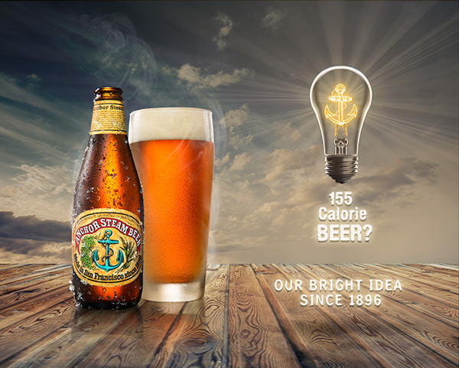
What is “less bad” about this advertisement?
__________________________________
__________________________________
__________________________________
__________________________________
__________________________________
__________________________________
__________________________________
__________________________________
__________________________________
__________________________________
__________________________________

Come up with some examples of recent ads that used less bad comparison.

Product | What is Less Bad in the comparison? | Is this helpful to make this claim?  Is this OK?
Example:  Camel Lights  (now C. Blue) | “Light” cigarettes have less tobacco and nicotine, which gives the image of a healthier cigarette | Unethical. It might keep people smoking longer, because they think they are being at least a little safe.

Storyboard assignment #10. Follow the prompts below to complete the assignment and share it next class for points.

Identify a food or beverage you like (any kind): ____________________________________
Come up with a concept for a 30 second advertisement storyboard for this product that features a less bad comparison. Use the storyboard spaces and lines to describe individual scenes and dialogue in your ad. Use the space/number of scenes necessary for the ad you imagine. Don’t work about artistic quality – stick figures are OK. See example on Workbook 1 page 6.
Scene 1 | Scene 2 | Scene 3

Scene 4 | Scene 5 | Scene 6

Comparison (USP) in Advertising Workbook Entry 3 – Read the included materials, find appropriate examples, and complete storyboard assignment 11 due for points next class.

A unique selling proposition, is a persuasive claim in advertising that a given product has a feature, ability, or rating that competitor products do not have.

Unique selling proposition; Wikipedia, the free encyclopedia; 2019

The unique selling proposition (USP) or unique selling point is a marketing concept first proposed as a theory to explain a pattern in successful advertising campaigns of the early 1940s. The USP states that such campaigns made unique propositions to customers that convinced them to switch brands. The term was developed by television advertising pioneer Rosser Reeves of Ted Bates & Company. Theodore Levitt, a professor at Harvard Business School, suggested that, "Differentiation is one of the most important strategic and tactical activities in which companies must constantly engage." The term has been used to describe one's "personal brand" in the marketplace. Today, the term is used in other fields or just casually to refer to any aspect of an object that differentiates it from similar objects.

A unique selling proposition (USP) refers to the unique benefit exhibited by a company, service, product or brand that enables it to stand out from competitors. The unique selling proposition must be a feature that highlights product benefits that are meaningful to consumers. As described by Dr. James Blythe, the USP "contains the one feature of the product that most stands out as different from the competition, and is usually a feature that conveys unique benefits to the consumer." Communicating the USP is a key element of branding. In Reality in Advertising, Reeves laments that the USP is widely misunderstood. He outlined three basic rules for an advertisement that encapsulated his ideas about the USP:

Each advertisement must make a proposition to the consumer—not just words, product puffery, or show-window advertising. Each advertisement must say to each reader: "Buy this product, for this specific benefit." The proposition must be one the competition cannot or does not offer. It must be unique—either in the brand or a claim the rest of that particular advertising area does not make. The proposition must be strong enough to move the masses, i.e., attract new customers as well as potential customers.

The USP concept has become one of the eight broad approaches to creative executions in advertising. The USP approach is recommended where the product category is characterized by high levels of technological innovation. A clear USP helps consumers to understand differences between brand offerings in a category, and may also help consumers to form a positive attitude towards the brand and may ultimately contribute to improved levels of brand recall.

In order to determine an appropriate USP for any given brand, marketers must undertake extensive research of the category as well as consumers. It is important to be able to locate a space in the market, ensure that the feature is something that is unique, and also something that is valued by potential customers. Sellers also need to try selling it to themselves; this is so they know they are passionate about that business and confident it can succeed. The seller needs a key point to use when trying to sell their product or service, and coming up with it prior to selling will benefit. Having a point of difference to stand out is a major benefit in the markets; customers will be drawn to the business as it offers something no one else has. This is exactly what every business should be looking into whether it is home delivery service from the store or all-organic food at the restaurant.

In markets which contain many similar products, using a USP is one campaign method of differentiating the product from the competition. Products or services without differentiation risk being seen as a commodity and fungible by the consumer, thus lowering price potential. That's why having a unique selling point is essential to have a successful business that can handle competition and possible future comers in similar markets.

The desktop personal computer market is one example with many manufacturers and the potential for new manufacturers at any time. Apple used the slogan "Beauty outside, Beast inside." for its Mac Pro campaign to differentiate its product as "beautiful" compared with any other desktop computer. Buyers of this product were willing to pay a premium price, compared with technically similar desktop computers. Apple differentiates itself with a focus on aesthetics and cutting-edge technologies. Wal-Mart's "Save money, live better" (Waiz, 2013). Wal-Mart is concerned with being the cheapest department store and reminding their customers that it's not how much you spend on a product that matters. Something so simple that can attract customers like that and show the unique selling proposition of the business is what people look for.

Typically, the uniqueness is delivered by a unique process, ingredient, or system that produces the benefit described.

Anacin "Fast, incredibly fast relief." In 1952, Rosser Reeves created a TV commercial that capitalized on Anacin's "special ingredient," caffeine, by suggesting limitations of other aspirin and repeating, three times, the differentiation proposition: fast.
M&M's: "Melts in your mouth, not in your hand." 1954 M&Ms use a patented hard sugar coating that keep chocolate from melting in ones hands, thus a chocolate soldiers could carry, compared to other brands.
Head & Shoulders: "Clinically proven to reduce dandruff." 1961 Pyrithione Zinc was found, after 10 years of research, to be an ingredient that was actually effective in eliminating dandruff where other products were not effective. Adding the name "Shoulders" to the product name also indicated that the product eliminated the tell-tale white marks on clothing caused by dandruff flakes falling from the hair.
Domino's Pizza: "You get fresh, hot pizza delivered to your door in 30 minutes or less—or it's free." 1973-1993 "You Got 30 Minutes" 2007- Domino's uses what it calls the "make line" and other systems to make pizzas quickly.
FedEx: "When it absolutely, positively has to be there overnight."1978–1983". FedEx was the first company to specialize in overnight air freight and first to implement package tracking. This pioneering advantage was made possible by a new system outlined in the founder's 1965 Yale paper.
Metropolitan Life: "Get Met. It Pays." 1984 Met's newer "Whole Life Policy" was a sales success for the company. The policy offered one-third more coverage, for the same price, and grew in cash value for a bigger "pay out" over time. In advertisements, Met compared buying the policy to buying a home.
Identify the Unique Selling Proposition in each ad below.
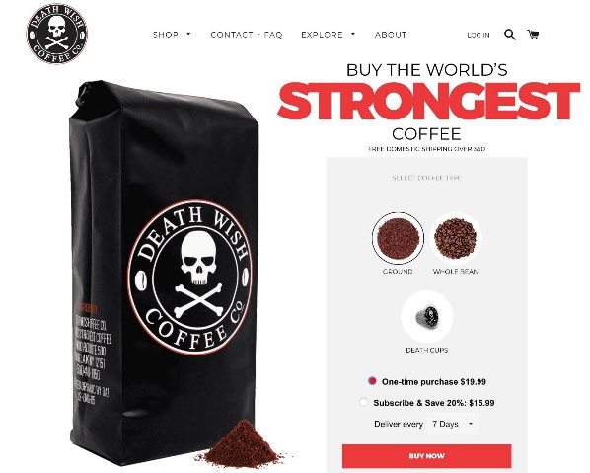
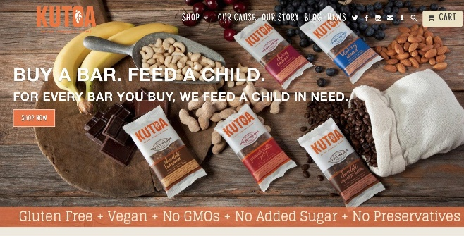
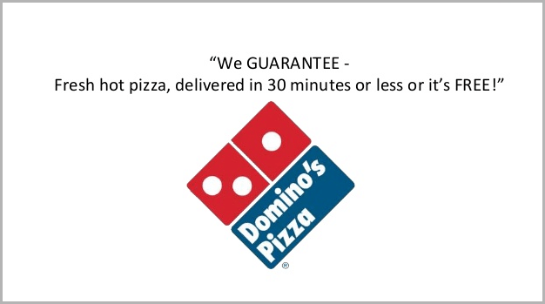
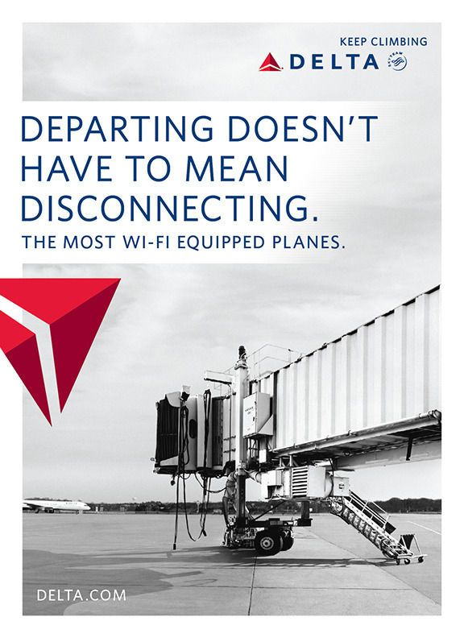
Storyboard assignment #11. Follow the prompts below to complete the assignment and share it next class for points.

Identify a household electronic device you have or want (any kind): ______________________
Come up with a concept for a 30 second advertisement storyboard for this product that features a unique selling proposition in order to create a positive comparison to similar products. Use the storyboard spaces and lines to describe individual scenes and dialogue in your ad. Use the space/number of scenes necessary for the ad you imagine. Don’t work about artistic quality – stick figures are OK. See example on Workbook 1 page 6.
Scene 1 | Scene 2 | Scene 3

Scene 4 | Scene 5 | Scene 6

Polished Ad Presentation (fixed image) & Analysis Assignment
For this assignment, you will be completing two major objectives:
- Create a Digital Sign advertisement that meets MarCom specifications (50pts)
  - Choose a DIFFERENT GHC entity to advertise for. This can be a GHC department, a GHC event, a GHC program of study, a GHC club, etc.
  - Research that entity and determine what you are trying to persuade people to do. Are you trying to get people to attend a specific event? To join a club? To meet with a specific office by a certain deadline?
  - Craft an ad concept using any or all persuasive techniques discussed in class so far. You must at least include use of association, endorsement, identification, or image/status. I expect that you will use several individual strategies, not just one.
  - Make a 16x9 PowerPoint slide (single fixed image) that contains all relevant information and makes a clear attempt to persuade using the strategies discussed in class. In order to set the slide size to 16x9, click on the ‘Design’ tab in PowerPoint and select 16x9 from the ‘Slide Size’ dropdown menu on the right.
  - Submit the PowerPoint slide to me by email (sstuglin@highlands.edu ) the midnight before the class in which it is due.
  - 25 pts for quality of persuasive attempts: effectiveness, creativeness
  - 25 pts for quality of image: polish, professionalism
- Write an analysis of the persuasive strategies at work in your advertisement (25pts)
  - Identify no less than three and no more than five persuasive strategies discussed in class that you incorporated into the advertisement.
  - For each strategy, write one paragraph
    - What is the strategy and how does it work?
    - Give an example from class of that strategy at work
    - How did you incorporate this strategy into your ad?
    - Why did you choose this strategy over others?
  - At minimum, the analysis should be three solid paragraphs
  - Type the analysis, single spaced, 12-point font, with your name on the top.
  - PRINT the document the evening before it is due. Printer issues right before class are not an acceptable excuse for not having this assignment ready to turn in
  - 20 points for quality of description of strategies
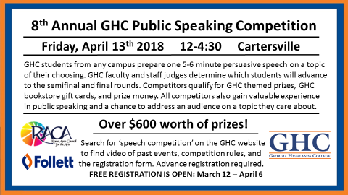
  - 5 points for college appropriate spelling, grammar, punctuation

Example of a Digital Sign made for the 2018 Speech Competition

Print off Workbook Four!

