GHHU 2901
Persuasion in Advertising

PART ONE
WORKBOOK

"We do not first see, and then define, we define first and then see. In the great blooming, buzzing confusion of the outer world we pick out what our culture has already defined for us, and we tend to perceive that which we have picked out in the form stereotyped for us by our culture."
- Walter Lippmann Public Opinion

NAME: __________________________________________________________________

Instructions
DO NOT LOSE THIS WORKBOOK

A. Complete the workbook entry before class.
This will include creating a ‘storyboard’ for each class period. These are worth points!
B. Use the workbook during class to facilitate class discussion.
C. The workbook includes all major assignment rubrics.

Association in Advertising Workbook Entry 1 – Read the included materials, find appropriate examples, and complete storyboard assignment 1 due for points next class.
Ethos, by M.T. Wroblewski, Small Business Chronicle Online, 2018

Few concepts have survived the test of time quite like Aristotle's “modes for persuasion” – the notion that a persuasive appeal needs three elements to be successful: ethos, logos and pathos. Ethos is an appeal to ethics and character, meaning that an audience must believe the speaker is ethical, credible and trustworthy. Logos is the appeal to logic; pathos is an appeal to emotion.
Two thousand years after Aristotle developed this “rhetorical triangle,” rhetoric teachers still rely on it to teach college students how to craft effective persuasive arguments. And advertisers still invoke ethos, logos and pathos, knowing they must achieve a delicate balance of the three elements. The appeals also form the basis for how marketing experts, and groups that bestow industry awards, deem an effective “good” or “great” – in other words, effective at persuasion.
Since the earliest days of television – when products were placed in the hands of and promoted by well-known people for the first time – business owners have known that one of the best ways to inject ethos in their messages is to rely on celebrities to deliver the messages for them.
“In order to have effective ethos, the author – or in the case of advertisements, the celebrity endorser – needs to convey a level of practical sense, morality and goodwill,” writes Christa Kettlewell in her research on the subject for Clemson University. “One of the key factors that make it clear as to why celebrity endorsements are utilized in advertising is that utilizing a well-known celebrity endorser provides reassurance for customers in terms of product quality.”

--------------------------------------------------------------------------------------------------------------------
In this workbook, we’ll explore four persuasive techniques used in advertising that are all special sub-types of ethos from Aristotle’s rhetorical triangle:
- Association
- Endorsement
- Identification
- Image / Status

Association, broadly speaking, refers to the persuasive technique of associating one thing with another, in order to impart traits from the first thing to the second. These traits can be either good or bad. For example, in contemporary politics, a Democrat might associate their Republican opponent with President Trump, in an attempt to transfer negative opinion about Trump to their opponent. In advertising, you might see a commercial for a food featuring an attractive woman eating the food. The ad is an attempt to associate the attractiveness of the person on screen with attractiveness in the product.
Although association is an ancient rhetorical technique, modern public relations and advertising began using association thanks to the efforts of Edward Bernays. Among other things, Bernays demonstrated that desirability is at the core of shaping public opinion. If you want people to like a product or idea, have it held by or used by someone people find desirable.
The Father of Market Research by Miguel Connor, American Marketing Association online
This marketing practice still very prevalent, especially on the internet and its A/B testing frenzy—where colors, graphics, and even fonts are tested and used to tie a brand to a desired emotion. Bernays actually called this idea the “tie in.” He (and the rest of us marketers) owe this as much to Pavlov and his dogs as to Freud (and Bernays admitted this).
His most notorious campaign on Association was his ability to make smoking popular with women, during a campaign for the American Tobacco Association in the 1920s. In those days, women smoking was taboo, even illegal in some parts of the country. Bernays, through public events and media exploitation, was able to connect the distasteful idea of women smoking with the nascent feminist movement. Put simply: the “tie in” was that being against women smoking was being against women’s rights. By the 1930s, women smoking wasn’t just accepted but became a symbol of American freedom.
(It should be noted that, like Dichter, who also worked for cigarettes companies, Bernays would repent later in life and join antismoking lobbyists).

Psychoanalysis Shapes Consumer Culture by Lisa Held, American Psychological Association online, Dec 2009
Who knew that Sigmund Freud, the father of psychoanalysis and critic of all things American, was an unwitting contributor to the rise of Western consumer culture?
Women sporting cigarettes as a symbol of female empowerment and the ubiquitous bacon-and-egg breakfast were two public relations campaigns inspired by Freudian ideas. The link between theory and practice was Edward L. Bernays, the acknowledged father of public relations and nephew of Sigmund Freud.
Bernays was born in Vienna, Austria, in 1891 but grew up in New York City. His mother was Freud's sister and his father was the brother of Freud's wife, Martha Bernays. He maintained contact with his uncle, and the family often joined Freud for summer holidays in the Alps. Bernays began his career shaping public opinion by creating a media campaign to raise awareness of venereal disease and sexual hypocrisy. But his application of psychoanalytic principles to public relations and advertising came only after reading Freud's "General Introductory Lectures," a gift from Freud to his nephew in thanks for a box of Havana cigars.
In this case, a cigar did prove to be much more than a cigar. The marriage of psychoanalysis and public relations, facilitated by the box of Havanas, made Bernays a very wealthy man.
Intrigued by Freud's notion that irrational forces drive human behavior, Bernays sought to harness those forces to sell products for his clients. In his 1928 book, "Propaganda," Bernays hypothesized that by understanding the group mind, it would be possible to manipulate people's behavior without their even realizing it. To test this hypothesis, Bernays launched one of his most famous public relations campaigns: convincing women to smoke.
In 1929, it was taboo for women to smoke in public and those who flouted convention were thought to be sexually permissive. Bernays' client was George Washington Hill, president of the American Tobacco Company, who envisioned breaking this taboo to broaden the market for his Lucky Strike brand. Bernays asked Hill for permission to consult with New York's leading psychoanalyst and Freud disciple, Dr. A.A. Brill, and was granted this unusual request.
This was the first but not the last time Bernays would consult with psychoanalysts to help shape his public relations campaigns. When asked what cigarettes symbolized to women, Brill's response was that cigarettes were symbolic of male power.
Equating smoking with challenging male power was the cornerstone of Lucky Strike's "Torches of Freedom" campaign, which debuted during New York's annual Easter Parade on April 1, 1929. Bernays had procured a list of debutantes from the editor of Vogue magazine and pitched the idea that they could contribute to the expansion of women's rights by lighting up cigarettes and smoking them in the most public of places—Fifth Avenue. The press was warned beforehand and couldn't resist the story. The "Torches of Freedom Parade" was covered not only by the local papers, but also by newspapers nationwide and internationally. Bernays was duly convinced that linking products to emotions could cause people to behave irrationally. In reality, of course, women were no freer for having taken up smoking, but linking smoking to women's rights fostered a feeling of independence.

How do companies sell things, according to these excerpts about Bernays?
______________________________________________________________________________
______________________________________________________________________________
______________________________________________________________________________
______________________________________________________________________________
______________________________________________________________________________
______________________________________________________________________________

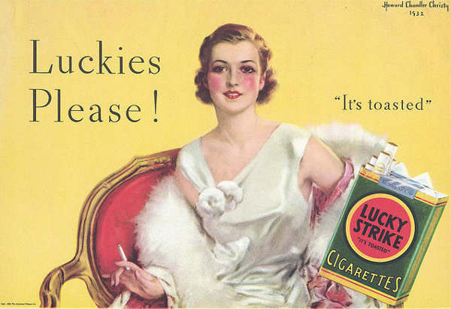
This Torches of Freedom ad uses Bernays’ strategies to sell cigarettes. What similar modern ads have you seen recently?
_________________
_________________
_________________
_________________
_________________
_________________
How did those ads attempt to do the same things you see happening in this Lucky Strike ad?
______________________________________________________________________________
______________________________________________________________________________
______________________________________________________________________________
______________________________________________________________________________
______________________________________________________________________________
______________________________________________________________________________

Near each ad, indicate how you think it uses association in order to sell a product.

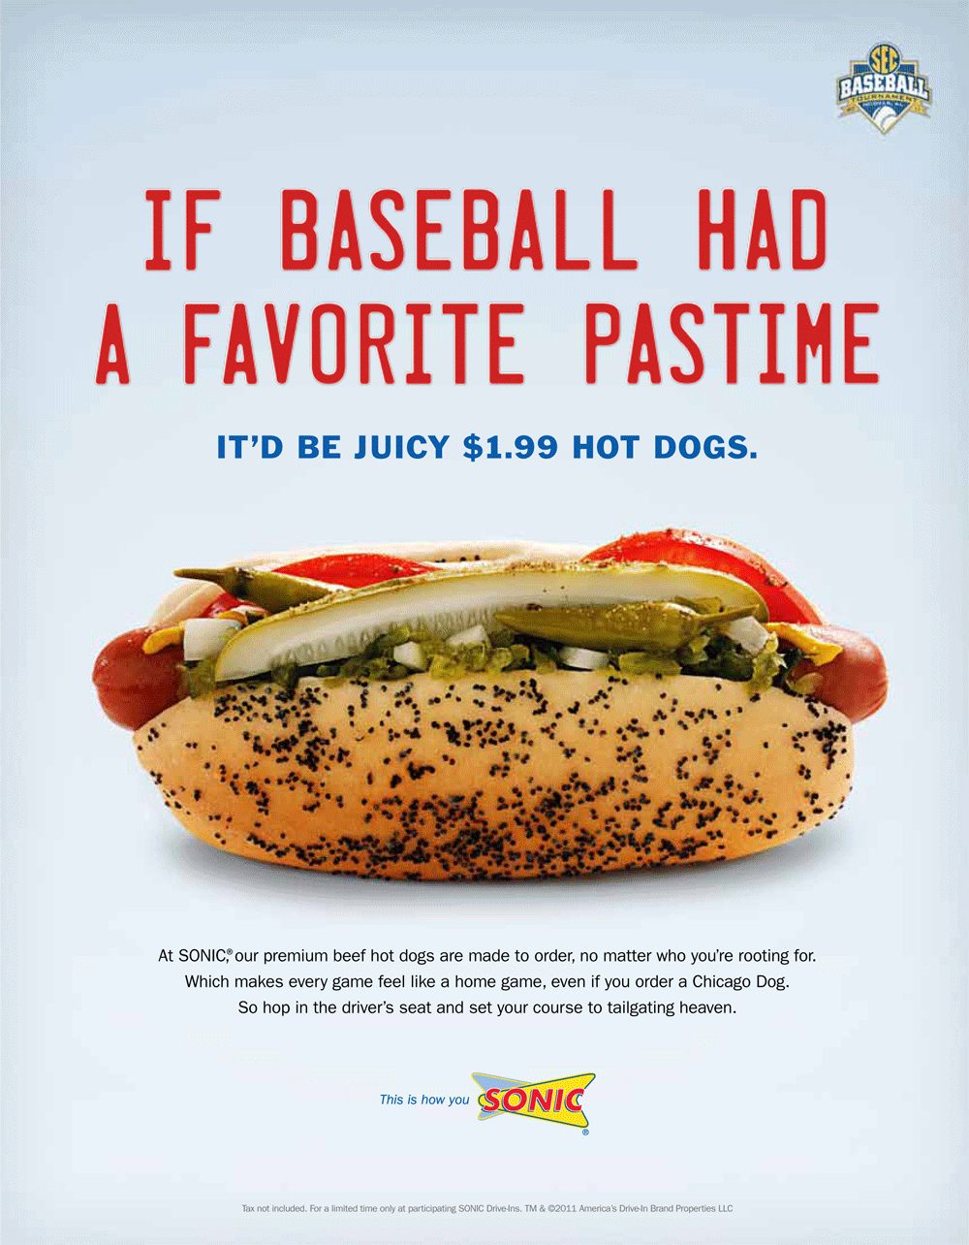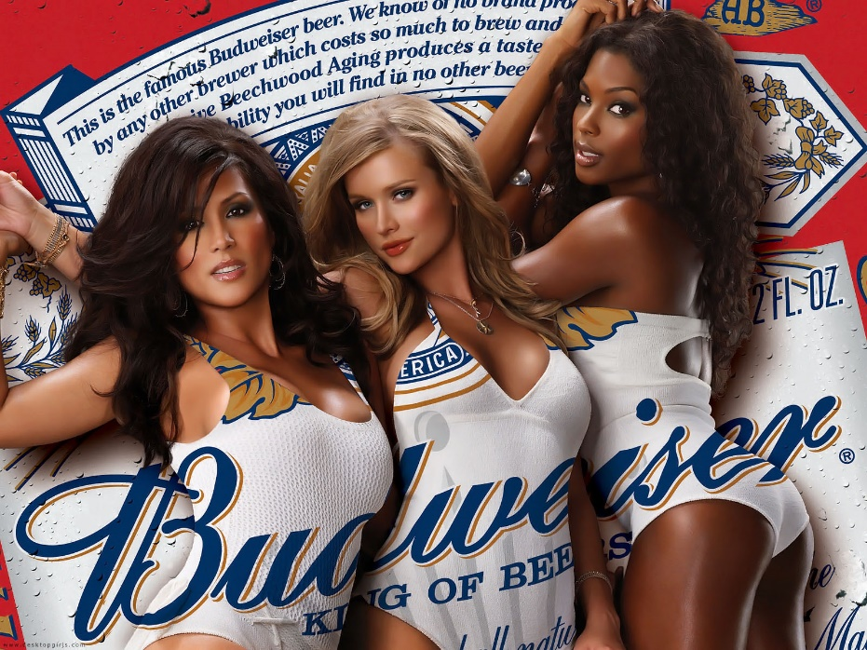
_______________________________________ ____________________________________
_______________________________________ ____________________________________
_______________________________________ ____________________________________
_______________________________________ ____________________________________
_______________________________________ ____________________________________
_______________________________________ ____________________________________
_______________________________________ ____________________________________
_______________________________________ ____________________________________
_______________________________________ ____________________________________
Storyboard assignment #5. Follow the prompts below to complete the assignment and share it next class for points.

Identify an app or website you use (any kind): ____________________________________
Come up with a concept for a 30 second advertisement storyboard for this product that features positive or negative association in order to get people using the app or website. Use the storyboard spaces and lines to describe individual scenes and dialogue in your ad. Use the space/number of scenes necessary for the ad you imagine. Don’t work about artistic quality – stick figures are OK. See example on Workbook 1 page 6.
Scene 1 | Scene 2 | Scene 3

Scene 4 | Scene 5 | Scene 6

Endorsement in Advertising Workbook Entry 2 – Read the included materials, find appropriate examples, and complete storyboard assignment 1 due for points next class.

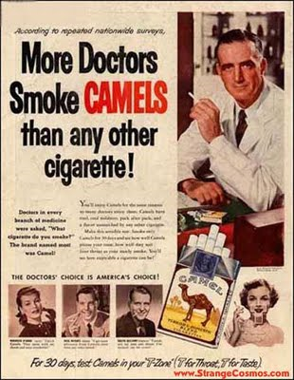
In advertising, endorsement refers to a person or persons that are said to support or use a given product or service, which stands as a recommendation for the audience to use it, too. This generally takes two forms:
- Endorsement from Opinion Leaders – opinion leaders are the intermediary in the two-step flow model of communication. Basically, the opinion leader can be anyone that a large group of people looks to for information, advice, trends, or perspective. This can include celebrities, athletes, politicians, religious leaders, organizers, etc.

- Endorsement from Experts – experts can be any group that would have reason to know more about a product or service than the general public – but not necessarily about all products. A famous doctor might endorse a particular medicine – this is endorsement from experts. The same doctor endorsing a car is not endorsement from experts, because doctors have no reason to know more about cars than the general public.
Come up with some examples of recent ads that used endorsement.
Product | Opinion Leader or Expert? | Premise
Example: Deodorant | Opinion Leader | Pro Tennis Player talked about needing “extra” protection and said product always worked for her

The Father of Market Research by Miguel Connor, American Marketing Association online

Modern marketing demands an expert in the field not only to promote a product but grant gravitas to a company. Every CEO or department head seems to have a blog or active social media account or webinar appearance. Their ideas are curated for different agendas, even by competitors in the industry. This is almost standard today.
This phenomenon originated with Bernays, and one could add the celebrity or expert endorsement as well. He called this marketing tactic “third party authorities” that promoted his clients’ causes.
“If you can influence the leaders, either with or without their conscious cooperation, you automatically influence the group which they sway,” he once said.
The greatest example of this is how Bernays was able to increase the sales of bacon​. While researching for the Beech-Nut Packing Company, he found an empty space in American’s diets: their light breakfasts, which in those days was not much more than a roll and juice.
Bernays’ was able to obtain the opinions of more than 4,500 physicians endorsing the idea that a heavier breakfast awarded more energy for the day. Not trusting the public to accept these findings, Bernays flooded the market with manipulated press releases, articles, and advertisements—with the message that doctors personally ate large breakfasts or that bacon and eggs were part of that “nutritious breakfast.”
Sales of bacon went through the roof, and Bernays confessed later in life he was surprised consumers fell for such a stunt.

What is an Endorsement in Advertising? by Apryl Duncan, The Balance, 2018

Over the last hundred years, there have literary been thousands of advertising endorsements. From athletes and movie stars, to doctors and mechanics, endorsements are a major part of the advertising and public relations industries. And with good reason.
When a product or service chooses to align itself with someone famous, or an expert in that field, they are taking a shortcut to recognition, goodwill, and credibility. For instance, you may never have given a second thought to a certain brand of cereal. But when an Olympic gold medal athlete you know comes out and says they eat it, it's on your radar.
In other words, endorsements are an easy way for a brand to attach themselves to the positive feelings associated with a celebrity or industry professional.
Types of Endorsements
There are four basic types of endorsements, mostly paid that brands have available to them. Sometimes they are free, especially for charities such as celebrities speaking out on behalf of breast cancer screening tests.
- Using the Product or Service: This is perhaps the most common in sports and fashion. For example, Kobe Bryant and Michael Jordan are paid millions of dollars to be seen wearing Nike shoes. Medical brands will pay esteemed physicians, dentists, doctors, and other medical professionals to tell the world that they use a specific product.
- Speaking on Behalf of the Brand (aka Testimonials): Appearing in ads for a product or service is another popular way for brands to use endorsements. Many major celebrities do this to earn millions of additional dollars every year (think Christopher Walken for Kia) although most opt to endorse products that are not seen in this country. For example, Arnold Schwarzenegger has endorsed a variety of Japanese products. This is often a good option because if a celebrity falls out of grace, their overseas image is more protected against negative press than it would be stateside.
- Unpaid Testimonials: Advertisers have the choice of paying someone to write or say something that can endorse the brand, but it's even better when that testimonial is completely free. This can happen in a few ways. A famous blogger, YouTuber, professional, or celebrity, can say something positive about the brand. A famous example of this comes from England. When the TV chef Delia Smith uses a certain kind of cooking utensil on her cooking show, sales for that particular model shoot up ten-fold the following day. If a well-followed blogger gives a restaurant a glowing review, business (at least in the immediate aftermath) will boom.
- "Fake" Endorsements: This is not to imply anything illegal going on. It is simply referring to the kinds of endorsements that come from actors who are paid spokespersons for everything from a rental car company to a specific household cleaning product. These spokespeople can appear as families explaining how wonderful the product is or appear as medical professionals wearing white lab coats. They have to be identified as actors in these commercials, even if they are speaking the words of a real family or doctor, and therefore the power of this kind of endorsement is much weaker than the other three. Very few people watch an ad featuring an actor and think the product will be as good as it's stated.

The Dangers of Endorsement Deals
Endorsements tie two brands together. One brand is an actual product or service, and the other is a personal brand, from a movie or TV star, musician, or industry professional. The hazard is, once the two are tied together, things can get messy if anything goes wrong with either brand. One only has to consider O.J. Simpson and Bill Cosby to understand the implications of an endorsement gone awry.
Danger to the Brand: Should anything negative happen to the person endorsing the brand, the brand itself can suffer very quickly. You only have to look at the issues that Tiger Woods created for the brand he endorsed. In these instances, a crack PR and legal team are needed to stop the bleeding immediately. But in some cases, the damage is too great and the brand must disavow the endorsement.
Danger to the Endorser: Similarly, should a brand come under fire for doing something wrong, the famous person endorsing it can become tarnished unless they move fast to remove themselves from the relationship. If it is discovered a company is using sweatshops, engaging in false advertising, or is flat out breaking the law, that could easily tarnish the reputation of the endorser.
Are Celebrity Social Endorsements Worth the Big Bucks or the Gamble?
By Gabriel Beltrone September 30, 2013 Adweek

In the brave new world of social media, marketers are doubling down on celebrity endorsements, banking on stars’ earned media mojo to help their campaigns catch fire.
Take HTC’s splashy, $1 billion campaign starring Robert Downey Jr. or Pepsi’s $50 million endorsement agreement with Beyoncé. “Pretty much anything she does is covered both in traditional and social media,” said William Gelner, chief creative officer of 180LA, which this spring created a popular Pepsi spot starring the singer.
Lately, brands like Audi, Honda and Diet Coke have enlisted A-listers like Claire Danes, Nick Cannon and Taylor Swift, fueling their ads with social star power.
Often such deals give advertisers a direct line to celebrities’ fan followings via their personal Twitter accounts and Facebook pages. The true asset, however, is a star’s relevance, buying a marketer the kind of buzzy exposure that only a Hollywood headliner can bring.
“A lot of what social allows a brand to do is to piggyback off earned media, utilizing the fans to do the work for you,” said Anna Holland, executive group director at WPP’s 171 Worldwide, partner on HTC’s push with Downey. “He just came off Iron Man 3 and that alone brings awareness to [HTC].”
The increased visibility of social also amplifies the potential risk of such deals. For one, it raises the bar for what passes as a convincing celeb-marketer marriage, said Chris Raih, managing director of Los Angeles agency Zambezi, which this summer launched a Popchips ad starring Katy Perry (an investor and creative partner in the company).
Or a brand may find itself entangled in a fiasco on the scale of the Mountain Dew-Tyler, the Creator dustup, the Rick Ross lyrics controversy or the Paula Deen meltdown. Still, “it doesn’t happen that often,” said C. Samuel Craig, professor of marketing at NYU’s Stern school, plus brands can usually distance themselves quickly.
YouTube does have its benefits. Brands can get more bang for their buck with longer ads and richer storylines. Fans can watch spots starring their favorite stars on demand—unlike TV where a diverse cross section of viewers watches a celebrity some might not care for, rendering a celebrity-fronted spot less effective.
“Celebrities by their very nature tend to be quite polarizing,” said Peter Daboll, CEO of Ace Metrix, which measures ad impact. “TV is a very blunt targeting instrument.”
Putting a star in an ad isn’t always a silver bullet. “It really only improves your odds with those people who are fans of the celebrity,” said Bruce Clark, marketing professor at Northeastern University’s D’Amore-McKim school.

What does each author say about the effectiveness of humor in advertising?
#1 Connor ______________________________________________________________________________
______________________________________________________________________________
______________________________________________________________________________
______________________________________________________________________________

#2 Duncan
______________________________________________________________________________
______________________________________________________________________________
______________________________________________________________________________
______________________________________________________________________________
#3 Beltrone ______________________________________________________________________________
______________________________________________________________________________
______________________________________________________________________________
______________________________________________________________________________
Next to each ad, identify whether the ad is an opinion leader or expert endorsement, and explain why it might be effective at persuading audiences to use the product.
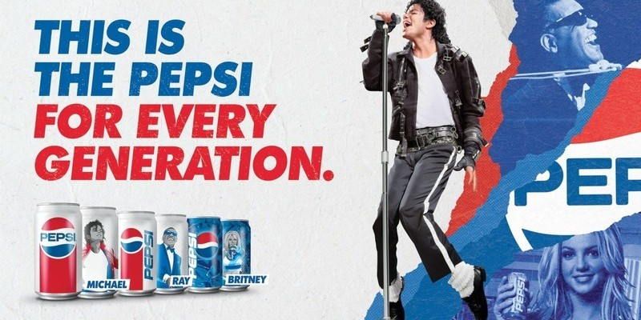
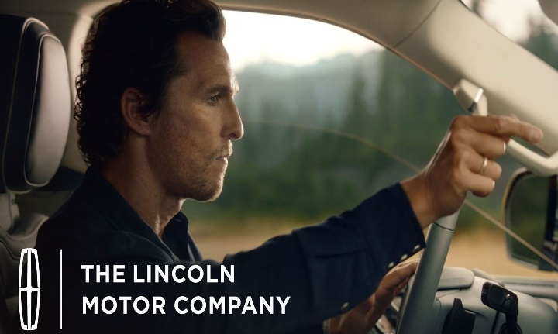

Storyboard assignment #6. Follow the prompts below to complete the assignment and share it next class for points.

Identify a clothing brand you use (any kind): ____________________________________
Come up with a concept for a 30 second advertisement storyboard for this product that features an opinion leader or expert endorsement of the product. Use the storyboard spaces and lines to describe individual scenes and dialogue in your ad. Use the space/number of scenes necessary for the ad you imagine. Don’t work about artistic quality – stick figures are OK. See example on Workbook 1 page 6.
Scene 1 | Scene 2 | Scene 3

Scene 4 | Scene 5 | Scene 6

Identification in Advertising Workbook Entry 3 – Read the included materials, find appropriate examples, and complete storyboard assignment 1 due for points next class.

"Identification" as a Key Term in Kenneth Burke's Rhetorical Theory, by Brooke Quigley; American Communication Journal Online

In A Rhetoric of Motives (1969), Kenneth Burke selects "identification" as the key term to distinguish his rhetorical perspective from a tradition characterized by the term "persuasion." As he is careful to note, his focus on identification does not mean he dismisses the traditional focus on persuasion; his contribution is accessory to the traditional focus, and he uses both concepts in his own thinking. Burke sees that interactions in our contemporary world are, in some ways, "more complicated" than can be understood by viewing persuasion solely as the explicit, intentional acts which a rhetor directs to a specific, known audience. The following discussion offers a brief definition of some elements of Burke's concept of "identification" and describes several ways the term extends our traditional understanding of "persuasion."
Burke explains identification as a process that is fundamental to being human and to communicating. He contends that the need to identify arises out of division; humans are born and exist as biologically separate beings and therefore seek to identify, through communication, in order to overcome separateness. We are aware of this biological separation, and we recognize additional types of separation based on social class or position. We experience the ambiguity of being separate yet being identified with others at the same time: we are "both joined and separate, at once a distinct substance and consubstantial with another." (Burke, 1969, p. 21).
Burke assumes we not only experience separateness but are goaded by the spirit of order and hierarchy and feel guilty about the differences between ourselves and others (who occupy different positions in the social hierarchy) and about our inevitable failure to always support order, authority and hierarchy. As Burke asserts, "Identification is affirmed with earnestness precisely because there is division. Identification is compensatory to division." (Burke, 1969, p. 22). To overcome our division and our guilt, we look for ways in which our interests, attitudes, values, experiences, perceptions, and material properties are shared with others, or could appear to be shared. These instances of "overlap" make us "consubstantial" with others. We continually seek to be associated with certain individuals or groups (and not others), attain some position in the hierarchy of social relations, and relieve ourselves of the guilt we bear.
As Burke sees it, the human need to identify provides a rich resource for those interested in joining us or, more importantly, persuading us. Burke's human agent is separate and guilty, "goaded by a spirit of perfection," and in this uneasy state is thus "available" to the art of those who would attempt to wield influence for purposes of good or ill. A key part of Burke's mission in writing is that we understand the processes by which we build social cohesion through our use of language. His goal is that we learn to perceive at what points we are using and abusing language to cloud our vision, create confusion, or justify various and ever present inclinations toward conflict, war and destruction--or our equally-present inclinations toward cooperation, peace and survival. Thus, Burke sees in processes such as identification, the working out of the daily mundane processes of social life, as well as the larger, significant choices that may lead to our corporate destruction or salvation.
Burke's concept of identification needs to be seen within the context of his understanding of language as symbolic action. Human beings are actors. Using language is one way of acting in the world, and for us to act by using language is our most defining characteristic. By our very nature, we are beings who respond to symbols, and are symbol-using and symbol-abusing. Humans act by using language that is purposeful and that conveys our attitudes. It is from this understanding that Burke draws his definition of rhetoric as "the use of words by human agents to form attitudes or induce actions in other human agents." (Burke, 1969, p. 41). Within this perspective, identification involves at least three types of processes or states: 1) the process of naming something (or someone) according to specific properties; 2) the process of associating with and dissassociating from others--suggesting that persons (and ideas or things) share, or do not share, important qualities in common; and 3) the product or end result of identifying--the state of being consubstantial with others. It is the associating process, whereby individuals persuade others, or themselves, that they share important qualities in common, that is the focus of the present discussion.
Burke describes the most obvious case of the associating type of persuasion in traditional terms, as a form of explicit design: "a speaker persuades an audience by the use of stylistic identifications; his act of persuasion may be for the purpose of causing the audience to identify itself with the speaker's interests..." (1969, p. 46). Burke's examples of deliberate attempts at identification include the politician who, when speaking to farmers says, "I was a farm boy myself," (1969, p. xiv) or the "baby kissing politician's ways of kissing women on their babies" (Burke, 1966, p. 302). Using Burke's perspective, Cheney (1983) has examined the ways organizations seek to establish such common ground directly with employees through newsletters. Cheney also looks at two types of identification strategies discussed by Burke which are less direct: identification by antithesis, whereby a speaker promotes identification with a listener by virtue of an "enemy" both speaker and listener have in common; and identification by an "assumed we" whereby a speaker uses references such as "we," in a way that is largely unnoticed but allows the speaker to group together parties who have little in common.
In this paper, several dimensions of Burke's understanding of identification by common ground are illustrated by reference to public response following the death of Princess Diana in August of 1997. At the time of her death, individuals in England, the U.S., and elsewhere were interviewed as part of a week of unprecedented television coverage. Many who shared memories of her, especially young women, commented in ways that suggested they identified with Princess Diana at various stages in her public life. However, many women and men were surprised at their own response of grief or concern, not having realized until her sudden death that they felt a significant connection to her. In part, their response suggests they identified with her in ways they had not realized (Quigley, 1998). By using Burke's perspective on identification, we can explore some of the less obvious ways that persons may have identified with Princess Diana, to indicate potential avenues of analysis that could help explain her demonstrably wide appeal. Burke's perspective also allows us to consider that identification in contemporary society may occur through mass media and may involve large and diffuse audiences.
Identification through form. According to Burke, "many purely formal patterns can awaken an attitude of collaborative expectancy in us." (Burke, 1969, p. 58). Once we grasp the trend of the form, it invites participation. This is the case with forms such as tropes and figures, and may also be the case with larger forms, such as story or myth. Identification with Princess Diana may have been greatly facilitated by a very familiar mythic form--the story of the obscure young girl who meets the prince and finds her life transformed. Numerous news reporters and many individuals interviewed at the time of Princess Diana's death referred to her "storybook" or "fairy tale" romance and wedding. Even though these individuals did not say they actually believed in such a story, some did reveal that they got caught up in the celebration at the time. It's possible these and other individuals, particularly young women, identified with the princess and the royal family and may have hoped, at some level, that a familiar and powerful story would turn out to be true. Burke would have us be on the lookout for such invitations to identify through familiar and attractive forms.
Identification as semi-conscious.
In processes "not wholly deliberate yet not unconscious," a speaker may use language and other symbols associated with wealth or class, or an audience member may identify with such nuances of wealth without being fully aware of doing so (Burke, 1969). Burke's perspective suggests that we consider the impact of messages we do not fully intend to send or do not consciously intend to heed. Such opportunities to identify semi-consciously might be expected to occur, especially when there exists "mystery" resulting from hierarchical estrangement, as would happen in relations between royalty and commoners. "Mystery arises at the point where different kinds of beings are in communication. There is strangeness but also the possibility of communion." (Burke, 1969, p. 115).
According to Burke, one contemporary term we might use to describe mystery is "glamour," and that certainly has been a term used often in association with Princess Diana. During the royal wedding, people might have identified through the presence of, for example, uniforms, insignia, the carriage, and the pageantry of the event. In later years, Princess Diana was often seen as having a glamorous, high society lifestyle. Without thinking too much about it, many may have identified with the princess at the time of the wedding and at other times, in part, through the symbols of wealth, class and glamour that added to a sense of estrangement and mystery, yet invited communion.
Identification through self-persuasion.
Burke suggests that an essential part of identification occurs through of self-persuasion; we promote social cohesion through our innumerable identifications, in part through persuading ourselves. In some cases, the process of persuasion is not complete until we act upon ourselves rhetorically (Burke, 1969). Burke's picture of the individual consciousness is one of a noisy and wrangling parliament, different factions of which may ascend in importance at different times. Whichever faction is in charge at a given time may convince, through carefully chosen language (including purposefully vague, imprecise language), the other members who make up the complicated self, thereby "completing" a process of persuasion begun outside the individual. At the time of Princess Diana's death, reports indicated that she was frequently the target of criticism in the British press, yet ordinary people "kept faith" with her. In the face of both positive and negative news reports, those who kept faith may have rationalized their choice internally in ways that strengthened their identification with her.
Identification through the mundane and recurring.
While it is obviously beneficial for us to focus on one-time events, such as a particularly important or effective speech, we can also benefit from examining less important, recurring messages with which we might identify. In our media-saturated environment, we are repeatedly exposed to messages that are not just mundane but are sometimes irritating and obnoxious. As Burke states, "And often we must think of rhetoric not in terms of some one particular address but as a general body of identifications that owe their convincingness much more to trivial repetition and dull daily reinforcement than to exceptional rhetorical skill." (Burke, 1969, p. 26). He would not have us ignore or dismiss such dull and omnipresent fare. In their shock at Princess Diana's death, some individuals remarked that she had become like a member of their family in that she was a daily presence, appearing through newspapers and television. It is possible that people, particularly the British, identified with her in numerous small ways, as she became part of the fabric of routine daily life.
Identification through representation.
An additional way we identify is by sharing vicariously in the role of leader or spokesperson (Burke, 1973). Many people interviewed about Princess Diana have said they felt connected to her in her various roles as young bride, mother, socialite, single mother, and crusader. As she "grew" in her role, even though she did so awkwardly at times, many who followed her activities felt she represented them and their country. In describing her continuing work for charities and various causes after her divorce, she was frequently described as an "ambassador of good will." This was the case whether she was visiting a foreign country or visiting an AIDS hospice in her own country. These were places ordinary people didn't go and she was seen as going in their stead. Those identifying with her as a type of leader might also have felt they shared in her transformations--from shy young girl to glamorous socialite, from decorative royal to committed crusader. She was able to change her identity and others may have felt, in identifying with her, they could also. The possibility of transformation is an interesting prospect, and for many would present an attractive invitation to identification. Thus, Princess Diana may have represented others through her highly visible lifestyle and work as well as through her ability to transform herself.
Obviously, Burke's perspective on identification is much broader than the several dimensions discussed here. However, these dimensions offer a brief look at the possibilities for exploring identification as other than a direct and deliberate strategy used by a rhetor to persuade an audience. Burke encourages us to look at processes that are semi-conscious, less than obvious, mundane, and representative, processes that invite us to collaborate in identification and transformation. Burke's understanding leads us to ask an expanded set of questions when trying to explain events such as the overwhelming public response to Princess Diana's death. While reference to processes of identification may not explain all aspects of the appeal of a public figure, it is surely one important avenue to explore. For such an exploration, Burke has provided additional tools that can help us understand persuasion as a complicated and rich phenomenon.

In the example at the left, the audience may identify with the couple in the image. The everyday occasion of playing with a child makes these people look like us, like real people. Our ability to connect to them helps make the ad a subtle suggestion to buy… they are like me, and they use Clorox. I should, too.

Use the spaces below to summarize what you read in the excerpt about Burke and Identification
Form | What is it? | Why does it persuade? | Can you think of an example?
Basic Identification
Semi-conscious
Self- persuasion
Mundane/ Recurring
Representation

Storyboard assignment #7. Follow the prompts below to complete the assignment and share it next class for points.

Identify a car/truck you want to own (any kind): ____________________________________
Come up with a concept for a 30 second advertisement storyboard for this product that features some attempt to get the audience to identify with the advertisement. Use the storyboard spaces and lines to describe individual scenes and dialogue in your ad. Use the space/number of scenes necessary for the ad you imagine. Don’t work about artistic quality – stick figures are OK. See example on Workbook 1 page 6.
Scene 1 | Scene 2 | Scene 3

Scene 4 | Scene 5 | Scene 6

Image/Status in Advertising Workbook Entry 4 – Read the included materials, find appropriate examples, and complete storyboard assignment 1 due for points next class.
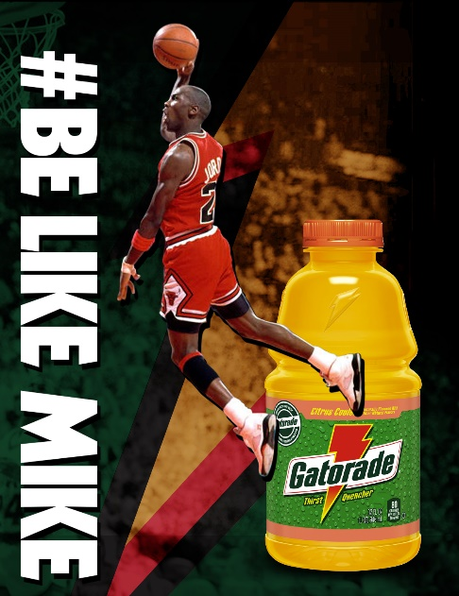
Ethos can also be used to persuade when used to argue that a certain product or service “comes with” a certain status or image. Using the product is shown to be part of or lead to this image or status in the ad.
In the blatant example at right, Gatorade will make the person drinking it “like Mike.” So, Gatorade will make us significantly taller than average, incredibly athletic, one of the best basketball players in history (and a mediocre baseball player), black, bald, and rich? Well, no. The ad just suggests that if you want to ‘be like Mike,’ you drink Gatorade, because he does. It is about image, not true transformation.
Recall some recent ads that suggested the audience would either become part of a certain image or gain status by using the product.

Product | Status or Image? | Premise
Example: McDonalds | Image | Fun happy group of teens hanging out, laughing and smiling, at McDs
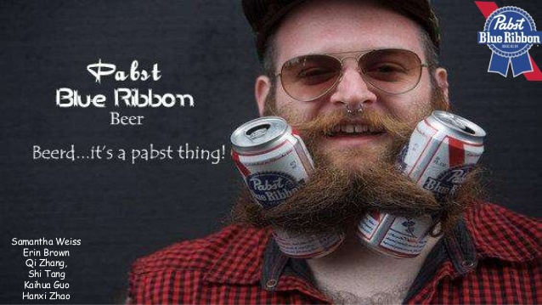
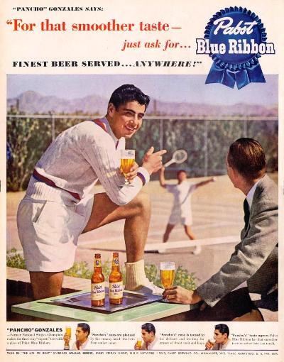
Note that advertising based on image can change over time, depending on the changing market and changing needs of the company. Consider these two ads for PBR beer. What changed between the 1950s and 2010s to warrant such drastically different images in PBR advertising? What does each image suggest about the consumer they are trying to reach?

______________________________________________________________________________
______________________________________________________________________________
______________________________________________________________________________
______________________________________________________________________________
______________________________________________________________________________
______________________________________________________________________________
______________________________________________________________________________
______________________________________________________________________________
______________________________________________________________________________
______________________________________________________________________________
______________________________________________________________________________

Can you think of another example of a company that has significantly changed the brand image it uses in advertising over time? Why do you think the company made the change?
______________________________________________________________________________
______________________________________________________________________________
______________________________________________________________________________
______________________________________________________________________________
______________________________________________________________________________
______________________________________________________________________________
______________________________________________________________________________
______________________________________________________________________________
______________________________________________________________________________

Why Brand Image Matters More Than You Think; 2016, by Solomon T.; Forbes

Brand image is more than a logo that identifies your business, product or service. Today, it is a mix of the associations consumers make based on every interaction they have with your business. Most entrepreneurs and small business owners don’t really think about their brand image until there's a problem with the image they're developing. I know I didn’t think seriously about my own brand image until years after founding my agency 10 years ago.

Business owners often associate brand image with expenses and unnecessary fluff that add no value to their existing product or service. They are so focused on making their offerings the best that brand image is forgotten.

The reality, though, is that brand image matters. It matters a lot. Here’s why brand image goes beyond branding as we know it:

Brand Image Makes An Impression

We know that making a good first impression is important, especially in business. Consumers will create an impression of your business and brand based on a variety of factors, such as the way your employees are dressed, your website, your business cards, the cleanliness of your store and more. Call it superficial, but these small details are points of contact you have with potential customers. In this case, presentation is everything.

I spent a lot of time on our business cards and I remember how impressed our clients were with the results. Although a business card itself doesn't make a sale, it does make a good impression about the expected brand promise. Rather than going for a standard card, we opted for a matte finish with custom die cut and spot UV to highlight our logo and add a tactile element. These small upgrades truly made a difference in the appearance of our business cards and showed customers that we were a brand to be taken seriously.

Brand Image Creates Recognition

You can probably spot an Apple device, a piece of Tiffany's jewelry or a can of Coca-Cola from afar. It may look simple, but it takes a lot to make your brand this recognizable to consumers. It’s not just about the logo or slogan; your brand image encompasses both visual elements and brand associations like speed, reliability and quality. If you don’t put the effort into maintaining a consistent brand image throughout every interaction a consumer has with your brand, you’ll find it very hard to develop an easily recognizable one.

As a service company, we learned early on that part of our brand image involves our relationships with customers. This was so important that we decided to tie it into our company culture and values. We encourage our employees to build relationships with our customers and care about their campaigns as if they were their own. We like to think of ourselves as an extension of our customer's teams.

Brand Image Shows How Put-Together You Are

Imagine walking into a restaurant where every server wore whatever they wanted, or a department store where no one wore a name tag. How could a customer identify who to turn to for help? Everything might be running smoothly in your eyes, but a polished brand image is necessary to show that you know how to run your business. The opposite of that? Chaos.

Even simple things can signal to potential customers that you didn’t just start your business yesterday, like having a professional email address. Having started my agency with a heavy creative focus, I was lucky that I had the resources to make our outward brand image look put-together, even if it wasn’t so on the inside yet. Thanks to our creative team, we had a state-of-the-art website, professional sales collateral and an overall professional image.
Forbes Agency Council is an invitation-only community for executives in successful public relations, media strategy, creative and advertising agencies. Do I qualify?

Brand Image Builds Credibility And Equity

Believe it or not, your brand image is paramount to building credibility and loyalty among potential customers. If you consistently work at maintaining a stable brand image, be it the freshness of your food or your packaging, it contributes to a consumer’s relationship with your brand. The more often you can deliver on your brand promise with a strong brand image, the easier it will be for consumers to remember your brand and what it stands for.

Because we want our brand to stand for great customer service, we work hard at coaching our employees to deliver the brand image we have built up over the years. We regularly discuss our core values and culture code to ensure that everyone on our team knows what is expected and how we want to position ourselves in the market. Having a team that understands the company's core values is key to ensuring they make the best decisions in their day-to-day interactions with customers.

The Bottom Line: Brand Image Matters

Brand image is important for any business. When consumers buy a product or service, they aren't just buying a product or service; they're buying what your brand stands for. That's why it's so important to design your brand image to convey exactly what you want it to say. I recommend thinking about your brand image as a whole early on. Be intentional about your brand image and build it from there.

According to Solomon, what are the most important aspects of image in advertising?
______________________________________________________________________________
______________________________________________________________________________
______________________________________________________________________________
______________________________________________________________________________
______________________________________________________________________________
______________________________________________________________________________
______________________________________________________________________________
Storyboard assignment #8. Follow the prompts below to complete the assignment and share it next class for points.

Identify a large store you shop at regularly (any kind): _________________________________
Come up with a concept for a 30 second advertisement storyboard for this store that features a new image or appeal to status that you craft for the ad. Use the storyboard spaces and lines to describe individual scenes and dialogue in your ad. Use the space/number of scenes necessary for the ad you imagine. Don’t work about artistic quality – stick figures are OK. See example on Workbook 1 page 6.
Scene 1 | Scene 2 | Scene 3

Scene 4 | Scene 5 | Scene 6

Polished Ad Presentation (fixed image) & Analysis Assignment
For this assignment, you will be completing two major objectives:
- Create a Digital Sign advertisement that meets MarCom specifications (50pts)
  - Choose a GHC entity to advertise for. This can be a GHC department, a GHC event, a GHC program of study, a GHC club, etc.
  - Research that entity and determine what you are trying to persuade people to do. Are you trying to get people to attend a specific event? To join a club? To meet with a specific office by a certain deadline?
  - Craft an ad concept using any or all persuasive techniques discussed in class so far. You must at least include use of association, endorsement, identification, or image/status. I expect that you will use several individual strategies, not just one.
  - Make a 16x9 PowerPoint slide (single fixed image) that contains all relevant information and makes a clear attempt to persuade using the strategies discussed in class. In order to set the slide size to 16x9, click on the ‘Design’ tab in PowerPoint and select 16x9 from the ‘Slide Size’ dropdown menu on the right.
  - Submit the PowerPoint slide to me by email (sstuglin@highlands.edu ) the midnight before the class in which it is due.
  - 25 pts for quality of persuasive attempts: effectiveness, creativeness
  - 25 pts for quality of image: polish, professionalism
- Write an analysis of the persuasive strategies at work in your advertisement (25pts)
  - Identify no less than three and no more than five persuasive strategies discussed in class that you incorporated into the advertisement.
  - For each strategy, write one paragraph
    - What is the strategy and how does it work?
    - Give an example from class of that strategy at work
    - How did you incorporate this strategy into your ad?
    - Why did you choose this strategy over others?
  - At minimum, the analysis should be three solid paragraphs
  - Type the analysis, single spaced, 12-point font, with your name on the top.
  - PRINT the document the evening before it is due. Printer issues right before class are not an acceptable excuse for not having this assignment ready to turn in
  - 20 points for quality of description of strategies
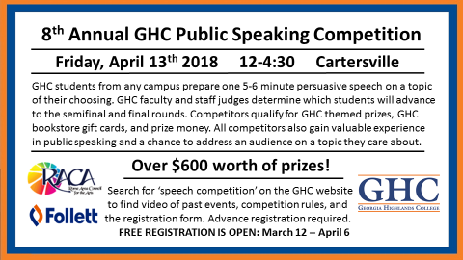
  - 5 points for college appropriate spelling, grammar, punctuation

Example of a Digital Sign made for the 2018 Speech Competition

Print off Workbook Three!

