GHHU 2901
Persuasion in Advertising

PART ONE
WORKBOOK

"Facts are irrelevant.
What matters is what the consumer believes."
- Seth Godin

NAME: __________________________________________________________________

Instructions
DO NOT LOSE THIS WORKBOOK

A. Complete the workbook entry before class.
This will include creating a ‘storyboard’ for each class period. These are worth points!
B. Use the workbook during class to facilitate class discussion.
C. The workbook includes all major assignment rubrics.

Humor / Virality in Advertising Workbook Entry 1 – Read the included materials, find appropriate examples, and complete storyboard assignment 1 due for points next class.

Virality: the tendency of an image, video, or piece of information to be circulated rapidly and widely from one Internet user to another; the quality or fact of being viral.

What is the last ad you remember going viral? ________________________________________
What made it go viral? (Why did you share or why did so many others share?) ______________
______________________________________________________________________________
______________________________________________________________________________
______________________________________________________________________________
______________________________________________________________________________

--

Funny Ads: Effective, or Just Good for a Laugh?
By Elizabeth S. Mitchell; July 16, 2012; Ad Week

If you’re going to sit through commercials while watching TV, ads that make you laugh – or at least smile – help to lessen the annoyance, and may even keep you from changing the channel or fast-forwarding. I mean, who hasn’t cracked a smile at the dancing M&M or Allstate’s personification of “Mayhem”?

But does getting an audience to laugh necessarily get them interested in a product or service? According to Advertising Age, a study done by Ace Metrix, which used a scoring system based on factors such as watchability, likability, and persuasion, found that while funny ads often get more attention and are better liked by the viewing audience, humor alone does not make an ad effective. In fact, ads that were simply funny were found to be slightly less likely to increase desire or purchase intent than informative, unfunny ones.

But that doesn’t mean humor doesn’t count. Peter Daboll, CEO of Ace Metrix, tells Advertising Age that to really work, an ad should be funny, relevant, and informative. “If you’re equal on relevance and information, almost always funny will win…because it drives the other scores like likability and attention,” Mr. Daboll said.

An example he gives of an ad campaign that successfully encompasses all of these factors is Procter & Gamble Co.’s ads from Grey Global Group that show blindfolded people smiling as they sniff the dirty, Febreze-treated workout gear of Azerbaijani wrestlers. This group of ads scores high for both humor and effectiveness. They work “because you’re not just going for a laugh but trying to get some of these other attributes in there,” said Mr. Daboll.

Fair enough. But effectiveness aside, I’d still rather watch Dean Winters as a lovesick teenage girl than ponder whether or not I’m “in good hands.”
--

Is Humor in Advertising Effective?
April 9, 2018 by Daniel Karell; PR and Advertising @ Point Park University Online

On the most basic level, something that connects all humans is laughter. Laughter is an important part of human psychology. It gives us a way to process all kinds of information, from funny stimuli to a situation where laughing is the only possible reaction because circumstances are tough. Humor grabs our attention, and that’s why it’s often used in advertising.

With people constantly using smart phones or distracted by conversation with others, TV advertisers have turned to humor with more frequency to catch the attention of consumers. Once the consumer is watching, the hope is that he or she enjoys the humor and remembers the product in the future. Many companies opt for bold, humorous TV advertising campaigns in front of a big audience, such as the Super Bowl or season finale of a popular show. Ultimately, a long humorous advertising campaign becomes part of pop culture and enters our daily vocabulary. Think of the Geico Caveman, Allstate’s Mayhem character, or the Old Spice muscle man. Injecting humor into an advertising campaign can make a lasting impression on consumer awareness.

Adding humor to an advertising campaign is a way for organizations to make an emotional connection with consumers. Humor tugs at our emotions, eliciting a positive emotion like laughter, which creates an impression. It also connects consumers to the commercial itself, and hopefully to the product being marketed. Our reactions to humor make it an effective tool for advertising. Humor in advertising:
-Grabs the audience’s attention
-Associates the positive emotion elicited from the advertisement with the brand
-Makes a lasting impression

A study from 1993 that still stands up today by the Journal of Marketing found that when looking at the effects of humor in advertising, “humor is more likely to enhance recall, evaluation, and purchase intention when the humorous message coincides with ad objectives, is well-integrated with those objectives, and is viewed as appropriate for the product category. Under such circumstances, humorous advertising is more likely to secure audience attention, increase memorability, overcome sales resistance, and enhance message persuasiveness.”

Humor in advertising can help connect consumers to a product that may seem dry or be a niche product on paper. For example, a company selling organic and natural beauty products may only be of interest to a subset of our society. But with a creative, funny and viral product campaign, it can at least increase brand awareness as consumers share the ad with friends. The ad is more likely to make its way to the specific subset, or even grow the market base.

--

The Visual Communication Guy: Designing, Writing, and Communication Tips for the Soul
The Humor Appeal (Advertising) September 15, 2017 Curtis Newbold

What is the Humor Appeal? The Humor Appeal is one of roughly twenty advertising strategies that marketing professionals use to persuade people to buy a product, pay for a service, donate to a cause, or otherwise be persuaded. The Humor Appeal persuades people to like a company, brand, product, service, or idea by making them laugh and feel good.

When Should I Use the Humor Appeal? The humor appeal is especially good when the product, service, or idea you are promoting is not particularly controversial and your intention is to create goodwill for your company. Be careful when using humor, though, that you don’t alienate the people you are trying to reach. Different types of humor appeals to different types of people. Recognize what will actually be funny (you never want to try to be funny and then fail) and take note of what your target audience may find offensive. The larger your target audience, the more broadly you want your humor to appeal. The more narrow your audience, the more niche kind of humor and even inside jokes you can pull off.

Humor requires creativity and ingenuity and it is best when tested on other people before launching it. Humor is especially good when using visual comparisons and metaphoric or idiomatic imagery that people will understand quickly. Consider using puns and other plays on words. Use language that is catchy and makes people smile.

Examples of Humor Appeals in Action
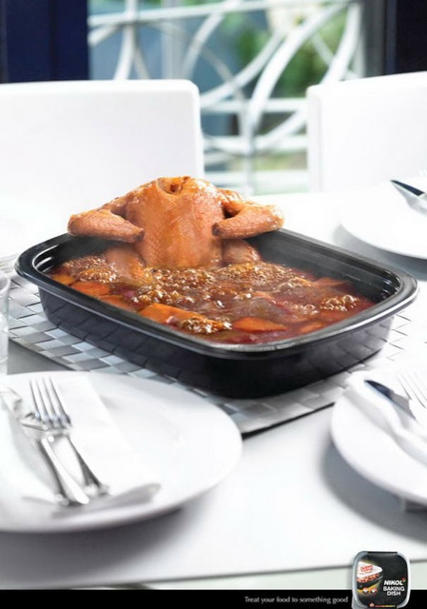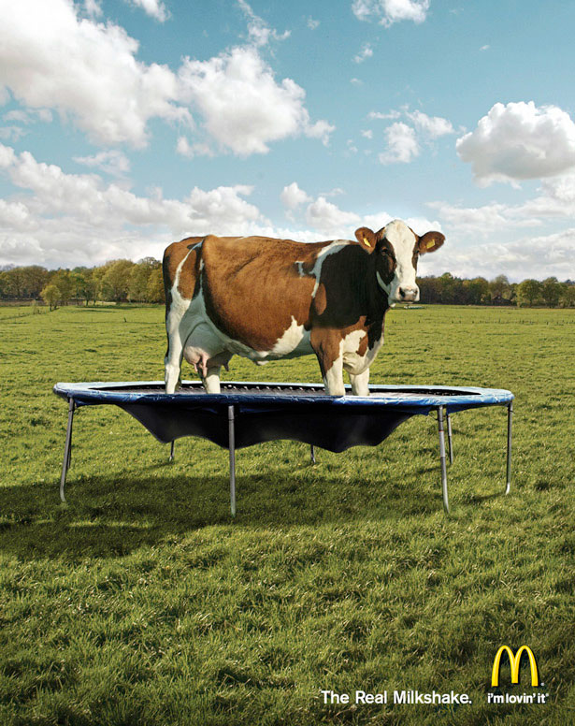

What does each author say about the effectiveness of humor in advertising?
#1 Mitchell ___________________________________________________________________________
______________________________________________________________________________
______________________________________________________________________________
#2 Karell _____________________________________________________________________________
______________________________________________________________________________
______________________________________________________________________________
#3 Newbold ___________________________________________________________________________
______________________________________________________________________________
______________________________________________________________________________

Identify two examples of relatively recent ads that you found humorous and answer the questions regarding each.
Example 1
What was the product/service being advertised? ______________________________________
What was the basic premise of the ad? ______________________________________________
______________________________________________________________________________
______________________________________________________________________________
______________________________________________________________________________
What did you final funny about it?__________________________________________________
______________________________________________________________________________
______________________________________________________________________________
______________________________________________________________________________

Example 2
What was the product/service being advertised? _______________________________________
What was the basic premise of the ad? ______________________________________________
______________________________________________________________________________
______________________________________________________________________________
______________________________________________________________________________
What did you final funny about it? _________________________________________________
______________________________________________________________________________
______________________________________________________________________________
______________________________________________________________________________
Continue to the storyboard assignment on the next page.
Storyboard assignment #1. Follow the prompts below to complete the assignment and share it next class for points.

Identify a food product you enjoy (any kind): ________________________________________
Come up with a concept for a 30 second advertisement storyboard for this product that tries to be funny, or has the qualities you think necessary to go viral. Use the storyboard spaces and lines to describe individual scenes and dialogue in your ad. Use the space/number of scenes necessary for the ad you imagine. Don’t work about artistic quality – stick figures are OK. See example.
Scene 1 | Scene 2 | Scene 3

Scene 4 | Scene 5 | Scene 6

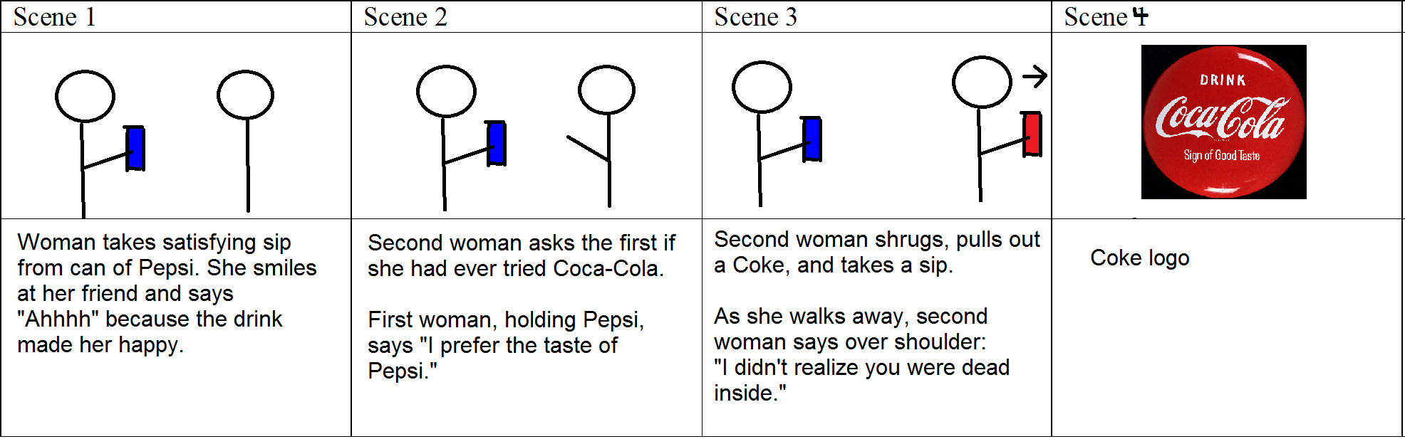
Slogans in Advertising; Workbook Entry 2 – Read the included materials, find appropriate examples, and complete storyboard assignment 1 due for points next class.

Long Slogans Are Absolutely, Positively More Effective Than Short Ones
By Al Ries. Published on September 07, 2010. AdAge.com

After three years of operations and $29 million in losses, Federal Express gave up trying to compete head-to-head with air-cargo leader Emery Air Freight. Instead, it decided to focus the company on overnight service. Federal Express could have positioned itself as: "The overnight company." But it didn't. Instead, it launched a campaign that not only turned around the brand, but also made marketing history: "When it absolutely, positively has to be there overnight." When Scarlett O' Hara said to Rhett Butler in "Gone with the Wind," "Rhett, if you go, where shall I go, what shall I do?" he could have said, "I don't care." But he didn't. What he said was: "Frankly, my dear, I don't give a damn." When Frank Perdue was the spokesperson for his chicken brand, he could have said, "Perdue, the tender chicken." But he didn't. What he said built the brand and also made marketing history: "It takes a tough man to make a tender chicken."

The shorter, the better. In spite of these and many other long-form slogans, the marketing industry seems fixated on the idea that when it comes to slogans, the shorter the better. As a matter of fact, they're rarely called "slogans" anymore. They're usually called "taglines" to indicate their diminished importance. Some examples.

Ally Bank: Straightforward.
Acura: Advance.
American Express: Take charge.
AT&T: Rethink possible.
CA Technologies: We can.
FedEx: We understand.
Fidelity investments: Turn here.
Ford: Drive one.
Goodyear: Get there.
Hertz: Journey on.
Infiniti: Inspired performance.
Lexus: Pursuing perfection.
Porsche: Intelligent performance.
Toyota: Moving forward.
Volkswagen: Das auto.

Short slogans like these, in my opinion, are not very effective. And it's not because they're short; it's because they're not very memorable. What makes a slogan memorable? Emotion. A slogan needs a dose of real emotion in order to make it memorable. "Overnight" articulates the FedEx position, but it needs "absolutely, positively" to add the emotional frosting to the positioning cake. Compare the old slogan with FedEx's new slogan, "We understand." You can visualize someone yelling into the phone, "My package absolutely, positively has to be in L.A. tomorrow." And the FedEx clerk on the other end of line calmly says, "We understand." The words have meaning, but there's no emotion in the concept of "understanding."

Sure, slogans should be as short as possible, but there's a trade-off. Slogans should be long enough to contain some words that knock on the right side of the consumer's brain. The emotional side of the brain as opposed to the left side, the logical, analytical side. "Just do it" is one of those slogans. It's memorable because the slogan emotionally touches a "procrastination" button that exists on the right side of your brain. "Why keep thinking about it? Just do it." "A diamond is forever" is also a memorable slogan for exactly the same reason. It touches a "love" button on the right side, especially among women.

Memorable slogans are usually long.
In truth, it's difficult to find many short slogans that are memorable. Most of the slogans people remember are relatively long.

Ace Hardware: "Ace is the place with the helpful hardware man." (9 words)
Avis: "Avis is only No.2 in rent-a-cars, so why go with us? We try harder." (12 words)
Dyson: "The first vacuum cleaner that doesn't lose suction." (8 words)
Geico: "15 minutes can save you 15 percent or more on car insurance." (12 words)
Las Vegas: "What happens in Vegas, stays in Vegas." (7 words)
M&M's: "Melts in your mouth, not in your hands." (8 words)
The New York Times: "All the news that's fit to print." (7 words)
Reese's peanut butter cups: "Two great tastes that taste great together." (7 words)
Reno, Nevada: "The biggest little city in the world." (7 words)
Roto-Rooter: "That's the name and away go troubles down the drain." (10 words)
Saturn: "A different kind of company. A different kind of car." (10 words)
Secret deodorant: "Strong enough for a man, but made for a woman." (10 words)
Smuckers: "With a name like Smuckers, it's got to be good." (10 words)
Splenda: "Made from sugar so it tastes like sugar." (8 words)

Owning a word can take many words. While the objective of a marketing strategy should be to "own a word in the mind," the tactics to do so might involve a number of words. Mercedes-Benz owns "prestige" in the mind even though it has (rightly so) never used the word in its advertising. Rather, Mercedes built its prestige position with high prices and a very effective advertising slogan, "Engineered like no other car in the world."

Volvo is an example of a lazy approach to branding. Apparently, Volvo management thinks, "We own 'safety' so all we need to do is to remind people of that fact." Hence the current Volvo slogan, "For life." For life? That's a pretty anemic way of alluding to a major problem in America, the annual carnage on our highways. Last year, there were 33,963 traffic deaths, by a wide margin, the No.1 cause of accidental death in America. Sure, traffic deaths are declining, but the reason is probably better and faster medical help, not fewer accidents. (If you compare the war in Iraq to the war in Vietnam, you will find similar statistics. Fewer deaths per hundred casualties.) "For life" is an insipid slogan to deal with the issue of automobile safety. You might expect the company to get angry and express the issue in an emotional way. Something like the current seat-belt campaign. The posters don't say: "Seat belts for safety." They say: "Click it or ticket." Ironically, Volvo's new chief executive, Stefan Jacoby, was portrayed in The Wall Street Journal last month as looking for ways "to pump more emotion into the brand." One of the ways Mr. Jacoby is considering, according to the Journal, is by "going retro."

I have a suggestion. Why doesn't Volvo launch a full-bore campaign for automobile safety, starting with the dropping of Volvo sports cars and convertibles? Why not do for "safety" what Dove has done for "real beauty." Another idea being considered by Volvo, according to the Journal, is "creating bigger and more luxurious cars." Why is it that management's solution to every problem usually involves expanding the brand? This can work to some degree when a brand is strong. But it's usually a serious error when a brand is weak. Study history, Mr. Jacoby. Volvo was once on a roll, buttressed by reams of safety publicity. As recently as 1992, Volvo was the largest-selling European premium car brand in the U.S. market, outselling BMW, Mercedes-Benz, Audi and Jaguar. How the mighty have fallen. Last year, both BMW and Mercedes each sold more than three times as many vehicles in the U.S. market as Volvo. Even Audi outsold Volvo.

Narrowing the focus at Folgers. Brand expansion is the direct cause of weak slogans. A broad line often encompasses many products with little in common, forcing the use of platitudes and generalities. Yet you sometimes can develop strong slogans for line-extended brands by concentrating on one aspect of the brand. Take Folgers long-running slogan "The best part of wakin' up is Folgers in your cup." Why would a coffee brand focus on breakfast when coffee is consumed all day long? (Check out your local Starbucks at 5 p.m.) The same reason Federal Express focused on overnight delivery. If you "narrow the focus," you can often create a slogan with a strong, emotional component. And you can do so without giving up any segment of the market. "If it's good at breakfast, it's bound to be good the rest of the day," thinks the consumer. Like Folgers, FedEx never did give up anything either. From Day One, it has always provided two-day and three-day services. Compare Folgers with Maxwell House and its "Good to the last drop" slogan. Actually the new slogan is: "Be good to the last drop," a one-word extension to the brand's longtime positioning. Where's the emotional resonance with a slogan like that? Actually, it's confusing. I don't want to "be good to the last drop." I want the last drop to be good to me. The superiority of Folgers approach is documented by sales. Two decades ago, Folgers led Maxwell in ground coffee by 30%. Last year, Folgers' lead was 73%.

Yet I wonder whether the advertising community would agree with me. Creative people tend to prefer shorter slogans. Advertising Age selected "Good to the last drop" as one of the top 100 advertising campaigns of the 20th century (No. 15.) "The best part of wakin' up" didn't make the list.

Thinking narrowly isn't logical. Logic suggests that you want a slogan that's all inclusive. Let's reach out and touch everybody. And furthermore, let's cram as many ideas as we can into our slogan (as well as keep it short.) Walmart management probably thinks its current slogan, "Save money. Live better," is an improvement over "Always the low price. Always." The new slogan tells consumers what they can do with the money they save by shopping at Walmart. It's a broader, more-inclusive slogan. But it doesn't touch an emotional button the way that "Always the low price. Always," did. The repetition of the word "always" suggests that when you absolutely, positively want to save money, shop at Walmart.

And why would United Airlines drop "Fly the friendly skies of United" in favor of "It's time to fly"? Where is the emotion in "It's time to fly"? Sounds like what a desk clerk might say when announcing the departure of a flight. And why would Avis drop "Avis is only No. 2 in rent-a-cars, so why go with us?" Actually I know why. They're no longer No.2. But without the buildup, its current slogan, "We try harder," seems lame. It lacks emotion.

Adding a word. Sometimes you can dramatically improve a slogan by adding a single word. "The driving machine" says essentially the same thing as "The ultimate driving machine," but without the emotional impact. Same thing as "The driver's car," the headline of a BMW advertisement that pre-dated the "ultimate" campaign. And I suppose the BMW folks are congratulating themselves for "Joy," their new master slogan with "The ultimate driving machine" relegated to a secondary position. It was bound to come. Master slogan and sub-slogans are analogous to master brand and sub-brands. Marketing is like the income tax. Every year it gets more complicated. "Don't squeeze the Charmin," could have been Mr. Whipple's rallying cry. But Procter & Gamble wisely added an additional word. "Please don't squeeze the Charmin." That provided the emotional kick to the phrase as well as a rhyme. And Charmin went on to dominate the toilet-tissue market.

When Abraham Lincoln was asked how long a man's legs should be in proportion to his body, he replied, "They ought to be long enough to reach the ground." How long should a slogan be? It should be long enough to reach an emotional connection in the consumer's mind.

--
Impact of Slogans on Branding
by Kumail Hemani; 3-26-2012; Social media Today

Words change meanings. In our daily life, we listen and say many things to justify our conversation - some words stay out in our mind, many go away with time. With human psychology, nobody can remember everything but when I say "Connecting People" your mind may immediately pick up that I am talking about Nokia. Although slogans work slowly, they are effective and their hold is long lasting.

Great advertising always earns extra credit whether we talk about banner advertisement or TV commercials or any other digital advertising; however, when we talk about slogans, there are many things we should keep in mind i.e. they should be memorable, conceptual, state a mission (elaborate company goal), predictable and actionable. I have managed 7 points to illustrate how a slogan works, the impact of slogan and why we should create one.

1. Why slogans are a must have. Why it is the important part of branding? A slogan is not just a tag-line that advertisers create; they play a strategic game; in the long run, good slogans play with customer's mind making it believe yours is a reliable product. So, companies keep experimenting until they get a perfect piece. McDonald's is the best example: They kept changing their slogans until 2003 when they found a perfect tag line "I'm lovin' it". This according to the company was ideal representation of their brand as they want each client to feel the same after using there service. Thus it was a perfect seller and ultimate reminder for the service of McDonalds! The slogans give a good feeling to the consumers of McDonald's and they actually feel happy going around with their family. Of course, slogans will not put you high up on the SERPs - but they sure do put you high up on the customer's mind and isn't that a SE you want your product to be high up on? Slogans make your brand easy to recall, remember and identify when it counts most, they make your brand more seem reliable. Pro Tip: should be complete, emotionally attached, and reliable.

2. How Slogans can be shadows for any brand. Creating a prominent identity is what every brand desires and so getting an extra identity is surely a bonus. Slogan is sewed with your brand name and is used everywhere along with it ... so it technically works as a shadow for your brand name. A brand name can not stand alone as compressed communication to speak for the brand. Thus brand slogans have a key role in communicating the essence of a brand. Slogan is deputized for branding as it is more impact full and gives meaning to the noun. Slogan is appealing as well as elaborate as compared to the one word noun. A phrase with a meaning is apparently easier for people to relate to and remember thus the impact of brand noun is accentuated with its shadow i.e. slogan. Pro tip: slogans should speak for the brand.

3. How slogans can make things actionable and can make your product / service desirable. Be it just a sales hook or real meaning for the brand, a slogan actually works as a DNA for any brand. A truly successful slogan, if it is to continue to stay successful, is not just a benefit but a commitment - it is what the brand stands for! This DNA for the brand does not only attract the customers but also the management and employees working under the name. Many times a slogan is actually a précis of the enterprise and is designed to mirror the commitment and loyalty of its employ us at the work place. Thus they remind the management as well the buyers the real meaning for the brand, which eventually works magic for the company and increases revenue. Pro Tip: slogans should represent the real essence of the brand

4. How slogans can work to build a strong relation with client. Moreover, slogans can also work as bridge between the clients and brand to build and strengthen the relationship. Since it gives meaning to the name, it can create feelings and attract people towards it. Thus, a person can relate and eventually be incline towards the brand resulting in increase of Return on Investment. Pro Tip: Must relate to everyday life situations in a way or another and Slogans should touch user on an emotional level.

5. Memorable hit by Slow Guns = Slogans. Slogans are usually based on 2 to 5 easy to remember words, long lines are hard to memorize so the shorter the better! The message they leave and what picture they sketch in our minds when someone reads, hears or simply 'sees' a slogan is crucial. Since brand name can not specify the essence of your business, you have to make something memorable that represents your brand. You should keep an eye on the sound it produces and the 'nerves' it touches when it strikes the customer's mind. Here is one: "Good to the Last Drop". It is simple, catchy, short and easy to remember and it perfectly defines the brand. IMO, you can't help but pay extra attention to that last sip of java. It makes the person feel the taste and remind them of the slogan "Good to the last drop". Pro Tip: slogans should be simple, cathy, short and easy.

6. Slogans should be predictable. Slogans should be easily predictable. What I mean by predictable is, "Good to the Last Drop" we can easily guess that it is talking about something that is drinkable. "Melt in mouth not in your hand" it can be said about chocolate or ice-cream. These slogans are easily predictable and give identity to their brand. Pro Tip: slogans should be predictable.

7. Slogans elaborate perspective for different organizations. Slogans also work best to display the real perspective for any business, this way it can attract the targeted audience easily and can also connect with them emotionally. For instance take an NGO or a charity website. Water 4 Kids have a slogan "Hope through Safe Water". This slogan does not only clarify the real job they do but also arouses sentiments. Pro Tip: Define the aim of product

Last Thought: After the good stand of your business representation, for example Nokia, when they launch new product, they don't need to do marketing for every launched product, then who does marketing for the new and upcoming products? Answer is: We! We all, who are interested in mobile technology does their work for FREE! So after a successful brand its community does their work. We can ask about the slogans from our audience to understand how they see the slogan as it is also responsible for the revenue of business. We can't visualize how slogan is impacting on our brand but it is definitely fruitful in the long term. We all make slogans to disclose ourselves in short words, I see myself as "Positive Thinker and Non-Stop Fun" as my name "Kumail" isn't enough to describe myself.

--

What does each author say about the design of slogans in advertising?
#1 Ries ___________________________________________________________________________
______________________________________________________________________________
______________________________________________________________________________
#2 Hemani
______________________________________________________________________________
______________________________________________________________________________
______________________________________________________________________________
Identify two examples of slogans that you found effective & answer the questions regarding each.
Example 1
What was the product/service being advertised? ______________________________________
What was the slogan? ____________________________________________________________
______________________________________________________________________________
Why was it effective or memorable for you? _________________________________________
______________________________________________________________________________
______________________________________________________________________________

Example 2
What was the product/service being advertised? ______________________________________
What was the slogan? ____________________________________________________________
______________________________________________________________________________
Why was it effective or memorable for you? _________________________________________
______________________________________________________________________________
______________________________________________________________________________

Storyboard assignment #2. Follow the prompts below to complete the assignment and share it next class for points.

Identify a household product you use (any kind): ____________________________________
Come up with a concept for a 30 second advertisement storyboard for this product that features a new slogan of your invention. Use the storyboard spaces and lines to describe individual scenes and dialogue in your ad. Use the space/number of scenes necessary for the ad you imagine. Don’t work about artistic quality – stick figures are OK. See example on Workbook page 6.
Scene 1 | Scene 2 | Scene 3

Scene 4 | Scene 5 | Scene 6
Kairos in Advertising; Workbook Entry 3 – Read the included materials, find appropriate examples, and complete storyboard assignment 1 due for points next class.

Setup: Creating a sense of urgency in an advertisement is all about making the consumer feel rushed. Often, this is accomplished by suggesting supply scarcity. An ad might suggest that a certain offer is only available for “a limited time” or “while supplies last” to encourage people to rush out and buy the product. Urgency is part of the classical rhetorical concept Kairos, which deals with the right timing and time-related persuasiveness of messages.

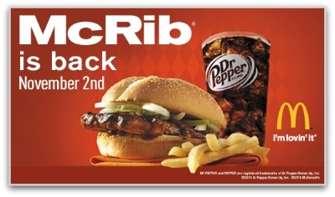
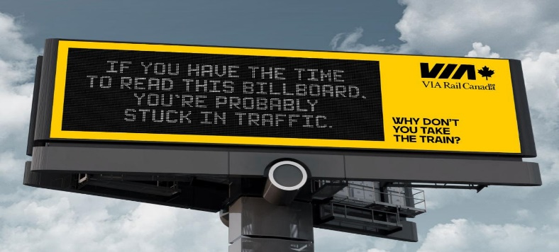
-McRib ad creates a sense of anticipation and urgency. ‘I have to get it before they run out!’
-Greenpeace ad is timely – ocean plastics, wildlife, and climate change are salient – we’ve all been talking about it.
-VIA ad is positioned at the perfect place and time. The ad only seen by people stuck in traffic there, and those are the target audience.

What is the last ad you remember that seemed to rush you to make a purchase? _____________ _____________________________________________________________________________
How did it make the consumer feel rushed? How did it create urgency? ____________________
_____________________________________________________________________________
What is the last ad you remember that seemed perfect for a given moment? _________________
_____________________________________________________________________________

What made it such a good fit? (What made it kairotic?) _________________________________
_____________________________________________________________________________
--
Kairos – Curtis Newbold, 2013 – The Visual Communication Guy
Kairos refers to the opportune moment. People are often more persuaded at different moments in time than others. For example, people are often more likely to give to charitable organizations after they have seen firsthand or been involved in a disaster of their own. Think about when you were a child; did you ask your parents for things when you knew they were in a bad mood to begin with? Most likely, you waited for the right moment to ask. Kairos is all about finding the opportune time to persuade your audience. If you want to invite people to a party, but you invite them three months in advance, they may forget. If you invite them the day before, they may have other plans. As the saying goes, timing is everything.

--
Kairos – Joseph Moxley (editor) – Writing Commons.org - 2012
"Kairos" is an ancient rhetorical concept that has gained importance in different disciplines over the centuries. So what is it? Kairos is knowing what is most appropriate in a given situation; for our purposes, let's think of it as saying (or writing) the right thing at the right time.
Appeals to kairos in written form try to make use of the particular moment—attempting to capture in words what will be immediately applicable, appropriate, and engaging for a particular audience. Kairos is timeliness, appropriateness, decorum, symmetry, balance—awareness of the rhetorical situation or "the circumstances that open moments of opportunity" (Kinneavy; Sipiora; Vatz; Bitzer; Hill 217). Kairos is crafting serendipity, like when the sun comes out at the end of a romantic comedy after all the conflicts have been resolved.
In Greek, both kairos and chronos literally mean "time," but kairos does not mean "time" in the same sense as used in contemporary English. In Greek, kairos represents a kind of "qualitative" time, as in "the right time"; chronos represents a different kind of "quantitative" time, as in, "What time is it?" and "Will we have enough time?" (Kinneavy; Stephenson). Kairos means taking advantage of or even creating a perfect moment to deliver a particular message.
Consider, for example, Dr. Martin Luther King Jr.'s famous "I Have a Dream" speech. The speech was rhetorically powerful: it changed minds, persuaded people to support the civil rights movement, and served as a powerful rallying cry for a generation of reformers. But the speech was so powerful in part because of its kairotic moment: the timing and atmosphere of the speech lent themselves to powerful oratory. Together, the "where" (the steps of the Lincoln Memorial in Washington, D.C.), the "why" (the culmination of a march on Washington by thousands of members of the civil rights movement), and the "when" (during the centennial celebration of the Emancipation Proclamation, at a time of day when broadcast networks could carry the speech live, and during a march which had drawn more than 250,000 people to the capital) created the perfect moment for King's message to reach the largest number of receptive listeners.
Although kairos has long been a key word for many disciplines, within the study of writing, kairos has been the topic of much debate in the last few decades. James Kinneavy is largely credited with reintroducing the importance of kairos into the discipline of Rhetoric and Composition and, thus, the composition classroom. According to Kinneavy, kairos is "the appropriateness of the discourse to the particular circumstances of the time, place, speaker, and audience involved" (84). Other scholars suggest that "kairos refers to a struggle, at the point of rhetorical intervention, between situational factors" (Sheridan, Michel, and Ridolfo). Both definitions get at the elusive, jaguar-in-the-jungle nature of kairos. Kairos is so hard to pin down because, as Phillip Sipiora suggests, it is "a dynamic principle rather than a static, codified rhetorical technique" (10). So, the rhetor must be "accomodative," waiting for the right time, matching her text to the precise moment in order to be most successful (Sipiora). It's sort of the Goldilocks rule of writing: you don't want your message to be too big, too small, too soft, or too hard; it should be just right.
So far, kairos seems pretty slippery, a sort of "I'll know it when I see it" kind of principle. In some ways, kairos represents the ephemeral, "fleeting" nature of "the right time." In terms of writing, we try to capture the moment of balance, the kairotic moment, and thus move the audience by appealing to that specific context.
Because kairos is so tied to the particular moment, or rhetorical situation, it is hard to provide concrete examples out of context. But a good way to think about kairos is to consider how rhetors try to persuade audiences based on unique timing and current events. For instance, consider the way restaurants, bookstores, and various campus entities appeal to incoming freshman students. Vendors have signs declaring "New to USF? Join this club to meet new people and learn about the campus!" and "First-year students, this week only: $100 off your first month at this apartment building!" They reference the particular moment, first stepping onto a new campus, to persuade you to do everything from opening a new bank account and buying logo bumper stickers to ordering a dozen pizzas. Effective uses of kairos take advantage of the particular time and place to make texts unique and give them a sense of immediacy.
Kairos is undoubtedly a pretty heady term, something with which ancient philosophers, modern rhetoricians, and contemporary composition students have wrestled. But it's worth wrestling with. For your own writing, you can skillfully employ kairos by doing the following:
- Examine the rhetorical situation, the factors that create that particular moment.
- Consider the order and timing of your text.
- Be accomodative; appeal to each specific context.
By using kairos as a guiding principle for your own texts, you can bring interest and timeliness to your writing projects. So when you begin to write, think of the moment that your writing will enter into—the audience that will read it, the conversation that it joins, the history surrounding the topic, and the words you use to craft your argument. Awareness and use of this knowledge create beautiful writing that, like turning the key in your door at the end of a long day, seems perfectly timed, effortless, and just right.
By now, you should know what kairos is: an attempt to persuade through appeals to timeliness. Here are a few possible examples of kairos:
- The call to "Act Now!" An appeal to some particular fast-approaching moment is often a rhetor's attempt to create a perfect kairotic moment for his or her message by creating a sense of urgency. You've likely seen a commercial or infomercial that pleads with the viewer to "Call now!" to receive some important prize or to avoid missing some sort of opportunity; this type of commercial or informercial employs kairos.
- The use of deadlines or goals. Such appeals to kairos are often seen as part of fundraising literature: by connecting a reader's or listener's response to a particular deadline or goal, the writer creates urgency and excitement.
- References to "current crises" or impending doom. Such references are prevalent in political and social campaigns. Consider, for example, the large number of financial bills, laws, and investigations undertaken by legislative bodies throughout the country after the most recent economic recession. Lawmakers were responding to and taking advantage of the kairotic moment created by the crisis in order to persuade their fellow lawmakers and constituents to support a particular fiscal policy.
--
What are the most important aspects of Kairos according to the Writing Commons piece ?
__________________________________________________________________________________________________________________________________________________________________________________________________________________________________________
________________________________________________________________________________________________________________________________________________________________________________________________________________________________________________________________________________________________________________________
Identify two examples of Kairotic ads that you found & answer the questions regarding each.
Example 1
What was the product/service being advertised? ______________________________________
What was the premise of the ad? ___________________________________________________
______________________________________________________________________________
Why was it kairotic for you? ______________________________________________________
______________________________________________________________________________
______________________________________________________________________________

Example 2
What was the product/service being advertised? ______________________________________
What was the premise of the ad? ___________________________________________________
______________________________________________________________________________
Why was it kairotic for you? ______________________________________________________
______________________________________________________________________________
______________________________________________________________________________

Continue to storyboard assignment on next page.
Storyboard assignment #3. Follow the prompts below to complete the assignment and share it next class for points.

Identify a household product you use (any kind): ____________________________________
Come up with a concept for a 30 second advertisement storyboard for this product that features kairos – the ad is in the right place and time and creates a sense of urgency. Use the storyboard spaces and lines to describe individual scenes and dialogue in your ad. Use the space/number of scenes necessary for the ad you imagine. Don’t work about artistic quality – stick figures are OK. See example on Workbook page 6.
Scene 1 | Scene 2 | Scene 3
What about this is the ‘right’ place and time?

Scene 4 | Scene 5 | Scene 6

Sophistry in Advertising; Workbook Entry 4 – Read the included materials, find appropriate examples, and complete storyboard assignment 1 due for points next class.

Sophistry (Merriam-Webster)

The original Sophists were ancient Greek teachers of rhetoric and philosophy prominent in the 5th century B.C. In their heyday, these philosophers were considered adroit in their reasoning, but later philosophers (particularly Plato) described them as sham philosophers, out for money and willing to say anything to win an argument. Thus sophist (which comes from Greek sophistēs, meaning "wise man" or "expert") earned a negative connotation as "a captious or fallacious reasoner." Sophistry is reasoning that seems plausible on a superficial level but is actually unsound, or reasoning that is used to deceive.
--
There are two ways we can think about how Sophistry applies to advertising:
- Distraction: Some advertising does what it must to make a weak product seem stronger. Recognizing the sophistry is recognizing what is being used to distract from the weakness in the product. This is not outright lying, but rather finding the best things to say about a product and ignoring anything else. In imagery, this includes finding ways to show a product in the best possible light, angle, etc.
- False Information: Some advertising deliberately misleads or provides demonstrably false information about a product. This is illegal (and subject to regulatory oversight in the United States by the Federal Trade Commission) but since ads are not screened by the government before airing, some misleading or false ads may air for a long time before enough complaints triggers a government review.
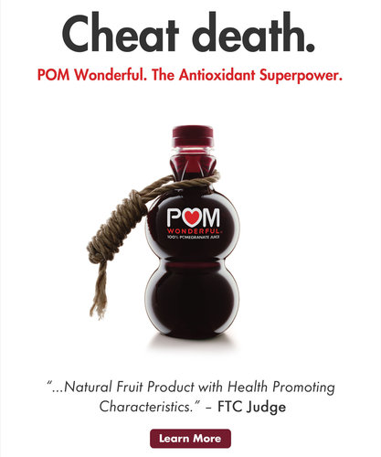
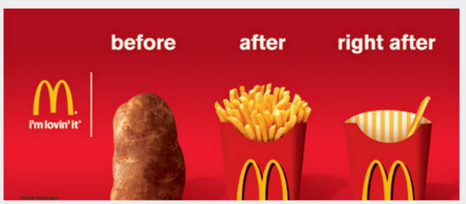
Which examples above are Sophistry as distraction or as false information?
Identify an example of a recent ad using distraction that you found & answer the questions.
What was the product/service being advertised? ____________________________________
What was the premise of the ad? __________________________________________________
_____________________________________________________________________________
What about it did you see as a distraction from a weakness of the product? _________________
____________________________________________________________________________________________________________________________________________________________
Identify an example of a recent ad using false information you found & answer the questions.
What was the product/service being advertised? ____________________________________
What was the premise of the ad? __________________________________________________
_____________________________________________________________________________
What about it did you see as including false information about the product? _________________
____________________________________________________________________________________________________________________________________________________________
--
18 false advertising scandals that cost some brands millions
Julien Rath; Feb. 27, 2017, Business Insider

It doesn't pay to deceive the public. In advertising, there's a big difference between pushing the truth and making false claims.

Many companies have been caught out for peddling mediocre products, using wild claims like "scientifically proven" with "guaranteed results." For companies that cross the line, it can cost millions and lead to a damaged reputation. We found 18 examples of false advertising scandals that have rocked big brands — some are still ongoing and not all companies have had to pay up, but each dealt with a fair amount of negative publicity.

Uber was forced to pay $20 million to settle claims brought to the FTC alleging the ride hailing service had inflated the hourly earnings for drivers in its online advertisements. The FTC started investigating Uber in 2015 and finished its investigation at the beginning of 2017. In a statement Uber said: "We've made many improvements to the driver experience over the last year and will continue to focus on ensuring that Uber is the best option for anyone looking to earn money on their own schedule."

Activia yogurt said it had "special bacterial ingredients." Ads for Dannon's popular Activia brand yogurt landed the company with a class action settlement of $45 million in 2010, according to ABC News. The yogurts were marketed as being "clinically" and "scientifically" proven to boost your immune system and able to help to regulate digestion. The Activia ad campaign, fronted by actress Jamie Lee Curtis, claimed that the yogurt had special bacterial ingredients. As a result, the yogurt was sold at 30% higher prices than other similar products. However, the Cleveland judge overseeing the case said that these claims were unproven. The lawsuit against Dannon began in 2008, when consumer Trish Wiener lodged a complaint. On top of the fine of $45 million, Dannon was ordered to remove "clinically" and "scientifically proven" from its labels, according to ABC. Phrases similar to "clinical studies show" were deemed permissible. Dannon denied any wrongdoing and claimed it settled the lawsuit to "avoid the cost and distraction of litigation."

DraftKings and FanDuel exaggerated novice users' chances of winning. The two biggest fantasy sports companies were ordered to pay $6 million each in 2016 to settle multiple false advertising lawsuits, Fortune reported. At the heart of the complaints was that both companies misrepresented the chances casual and novice players had of winning cash prizes and the chance to earn positive returns on their entry fees. It resulted out of an investigation that showed professional and high-volume players used automated computer scripts and sophisticated statistical game theory to achieve huge payoffs. According to a statement from the New York AttorneyGeneral the "settlement agreements impose the highest New York penalty awards for deceptive advertising in recent memory." According to Bloomberg, the merger discussions between both companies is progressing.

VW falsely advertised environmentally friendly diesel cars. In 2016, the Federal Trade Commission (FTC) filed a lawsuit against Volkswagen, which claimed the car company had deceived customers with the advertising campaign it used to promote its supposedly "Clean Diesel" vehicles, according to a press release. The year prior, it was exposed that VW had been cheating emissions tests on its diesel cars in the US for the past seven years. The FTC alleged that "Volkswagen deceived consumers by selling or leasing more than 550,000 diesel cars based on false claims that the cars were low-emission, environmentally friendly." On top of potential fines for false advertising, the company could have to pay out up to $61 billion for violating the Clean Air Act, according to Wired. The total settlement for Dieselgate was estimated to have reached $15 billion.

Tesco was criticized for an ad in response to the horse meat scandal, which suggested the problem affected "the whole food industry." In 2013, UK supermarket chain Tesco was criticized after it ran a "misleading" ad campaign in the wake of its horse meat scandal, according to The Telegraph. The supermarket had been caught selling beef contaminated with horse meat in some of its burgers and ready meals. In an attempt to recover from the PR disaster, Tesco ran a two-page spread in national newspapers with the headline "What burgers have taught us." In the ad, Tesco was criticized for implying that the whole meat industry was implicated in the horse meat fiasco, which was untrue. The UK advertising regulator ASA banned the campaign. Nearly £300 million ($432 million) was wiped off the value of Tesco following the horse meat scandal, according to The Guardian.

Red Bull said it could "give you wings." Energy drinks company Red Bull was sued in 2014 for its slogan "Red Bull gives you wings." The company settled the class action case by agreeing to pay out a maximum of $13 million — including $10 to every US consumer who had bough the drink since 2002. The tagline, which the company has used for nearly two decades, went alongside marketing claims that the caffeinated drink could improve a person's concentration and reaction speed. Beganin Caraethers was one of several consumers who brought the case against the Austrian drinks company. He said he was a regular consumer of Red Bull for 10 years, but that he had not developed "wings," or shown any signs of improved intellectual or physical abilities. Red Bull released this statement following the settlement: "Red Bull settled the lawsuit to avoid the cost and distraction of litigation. However, Red Bull maintains that its marketing and labeling have always been truthful and accurate, and denies any and all wrongdoing or liability."

New Balance said its shoe could help wearers burn calories. New Balance was accused of false advertising in 2011 over a sneaker range that it claimed could help wearers burn calories, according to Reuters. Studies found that there were no health benefits from wearing the shoe. The toning sneakers claimed to use hidden board technology and were advertised as calorie burners that activated the glutes, quads, hamstrings, and calves. Plaintiffs in the lawsuit claimed to have been harmed and misled by the sneaker company. On August 20, 2012, New Balance agreed to pay a settlement of $2.3 million, according to The Huffington Post.

Lumos Labs said Luminosity could help prevent Dementia. In January 2016, the makers of popular brain-training app Luminosity were given a $2 million fine from the Federal Trade Commission, which said the company deceived players with "unfounded" advertising claims. The app company made false claims about being able to help prevent Alzheimer's disease, as well as aiding players to perform better at school, the FTC found. Luminosity said in its ads that people who played the games for more than 10 minutes, three times a week would release their "full potential in every aspect of life," according to Time. Jessica Rich, a director at the FTC said: ""Lumosity simply did not have the science to back up its ads."

Kellogg said Rice Krispies could boost your immune system. Kellogg's popular Rice Krispies cereal had a crisis in 2010 when the brand was accused of misleading consumers about the product's immunity-boosting properties, according to CNN. The Federal Trade Commission ordered Kellogg to halt all advertising that claimed that the cereal improved a child's immunity with "25 percent Daily Value of Antioxidants and Nutrients — Vitamins A, B, C and E," stating the the claims were "dubious." The case was settled in 2011. Kellogg agreed to pay $2.5 million to affected consumers, as well as donating $2.5 million worth of Kellogg products to charity, according to Law360.

Airborne claimed it could help ward off harmful germs. Herbal supplement Airborne was a national hit throughout the 1990s. Marketing of the product claimed that it helped ward off harmful bacteria and germs, preventing everyday ailments like the flu and common cold. There were no studies to support Airborne's effectiveness claims that met scientific standards — so the Center for Science in the Public Interest (CSPI) got involved. The high-profile scandal ended with a huge settlement, with Airborne having to pay $23.3 million in the class-action lawsuit, and an additional $7 million settlement later, according to NPR.

Wal-Mart falsely advertised the price of Coke in New York. Wal-Mart agreed to pay more than $66,000 in fines, after over-charging customers from 117 stores in New York for Coca-Cola. The supermarket chain had advertised a nationwide sale on the soft drink in 2014, where 12-packs would cost just $3.oo. However, customers in New York State were charged $3.50. Wal-Mart staff allegedly lied about the reasons for the price-hike, telling customers that New York has a "sugar tax," according to Corporate Crime Reporter. New York Attorney General Eric Schneiderman, who conducted the investigation, concluded the price violated New York State's General Business Law 349 and 350.

Hyundai over-sold its cars' horsepower. Hyundai agreed to pay more than $85 million in a settlement in 2004, after it overstated the horsepower of cars imported to the US, according to Consumer Affairs. The class action lawsuit was on behalf of around 840,000 people who bought the 1996 to 2002 models of the Hyundai Elentra sedans and the Tiburon sport coupes. In 2001, the Korean Ministry of Construction and Transportation had uncovered the misrepresentation, which, for some models, overstated horsepower by 10%. The class action lawsuit was brought in southern California in September 2002. After it was settled in 2004, Hyundai sent letters offering prepaid debit cards to affected owners. They were worth up to $225.

Later, Kellogg said Mini-Wheats could make you smarter. In 2013, Kellogg was in even more trouble. The company agreed to pay $4 million for false advertising claims it made about Frosted Mini-Wheats. The cereal company had falsely claimed that the Mini-Wheats improved "children's attentiveness, memory and other cognitive functions," according to Associated Press. The ad campaign claimed that the breakfast cereal could improve a child's focus by nearly 20%. In its defense, Kellogg said that the ad campaign ran four years previously and that it had since adjusted its claims about the cereal. Kellogg also noted that it "has a long history of responsible advertising." People who consumed the cereal during the time the ad ran (January 28, 2009 to October 1, 2009) were allowed to claim back $5 per box, with a maximum of $15 per customer, according to Associated Press.

Extenze claimed it could extend penis length. The maker of penis enlargement pill Extenze agreed to pay $6 million to settle a class action lawsuit in 2010, according to CBS. Extenze had claimed its pills were "scientifically proven to increase the size of a certain part of the male body" in notorious late night TV commercials. Extenze agreed to pay $6 million to settle a false advertising class action lawsuit. CBS noted that its website was also updated to say: "These statements have not been evaluated by the Food and Drug Administration. Extenze is not intended to diagnose, treat, cure, or prevent any disease."

Splenda said it was "made from sugar. The Sugar Association asked for an investigation into alternative sweetener Splenda's "Made from Sugar" slogan. It complained that the tagline was misleading, and that the sweetener is nothing more than "highly processed chemical compound made in a factory," CBS reported. In 2007, a resulting lawsuit led by the makers of rival sweetener Equal, settled against Splenda. Equal was looking for $200 million from Splenda in the settlement for unfair profits. However, the exact amount of the settlement remains confidential, according to NBC.

L'Oreal claimed its skincare products were "clinically proven" to "boost genes." In 2014, cosmetics company L'Oréal was forced to admit that its Lancôme Génifique and L'Oréal Paris Youth Code skincare products were not "clinically proven" to "boost genes" and give "visibly younger skin in just seven days," as stated in its advertising. According to the FTC, the claims were "false and unsubstantiated." In the settlement, L'Oréal USA was banned from making claims about anti-aging, without "competent and reliable scientific evidence substantiating such claims," the FTC said. Though L'Oreal escaped a fine at the time, each future violation of this agreement will cost the company up to $16,000.

Eclipse said its gum could kill germs. Eclipse gum claimed in its ads that its new ingredient, magnolia bark extract, had germ-killing properties. A lawsuit brought by consumers alleged that the ads were misleading, according to Businessweek. Wrigley denied wrongdoing, but was ordered to pay more than $6 million to a fund that would reimburse consumers up to $10 each for the misleading product, in 2010.

Classmates.com was accused of tricking users into paying to respond to friends, who weren't actually on the site. Millions of people lit up when Classmates.com sent them an email saying old friends were trying to contact them, promising to rekindle old friendships and flames if subscribers upgraded to a "Gold" membership. But with the upgrade, the expected reunions never came. It turns out the social networking site used the ploy to get users to give up extra dollars. In 2008, one miffed user filed a suit alleging the "deceptive" emails were false advertising. Classmates.com eventually agreed to pay out a $9.5 million settlement —$3 for every subscriber who fell for the dirty trick — to resolve the case, according to the Business Journal. However, the website did not learn from its mistakes and in 2015 it was slapped with another $11 million in fines, according to Consumer Affairs.

Which of the examples in the Rath article were you surprised or not surprised about? _________
______________________________________________________________________________
______________________________________________________________________________
______________________________________________________________________________
______________________________________________________________________________
______________________________________________________________________________
______________________________________________________________________________

Given that the FTC policies claims in advertising, and that getting caught lying can cost money, why do companies use false or misleading information in advertising? Why do companies use distractions to conceal weaknesses in advertising? _____________________________________
______________________________________________________________________________
______________________________________________________________________________
______________________________________________________________________________

Is there a situation, company, or product you can think of that is justified using Sophistry in ads?
______________________________________________________________________________
______________________________________________________________________________
______________________________________________________________________________

Continue to storyboard assignment on next page

Storyboard assignment #4. Follow the prompts below to complete the assignment and share it next class for points.

Identify a service you use (any kind – barber, cable provider, phone company, oil change shop, etc): _________________________________________________________________________
Come up with a concept for a 30 second advertisement storyboard for this product that attempts to conceal or distract from the service weaknesses without deliberately lying about them. Use the storyboard spaces and lines to describe individual scenes and dialogue in your ad. Use the space/number of scenes necessary for the ad you imagine. Don’t work about artistic quality – stick figures are OK. See example on Workbook page 6.
Scene 1 | Scene 2 | Scene 3
What is the service weakness not apparent in the ad?

Scene 4 | Scene 5 | Scene 6

Print off Workbook Two!

