GHHU 2901
THE ELECTION OF 2018

PART TWO
WORKBOOK

“The major problem—one of the major problems, for there are several—one of the many major problems with governing people is that of whom you get to do it; or rather of who manages to get people to let them do it to them. To summarize: it is a well-known fact that those people who must want to rule people are, ipso facto, those least suited to do it. To summarize the summary: anyone who is capable of getting themselves made President should on no account be allowed to do the job.”
- Douglas Adams The Restaurant at the End of the Universe

NAME: __________________________________________________________________

Instructions
DO NOT LOSE THIS WORKBOOK

A. Complete the workbook entry before class.
B. Use the workbook during class to facilitate class discussion.
C. Bring the completed workbook to class at the end of the semester to turn in.
Keep talking about the election!: sign up for Twitter (if you are not already) and start using the #ChargersVote hashtag to tweet about the election. Remember that your civility agreement applies to Twitter and all other social networks.

Tuesday 9/25 – Georgia Gubernatorial Race
Engage: WB Entry 5: Advocacy 2

Read the Summary and Excerpts from “Do Governors Matter? Budgeting Rules and the Politics of State Policymaking” by Charles Barrilleaux and Michael Berkman, Political Research Quarterly (56:4) December 2003, 409-417.

Whether and how governors influence public policies in the U.S. is open to question. This research tests a model of gubernatorial influence on public policymaking in which gubernatorial power is conceived of the governor's power over the budgetary process relative to that of the state legislature. We argue that governors with greater control over the budget process will use those powers to deliver a higher proportion of policies that confer benefits to statewide versus more localized constituencies. As governors' electoral security increases, their willingness to support legislatively desired localized spending increases. Empirical results derived from pooled cross-sectional models largely support the models tested.
American state governments vary in the extent to which governors or legislators dominate the budgetary process and state policymaking, but overall state governors are stronger than ever before (Gosling 1994; Beyle 1996; Hedge 1998). Bureaucracies are more centralized, formal powers have been enhanced, governors enjoy a larger role in setting state priorities (Rosenthal 1998; Hedge1998; Clynch and Lauth 1991), and domestic policy devolution offers them and their policy innovations national visibility Further, the quality of the individuals who become governors has improved (Sabato 1978: 57) and contemporary governors are celebrated for their "pragmatism" and skill (Stanfield 1996). The National Governors' Association is increasingly prominent and influential, and governors regularly make major party presidential and vice-presidential short-lists.
Yet, we know little about the consequences of all this institution building. Models of American state policymaking tend to focus on legislatures at the expense of executives.1 In some cases, such as when measuring governmental capability (Brace 1993), information on the two is even combined into a single indicator. Although governors may appear to be central players in American politics, political scientists' models of state policymaking provide only limited tests of their roles. Whether governors influence state policymaking is important for at least three reasons. First, for students of democratic politics, the variations in the design of executive and legislative institutions that exist among the American states provide a unique opportunity to assess the distributive consequences of differing governmental designs. Institutional designs do not occur by happenstance but more often are put in place to achieve some political, managerial, or policy goal (Knott and Miller 1987). Second, research on American state politics portrays governors as either extremely influential (e.g., Beyle 2001) or as inconsequential (e.g., Erikson, Wright, and Mclver 1993). Given that governors are among the most visible officeholders in any state, a clearer understanding of whether, how, and under what circumstances they affect public policy is justified. Third, at least one prominent scholar, Paul Peterson(1995), argues that the states, because of the parochialism of legislatures, are particularly bad vehicles for achieving statewide policy goals. This is of particular concern in the present era, where policy responsibility for welfare, healthcare, and other policies are commonly referred to the states by the national government.
If, as we shall argue below, governors have incentives to produce public policies whose benefits have statewide, rather than district, incidence, the argument against states as vehicles for redistribution may not be as clear cut as Peterson suggests. Governors and legislators bring to state policymaking distinct preferences shaped by the composition of their constituencies. While legislators are "pulled by local geographic constituencies" governors must consider the interests of a "larger and more diverse group" (Crain and Miller 1990:1030). We argue that governors seek higher levels of spend-ing for redistributive programs that benefit their geographically diffuse constituencies in ways similar to legislators' pursuit of geographically concentrated distributive benefits. Thus, our core assumption is that governors have distinct, identifiable, institutionally based preferences. The budgetary process shapes the extent to which governors are able and strategically motivated to pursue these spending priorities. The rules that govern the budgetary process are con-tested and biased, and the governor has greater power over the process in some states than others (Gosling 1994). These powers can be used to direct resources toward their desired type of policy while limiting legislators' pursuit of their spending priorities.

CONCLUSION
Our findings confirm that the institutional design of executive and legislative powers in state budgeting have meaningful effects on public policy Governors affect state policy-making in a systematic and theoretically predictable way We introduced a model of state policymaking designed to capture any effects of differing powers of governors versus legislatures in the formal budgetary process. The model we devised is explicitly integrative in that it draws elements from two prevailing, and seemingly disparate, traditions in research on American governors: that which focuses on formal institutional powers and that which focuses on the governor’s partisan role. Our research shows each of these views to have merit. At times, it is the institutional effects that matter but at others governors mediate their individual interests in response to the competition for legislative seats. Governors appear to temper their preferences for redistribution when competition for legislative seats is high, but their bias remains toward redistribution. It may also be the case, although we are unwilling to make normative calls here, that governors may use their powers to enact what they believe sincerely to be optimal public policies.
Of course, both governors and legislatures influence policymaking in the states, as is intended in systems with powers shared across institutions. Governors with greater control of the budgetary process are rewarded with an increased emphasis on spending that confers statewide benefits, which we expect to aid governors' political ambitions. The partisanship of the governor does not appear to affect the extent to which states pursue developmental versus redistributive policies, and neither does that of the legislature. We do not take this as sign that parties do not matter, but as sign that legislatures and governors have strong preferences for policies with specific incidences of benefits regardless of their partisanship.
The professionalism of state legislatures also directly influences states' emphasis on developmental versus redistributive spending. And, the competitiveness of legislative elections produced a boost in redistributive spending. The relationships among competitiveness of elections, legislative professionalism, and partisanship are likely quite complex. Professional legislatures are likely to have more Democrats than unprofessional legislatures (Fiorina 1994) and to be competitive. They also more likely to have progressively ambitious members whose policy preferences are consistent with their ambitions (Maestas 2000). These relationships bear additional investigation. Paul Peterson's (1995) work may be read as a brief in favor of the nationalization of redistribution. The crux of the argument lies in his observation, based upon the assumption that legislators have no incentive to redistribute, that state governments are poor vehicles for redistributive policy.
Our results suggest that strong state institutions that function within competitive electoral systems will focus on redistribution. Put otherwise, state legislators and governors can be given tools that will lead them beyond district-level parochialism to consider statewide needs. Whether their perception of equitable and appropriate levels of service will comport with what might flow from a nationalized system is unknown, but our evidence suggests that they will at least focus on redistribution

Next, learn about the candidates for Georgia Governor! For each of the Gubernatorial candidates in Georgia, see what you can find out about their background and political views. You should try to complete the tables on the next two pages as much as possible, and we’ll discuss it and fill in the blanks in class. Start at procon.org, Ballotpedia, and the Atlanta Journal Constitution.

Stacey Abrams | Brian Kemp | Ted Metz
Democrat | Republican | Libertarian
Personal Life: Age? Relationship? Family? Location? Hobbies?
Credentials: Education? Work Experience? Elected office experience?
Employment issues: What would they do to increase employment? What do they think about the minimum wage? What do they think about the gender-pay gap? What about unions?
Health cost issues: What do they think about Obamacare? What alternatives/solutions/ideas do they have? Would they expand Medicaid? How would they help control healthcare costs?
Health issues: do they support euthanasia? Do they support medicinal use of marijuana? What do they say about the opioid epidemic? What about access to abortion?
Education issues: what do they think about higher education funding? What is their plan for the K-12 education system? Do they have a plan for teacher pay?
Stacey Abrams | Brian Kemp | Ted Metz
Democrat | Republican | Libertarian
Public Safety issues: what does each think about funding for police/fire? What do they say about access to guns (or certain kinds of guns)? Do they support Campus Carry?
Justice and Punishment issues: what do they think about mandatory minimum sentencing? Do they support private prisons? Do they support the death penalty?
LGBTQ issues: do they support same-sex marriage and LGBTQ access to adoption services? What would they do for trans people and public bathrooms? Do they support a business denying service to LGBTQ people based on a personal conviction or faith?
Environmental issues: Do they believe in climate change? Do they support “green” energy or fossil fuels? Do they support regulations against pollution or deregulation to help business?
Immigration issues: Do they support a Southern border wall? Do they support a path to citizenship for illegal immigrants? What would they do about Dreamers?
Broader political situation: do they support or resist Trump? Do they support or resist the GOP controlled Congress? Do they support the two Trump Supreme Court picks?
Funding: how is their Governor campaign being funded? Are there large out of state donations? Major political party funds? Big donors or small donors?
Advocacy 2 assignment: Go back over the last two pages of tables and assign a number to each row that indicates how much you care about that issue when considering who you want to be the Governor for Georgia. 10 indicates you care a great deal, 1 indicates you do not care at all. For example, if I really want the Georgia Governor to be a pro-business candidate that will be tough on crime, I might put a 9 or 10 next to the rows for employment, public safety, and justice/punishment.

Once you have ranked each of the rows on the prior pages from 1 to 10 in terms of importance, circle the three rows with the highest ranking. Write those issues at the top of each column below. Finally, find time to have three conversations with people on campus (not in the class). In each conversation, explain the three issues you care about, and what the candidates for Governor think about those issues. Allow the other person to explain what they think. You may choose this time to try to persuade them to think as you do on one or several of the issues. After the conversation, record your thoughts about how it went with each issue in the space below.
 | Issue #1 | Issue #2 | Issue #3
Conversation #1
with:
Conversation #2 with:
Conversation #3 with:
Tuesday 10/2 – US House Races in Georgia (no Senate Races)
Engage: WB Entry 6: Advocacy 3

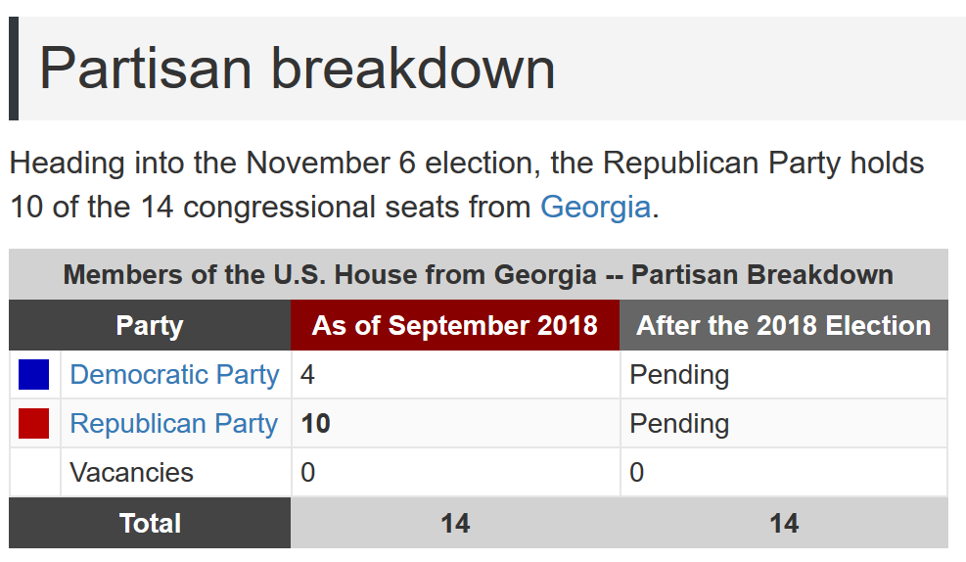(Ballotpedia)

This race will determine who will fill the fourteen seats available for Georgia. Included below are those districts across Northwest Georgia that likely include your home. US House of Representative seats are for a two-year term. GA has fourteen districts and each race is for a single Representative to that district.

 | Republican | Democrat | Other
14th District | Tom Graves (incumbent) | Steven Foster
13th District | David Callahan | David Scott (incumbent) | Martin Cowen (Libert)
11th District | Barry Loudermilk (incb.) | Flynn Broady Jr.
9th District | Doug Collins (incumbent) | Josh McCall | Cliff Baxter (?)
7th District | Rob Woodall (incumbent) | Carolyn Bourdeaux
6th District | Karen Handel (incumbent) | Lucy McBath | Jeremy Stubbs (?)
5th District | - | John Lewis (incumbent)
4th District | Joe Profit | Hank Johnson (incb.)
3rd District | Drew Ferguson (incb.) | Chuck Enderlin

Note that gerrymandering often guarantees a win for one party or the other in certain districts. There is also the possibility that the district lines are drawn in such a way as to include certain demographics, making a vote for one party more likely.

You can find out which district you live in using the map on the next page.
Congressional Districts for Georgia
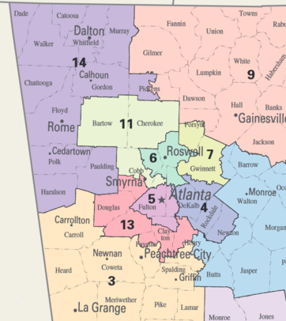
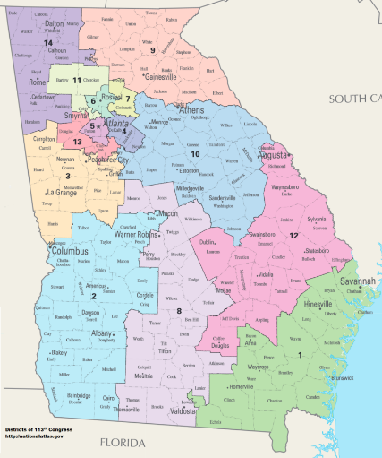
Note that the districts are drawn (and redrawn and redrawn) based on population figures represented in the federal census. The general idea is to make each district represent roughly similar proportions of the state population, although often this is not precise. This means you will see Atlanta divided into several small districts and all of Northeast Georgia represented by one district. There is advantage to being in the majority in the state legislature, which draws the lines of the districts. If, for example, you are a Republican-controlled legislature, you can draw the district lines to slightly benefit candidates of your party, increasing your chances at a majority in the US House and Senate.

Identify the candidates for U.S. House running in your congressional district (based on where you live). Write those candidates into the column headers below and research those candidates, the same way that you researched the Governor candidates.
Name: | Name: | Name:
Democrat | Republican | Other:
Personal Life: Age? Relationship? Family? Location? Hobbies?
Credentials: Education? Work Experience? Elected office experience?
Employment issues: What would they do to increase employment? What do they think about the minimum wage? What do they think about the gender-pay gap? What about unions?
Health cost issues: What do they think about Obamacare? What alternatives/solutions/ideas do they have? Would they expand Medicaid? How would they help control healthcare costs?
Health issues: do they support euthanasia? Do they support medicinal use of marijuana? What do they say about the opioid epidemic? What about access to abortion?
Education issues: what do they think about higher education funding? What is their plan for the K-12 education system? Do they have a plan for teacher pay?
Name: | Name: | Name:
Democrat | Republican | Other:
Public Safety issues: what does each think about funding for police/fire? What do they say about access to guns (or certain kinds of guns)? Do they support Campus Carry?
Justice and Punishment issues: what do they think about mandatory minimum sentencing? Do they support private prisons? Do they support the death penalty?
LGBTQ issues: do they support same-sex marriage and LGBTQ access to adoption services? What would they do for trans people and public bathrooms? Do they support a business denying service to LGBTQ people based on a personal conviction or faith?
Environmental issues: Do they believe in climate change? Do they support “green” energy or fossil fuels? Do they support regulations against pollution or deregulation to help business?
Immigration issues: Do they support a Southern border wall? Do they support a path to citizenship for illegal immigrants? What would they do about Dreamers?
Broader political situation: do they support or resist Trump? Do they support or resist the GOP controlled Congress? Do they support the two Trump Supreme Court picks?
Funding: how is their Governor campaign being funded? Are there large out of state donations? Major political party funds? Big donors or small donors?
Advocacy 3 assignment: Go back over the last two pages of tables and assign a number to each row that indicates how much you care about that issue when considering who you want to be the in the US House of Representatives for Georgia. 10 indicates you care a great deal, 1 indicates you do not care at all. For example, if I really want the Georgia Representative to be a pro-business candidate that will be tough on crime, I might put a 9 or 10 next to the rows for employment, public safety, and justice/punishment.

Once you have ranked each of the rows on the prior pages from 1 to 10 in terms of importance, circle the three rows with the highest ranking. Write those issues at the top of each column below. Finally, find time to have three conversations with people on campus (not in the class). In each conversation, explain the 3 issues you care about, and what the candidates think about those issues. Allow the other person to explain what they think. You may choose this time to try to persuade them to think as you do on one or several of the issues. After the conversation, record your thoughts about how it went with each issue in the space below.
 | Issue #1 | Issue #2 | Issue #3
Conversation #1
with:
Conversation #2 with:
Conversation #3 with:
Tuesday 10/9 – Georgia House and Senate Races
Engage: WB Entry 7: Advocacy 4
There are 180 districts in Georgia for the Georgia House of Representatives. There are 56 districts in Georgia for the Georgia Senate. It would be impossible to include information on all of those races in this workbook, even allowing for the fact that the vast majority of Georgia House and Georgia Senate candidates run unopposed in their district.
Your first task this week is to find out which districts (Georgia House and Georgia Senate) you live in. Use https://openstates.org/find_your_legislator/ to type in your address and find your current representatives. In the example below, the GHC Douglasville instructional site is represented by Mike Duggan (Georgia Senate 30th District) and Micah Gravley (Georgia House 67th District), both Republicans. Find yours and write them in below.
My GA Senate District ________________________ Incumbent: _______________________
My GA House District _________________________ Incumbent: _______________________
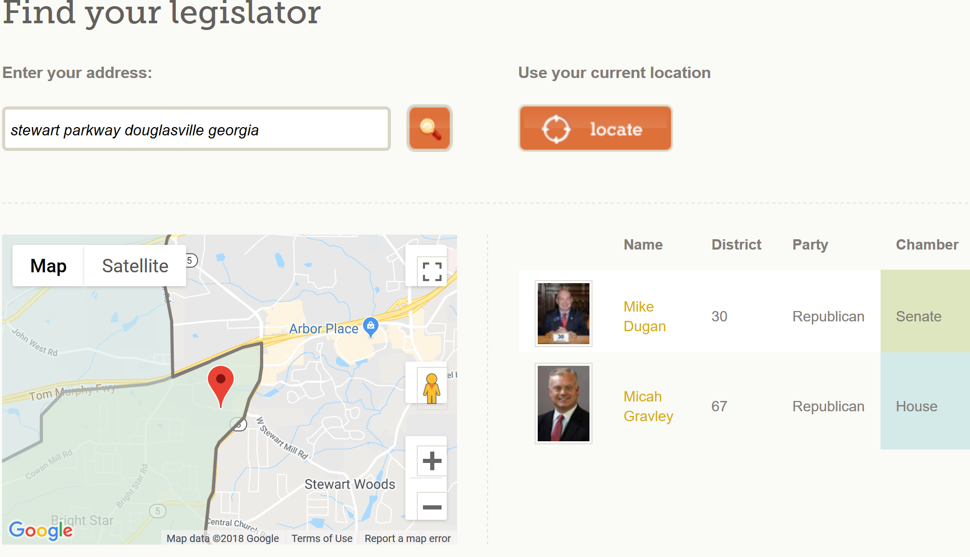

Next, find out if the incumbent is running for reelection, and whether there are any challengers. You can use https://ballotpedia.org/Georgia_elections,_2018 and click on “State Senate” and “State House” in the list halfway down the middle of the page to find complete district lists and find out the race details in your districts.
GA Senate Race (_______District) is _____________________ vs. ______________________

GA House Race (_______District) is _____________________ vs. ______________________
You will find that it can be difficult to find information on candidates for local office and many smaller state offices, such as Georgia House seats. That said, you should be able to find some information on the candidates in your district’s Georgia Senate and House races, starting with whatever Ballotpedia has. Fill that information in below. If the race is uncontested, just fill in the information for the incumbent that is running unopposed.

Georgia Senate Race (_____ District)
 | Candidate 1: | Candidate 2:
Background
Credentials
What stances could you find information for? Where does the candidate stand on any issue?

Georgia House Race (_____ District)
 | Candidate 1: | Candidate 2:
Background
Credentials
What stances could you find information for? Where does the candidate stand on any issue?

Advocacy 4 assignment: Go back over the last page and try to identify two issues you are interested in and that you were able to find information from your Georgia House and Georgia Senate candidates. Write those issues at the top of each column below. Finally, find time to have three conversations with people on campus (not in the class). In each conversation, explain the issues you care about, and what the candidates for Georgia House and Georgia Senate think about those issues. Allow the other person to explain what they think. You may choose this time to try to persuade them to think as you do on one or several of the issues. After the conversation, record your thoughts about how it went with each issue in the space below.
 | Issue #1 | Issue #2
Conversation #1
with:
Conversation #2 with:
Conversation #3 with:

Tuesday 10/16 – Demographics, Districting, and Data
Engage: WB Entry 8: Prepare Your Policy Presentation

2016 Election Results by Groups |  | Group | Clinton | Trump
SEX | Men | 48 | 41 | 52
Women |  | 52 | 54 | 41
RACE | White | 70 | 37 | 57
African-American |  | 12 | 89 | 8
Hispanic |  | 11 | 66 | 28
Asian |  | 4 | 65 | 27
Other |  | 3 | 56 | 36
AGE | 18-29 | 19 | 55 | 36
30-44 |  | 25 | 51 | 41
45-64 |  | 40 | 44 | 52
65 & over |  | 16 | 45 | 52
INCOME | <$50,000 | 36 | 53 | 41
$50,000-$100,000 |  | 30 | 46 | 49
$100,000 & over |  | 34 | 47 | 47
UNION HOUSEHOLD | Yes | 18 | 51 | 43
No |  | 82 | 46 | 48
PARTY | Democrat | 37 | 89 | 8
Republican |  | 33 | 8 | 88
Independent |  | 31 | 42 | 46
POLITICAL PHILOSOPHY | Liberal | 26 | 84 | 10
Moderate |  | 39 | 52 | 40
Conservative |  | 35 | 16 | 81

Review the voter data shown above.
What groups helped to elect Trump?

Age is an important demographic to consider in elections. See the following graphs from a piece titled “This may be the last presidential election dominated by Boomers and prior generations”
by Richard Fry at the Pew Research Center (August 2016).

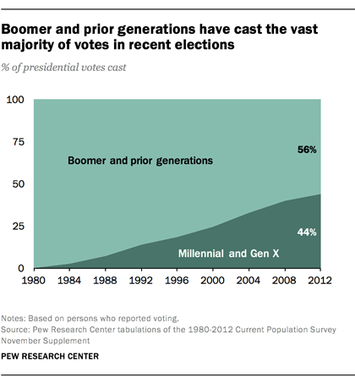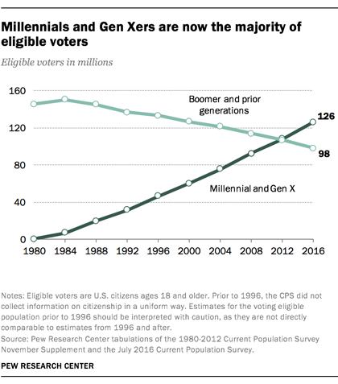

Broadly speaking, demographics changes make political races both predictable and unpredictable. If Pew Research Center or Gallup can predict how a certain demographic will vote and can determine the proportion of the total vote that demographic will have, the organization can predict the outcome of races. Still, much of this is made unpredictable because voter turnout is not guaranteed. There may be more of a certain group likely to vote a certain way, but if that group stays home on election day, it doesn’t matter.
If we acknowledge that demographic information can provide some good guidelines for what to expect and a lens for understanding how candidates are trying to appeal to voters (certain groups of voters), we should also remember that demographic info need always come with the disclaimer: “only if that group turns out to vote.”

January 27, 2016
The demographic trends shaping American politics in 2016 and beyond
By Paul Taylor at Pew Research Center

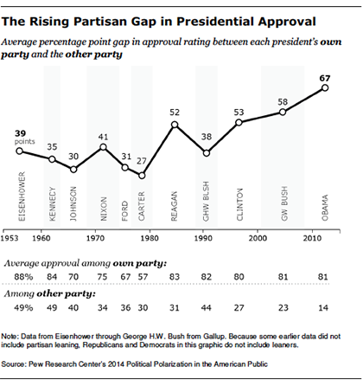
1. In an era of head-snapping racial, social, cultural, economic, religious, gender, generational and technological change, Americans are increasingly sorted into think-alike communities that reflect not only their politics but their demographics. The result has been a rise in identity-based animus of one party toward the other that extends far beyond the issues. These days Democrats and Republicans no longer stop at disagreeing with each other’s ideas. Many in each party now deny the other’s facts, disapprove of each other’s lifestyles, avoid each other’s neighborhoods, impugn each other’s motives, doubt each other’s patriotism, can’t stomach each other’s news sources, and bring different value systems to such core social institutions as religion, marriage and parenthood. It’s as if they belong not to rival parties but alien tribes.
And their candidates in 2016 might seem to be running for president of different countries. As the chart above illustrates, the partisan gap in how Americans evaluate their presidents is wider now than at any time in the modern era.
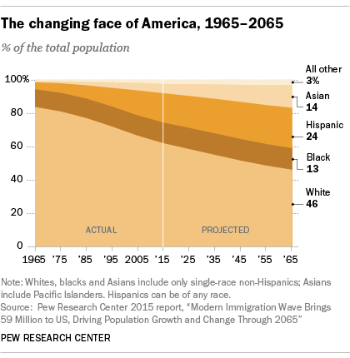

2. This political sorting has roots in two simultaneous demographic transformations that America is undergoing. The U.S. is on its way to becoming a majority nonwhite nation, and at the same time, a record share of Americans are going gray. Together these overhauls have led to stark demographic, ideological and cultural differences between the parties’ bases.
We now have one party that skews older, whiter, more religious and more conservative, with a base that’s struggling to come to grips with the new racial tapestries, gender norms and family constellations that make up the beating heart of the next America. The other party skews younger, more nonwhite, more liberal, more secular, and more immigrant- and LGBT-friendly, and its base increasingly views America’s new diversity as a prized asset.

3. At the turn of the century, there was no partisan difference in the votes of young and old. But in recent elections, there has been a huge generation gap at the polls. And Democrats and Republicans have become much more ideologically polarized.

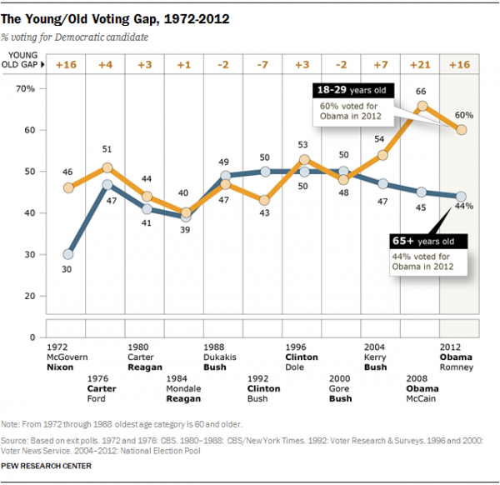

Today 92% of Republicans are to the right of the median Democrat in their core social, economic and political views, while 94% of Democrats are to the left of the median Republican, up from 64% and 70% respectively in 1994. The same 2014 Pew Research Center study also found a doubling in the past two decades in the share of Americans with a highly negative view of the opposing party.
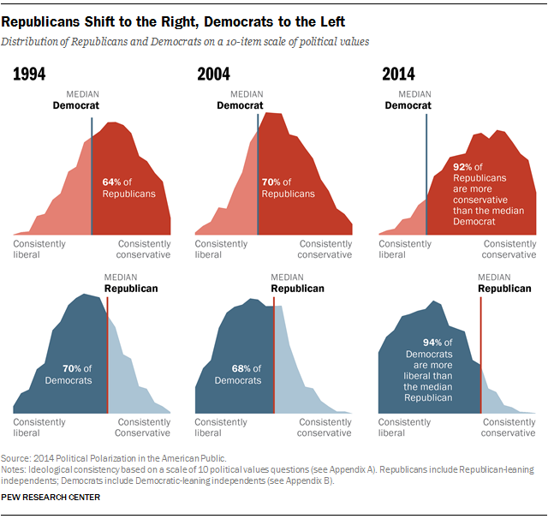

4. The cleavages between the political tribes spill beyond politics into everyday life. Two-thirds of consistent conservatives and half of consistent liberals say most of their close friends share their political views. And liberals say they would prefer to live in cities while conservatives are partial to small towns and rural areas. In their child-rearing norms, conservatives place more emphasis on religious values and obedience, while liberals are more inclined to stress tolerance and empathy. And in their news consumption habits, each group gravitates to different sources.
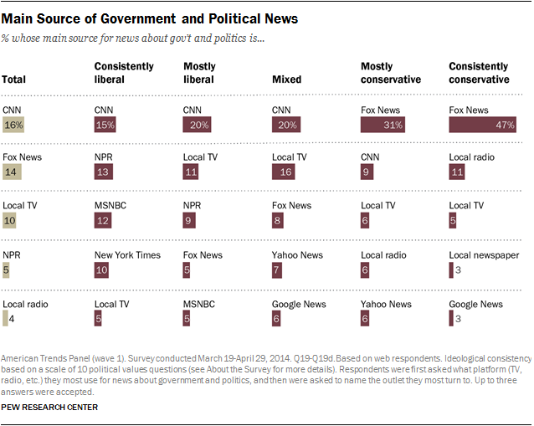
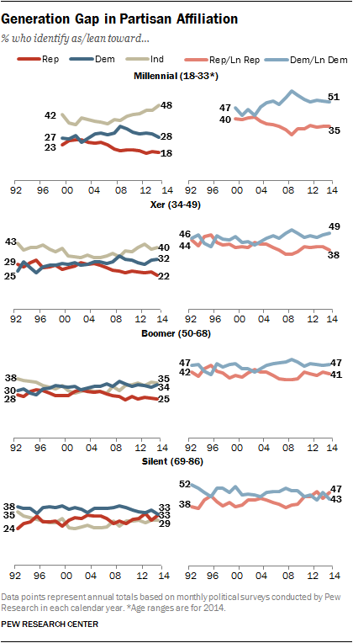

To be clear, not all of America is divided into these hostile camps. Even as partisan polarization has deepened, more Americans are choosing to eschew party labels. This group is heavily populated by the young, many of whom are turned off by the cage match of modern politics. They are America’s most liberal generation by far, but when asked to name their party, nearly half say they are independents. No generation in history has ever been so allergic to a party label.

5 Identity-based hyperpartisanship is thriving at a time when a majority of Americans tell pollsters they’d like to see Washington rediscover the lost art of political compromise. As ever, many Americans are pragmatists, ready to meet in the middle.
Yet nowadays these Americans are the new silent majority. They don’t have the temperament, inclination or vocal cords to attract much attention in a media culture in which shrill pundits and 140-character screeds set the tone. Those most averse to political compromise are ideologically consistent conservatives and liberals, majorities of whom want their side to prevail.
Congress’ members are more polarized by party than at any time since the Reconstruction Era. And recent elections have produced something else unprecedented in American political history – one party winning the popular vote in five of the past six presidential contests even as the other party has recently run up its biggest congressional and statehouse majorities in a century.

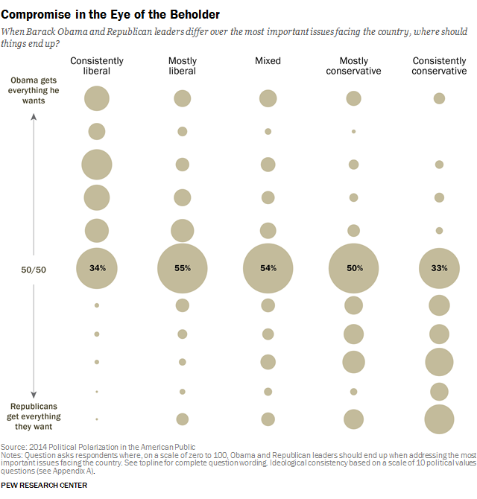

6. The Democratic base, dubbed the “coalition of the ascendant” by journalist Ronald Brownstein, is often the coalition of the unengaged, especially during non-presidential elections. In 2014, for example, just 19.9% of 18- to 29-year-old citizens voted, a record low. The old turning out in force more than the young is nothing new – that seems hard wired into the human life cycle. This matters little when the generations vote alike, but it makes a huge difference when, as now, they don’t. Thus we have the alternating red and blue election outcomes of the recent past, with President Obama’s victories in the big turnout years of 2008 and 2012 playing hopscotch with the GOP romps in the low turnout midterms of 2010 and 2014. This in turn has contributed to a Washington that’s paralyzed by gridlock and a hothouse for the sort of rancor that can fire up the hyperpartisans but can also send nonpartisans farther off to the political sidelines. And so the cycle of mean-spirited, broken politics perpetuates itself.

7. Might 2016 be the year we break the fever? So far it’s not looking that way. The public remains in a foul mood, frustrated by stagnant incomes, a shrinking middle class and gruesome global terrorism. Just 19% say they trust the government to do what’s right. Moreover, most Republicans and many Democrats say they believe that, on the issues that matter most to them, the other side is winning. And not since the early 2000s has a majority of the public said the nation is on the right track, making these past dozen years the longest sustained stretch of national pessimism since the onset of polling.

8. Politics is never static, which means today’s state of affairs isn’t necessarily a template for the future. This campaign has already illuminated deep fissures not just between both parties but within them. A lot of political business will get transacted between now and November. No matter what the outcome, the political firmament is likely to look different next year.
The most hopeful take on this long season of political discontent comes from our nation’s most astute early observer, Alexis de Tocqueville, who noted nearly two centuries ago that American democracy isn’t as fragile as it looks; confusion on the surface masks underlying strengths.

How would you connect these claims from 2012, 2014, and 2016 to 2018?

---------------------------------------------------------------------------------------------------------------------

Tuesday 10/23 Policy Presentations DUE
Engage: WB Entry 9: Political Debate

Continue to next page for Policy Presentation Assignment Rubric

Policy Presentation - 150 points Name: _______________________
Write a speech that takes a stand on a current political issue and asks your audience to take action in a specific way. The issue should have some relevance in the lives of your audience, and the goal should be achievable enough that your audience can take action to realize that change. An easy action to take could be a vote for a certain candidate in 2018. Note that while some attention to delivery is counted, most of the points are for a researched argument.
Assignment Specifics
1. Delivery Method: The speech should be delivered extemporaneously (see page 116)
2. Organization: Problem/Cause/Solution
3. Time limit: 5:30-6:00; finishing outside of this window will cost you points
4. Oral footnotes: you must cite five sources (source + credibility + information)
5. Paperwork: submit a typed outline/works cited with the speech (see page 71)
6. Visual Aids: AV/Tech not allowed. Props allowed but not necessary.
7. Artifacts: business casual dress or topic supporting dress required

Item | Excel | Good | Avg. | Fair | Poor | N/A | Misc
Attention Getter | 5 | 4 | 3 | 2 | 1 | 0
Topic/Central Idea/Thesis | 3 |  | 2 |  | 1 | 0
Credibility | 3 |  | 2 |  | 1 | 0
Value for Audience | 3 |  | 2 |  | 1 | 0
Preview of Ideas | 4 | 3 | 2 |  | 1 | 0
Organization of Ideas | 10 | 8 | 6 | 4 | 2 | 0
Transitions & Signposts | 5 | 4 | 3 | 2 | 1 | 0
Oral Footnotes (2 pts each) | 10 | 8 | 6 | 4 | 2 | 0
Credibility of Sources (2pts e) | 10 | 8 | 6 | 4 | 2 | 0
Good use of evidence | 6 |  | 4 |  | 2 | 0
Varied evidence forms | 6 |  | 4 |  | 2 | 0
Review of Ideas | 5 | 4 | 3 | 2 | 1 | 0
Closing Thought | 5 | 4 | 3 | 2 | 1 | 0
Paralanguage | 5 | 4 | 3 | 2 | 1 | 0
Verbal Pauses | 5 | 4 | 3 | 2 | 1 | 0
Eye Contact | 5 | 4 | 3 | 2 | 1 | 0
Stance & Gesture | 5 | 4 | 3 | 2 | 1 | 0
Expression & Energy | 5 | 4 | 3 | 2 | 1 | 0
Visual Aid |  |  |  |  |  | 0
Time | 10 | 8 | 6 | 4 | 2 | 0
Appearance/ Artifacts | 5 | 4 | 3 | 2 | 1 | 0
Outline | 10 | 8 | 6 | 4 | 2 | 0
Works Cited | 10 | 8 | 6 | 4 | 2 | 0
ARGUMENT 15 12 9 6 3 0 |  |  |  |  |  |  | Total Points /150  Letter Grade

Policy Presentation Preparation
Most of you have had Human Communication of Public Speaking before. If you have not, don’t stress about the public speaking aspect of this. Focus on the argument you will research and write in service of supporting a particular solution to an issue you see as a problem…
Step One: Determine your issue.
Step Two: Identify a Problem, Cause, and a Solution within that issue.
Step Three: Gather some sources to support your claim about the Problem, Cause, and Solution.
Step Four: Write the body paragraphs of the speech, organized into three main ideas (P, C, S).
Step Five: Write an Introduction. It should grab attention, introduce your topic, explain why you care about it and why we should listen to you talk about it, and preview your main ideas.
Step Six: Write a Conclusion. It should review your main ideas, thesis statement, why we should care about the issue, and conclude with a call to action (Vote for X).
Step Seven: Type a detailed outline of your speech. Type a works cited for your five sources.
Step Eight: Make speaking notes (generally on notecards) to use when you deliver.
Step Nine: Practice with a friend, classmate, or family member.

