GHHU 2901
THE ELECTION OF 2018

PART ONE
WORKBOOK

"Nobody will ever deprive the American people of the right to vote except the American people themselves.
They do this by not voting." - FDR

NAME: __________________________________________________________________

Instructions
DO NOT LOSE THIS WORKBOOK

A. Complete the workbook entry before class.
B. Use the workbook during class to facilitate class discussion.
C. Bring the completed workbook to class at the end of the semester to turn in.
Get started talking about the election!: sign up for Twitter (if you are not already) and start using the #ChargersVote hashtag to tweet about the election. Remember that your civility agreement applies to Twitter and all other social networks.

Workbook Entry 1: Personal Political Views
Next class: Civility and Incivility; Belief and Doubt
1. Pew Research Center Political Typology Test

Complete the test at http://www.people-press.org/quiz/political-typology/

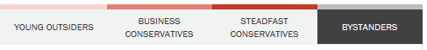
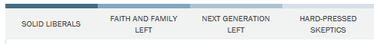
What was your result? Do you agree with that result?

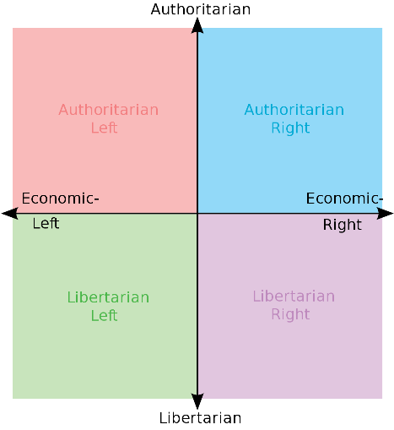
2. Political Compass Political Typology Test

Complete the test at https://www.politicalcompass.org/
What was your result? Do you agree with that result?

3. How different do you think the people in your life are on these measures?
4. What person do you know that aligns well with you on these measures?
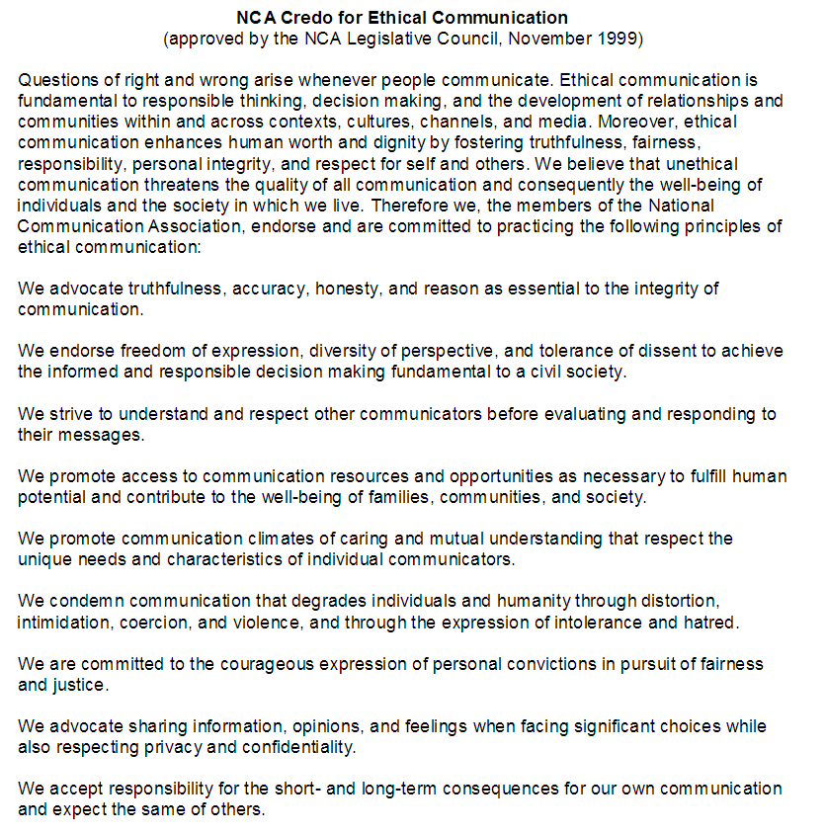

I understand that, with respect to any activities connected to the GHC GHHU 2901 Election of 2018 course, I am expected to communicate in a civil manner.
I understand that I must consider not only the intent of my communication but also the ways that it might be received by diverse others.
I understand that acts of incivility may have a negative impact on my course grade or keep me from passing the course.
PRINT NAME: ____________________ SIGN NAME: ____________________ DATE:_____

I understand that, with respect to any activities connected to the GHC GHHU 2901 Election of 2018 course, I am expected to communicate in a civil manner.
I understand that I must consider not only the intent of my communication but also the ways that it might be received by diverse others.
I understand that acts of incivility may have a negative impact on my course grade or keep me from passing the course.
PRINT NAME: ____________________ SIGN NAME: ____________________ DATE:_____
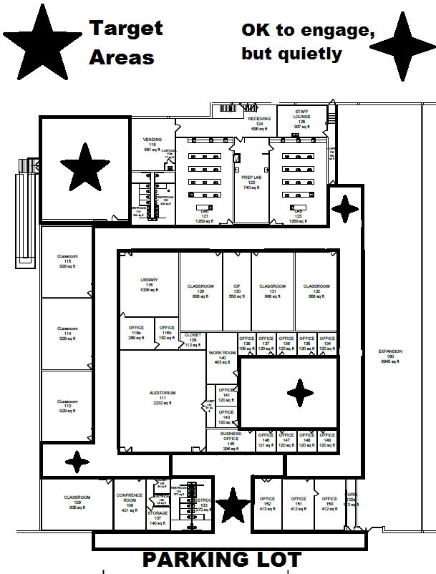
Workbook Entry 2: Friends and Family Poll
Next class: National Political Situation
Find time to sit down with 10 people not in the class. With each person, pose the three statements in each row and ask them to choose the one they most agree with. Record that person’s name in that column. On each issue (row), which perspective (column) is more common?

Trump has done more good things than bad as president. | Trump has done roughly equal good and bad things as president. | Trump is doing more bad things than good as president.
I am happy with the two Supreme Court nominees from Trump. | The Trump Supreme Court nominees are a mixed bag. | I am unhappy with the 2 Supreme Court nominees from Trump.
I am happy with the current economic situation. | There is good and bad in the current economic situation. | I am unhappy with the current economic situation.
We need more restrictions on guns and/or gun ownership. | Our gun policies are OK as they are. | We need fewer restrictions on guns and/or gun ownership.
We need more restrictions on legal immigration. | Our immigration policies are OK as they are. | We need fewer restrictions on legal immigration.
A Southern border wall will protect the country. | A Southern border wall won’t do much if anything. | A Southern border wall will hurt our country.
Businesses should be allowed to refuse service on the basis of sexual orientation. | Businesses should be allowed to restrict access to certain services for certain customers. (I’ll make you cupcakes, but not a wedding cake). | Businesses should not be allowed to refuse service on the basis of sexual orientation.
Coal and Oil are the future. | Nuclear power is the future. | Wind, Solar, and Hydro power are the future.
The minimum wage in Georgia is too low. | The minimum wage in Georgia is OK. | There shouldn’t be a minimum wage.
Private prisons are good for the country. | Private prisons are a mixed bag. | Private prisons are bad for the country.
The international trade dispute with China, Europe, etc will be good for the US. | The international trade dispute with China, Europe, etc will be good and bad for the US. | The international trade dispute with China, Europe, etc will be bad for the US.
The #MeToo movement is a good thing and should get more attention. | The #MeToo movement is a mixed bag. | The #MeToo movement is a bad thing and should get less attention.
The #BlackLivesMatter movement is a good thing and should get more attention. | The #BlackLivesMatter movement is a mixed bag. | The #BlackLivesMatter movement is a bad thing and should get less attention.
The focus on fake news is a good thing and should get more attention. | The focus on fake news is a mixed bag. | The focus on fake news is a bad thing and should get less attention.
The investigation into Russian meddling in the 2016 election is good and important work. | The investigation into Russian meddling in the 2016 election is a mixed bag. | The investigation into Russian meddling in the 2016 election is unnecessary.
Local officials are mostly trustworthy and protect our best interests. | Local officials are a mixed bag. | Local officials are often corrupt and don’t care about citizens’ needs.
Congress is mostly trustworthy and protect our best interests. | Congress is a mixed bag. | Congress is often corrupt and does not care about citizens’ needs.
The Confederate Memorial at Stone Mountain should be destroyed. | The Confederate Memorial at Stone Mountain should be moved to a Confederate themed museum. | The Confederate Memorial at Stone Mountain should be protected forever.
Taxes should be spent covering the costs of health care. | Taxes should be spent reducing the costs of health care. | Taxes should not be spent on health care.
The very rich should pay more in taxes than they do. | The very rich pay the right amount of taxes. | The very rich should pay less in taxes than they do.
The very poor should pay more in taxes than they do. | The very poor pay the right amount of taxes. | The very poor should pay less in taxes than they do.
The middle class should pay more in taxes than it does. | The middle class pays the right amount of taxes. | The middle class should pay less in taxes than it does.
Climate Change is real, and a major threat to us now and in the future. | Climate Change may be real, but isn’t a major threat. People adapt. | Climate Change is overblown or fake, and the threat is small.
Taxes should be spent covering the costs of college education. | Taxes should be spent reducing the costs of college education. | Taxes should not be spent on college education.

Workbook Entry 3: Issue Research
Next class: Georgia Political Situation: Trifecta and Triplex
Choose one issue from the issues reflected in the friends/family poll (or email me if you have another you want to do) and prepare a three paragraph summary of the issue, in your own words, that references but does not directly quote at length from, three sources. Your sources can include www.procon.org or www.ontheissues.org . Your summary should note what your stance on the issue is. You may handwrite here as you develop it, but you must turn in a typed copy with a works cited page.
Issue:
Summary:

A typed copy is due next class, with a separate, typed works cited page.
Workbook Entry 4: Advocacy 1
Next Classes: Political Persuasion, Voter Reg Booth, and Georgia Gubernatorial Race
Complete the following pages with examples of persuasion terminology, then complete the Advocacy 1 assignment on the last pages of the workbook.
Persuasive "Artistic" Proofs: Aristotle’s four means of persuading others in an artful way.
You might use these as warrants or grounds in your argument structure.

A. Logos - making a logical point in support of a claim.
GR. “Our national debt and our national deficit are at historic levels”
WR. “Governments should not spend more than they can bring in”
CL. “Therefore, we must support both spending cuts and tax increases.”

B. Pathos - stirring an emotion to create support for a claim.
GR. “9 million kids - young, defenseless, innocent children, starve every year”
WR. “You wouldn’t allow your kids to starve, and you shouldn’t allow this”
CL. “So vote yes on this program to extend food aid by $10 billion.”

C. Ethos - using personal trustworthiness as support for a claim.
GR. “Over 30 years in Congress, I served on 11 committees and 26 subcommittees”
WR. “On every vote, every day, I stood for conservative principles”
CL. “So I ask once again for your support; reelect me on Tuesday!”

D. Mythos - using broadly shared cultural knowledge to support a claim.
GR. “LGBT Americans have achieved cultural salience but not equal legal protection”
WR. “In the first civil rights movement Dr. King worked toward racial equality”
CL. “We must march in this new civil rights movement and support same-sex marriage.”

Further examples:

____________________________________________________________________________
____________________________________________________________________________
____________________________________________________________________________
____________________________________________________________________________
____________________________________________________________________________
____________________________________________________________________________
____________________________________________________________________________
____________________________________________________________________________
____________________________________________________________________________
____________________________________________________________________________
____________________________________________________________________________
____________________________________________________________________________

Labels and Connotation: The connotative meaning of terms is individualized and personalized, often difficult to identify for others, and almost never the denotative (dictionary) definition of a term or idea. We can use these to our advantage by selecting certain terms based on likely connotations that might prove useful to our cause.

Example 1: “Climate Change”
You will hear different groups use “climate change” or “global warming” to refer to the same set of phenomena, but such word choice is intentional. Advocates that believe the planet is getting hotter overall and that such will create unpredictable weather patterns and major storm events use “climate change” to encompass all of these phenomena. They used to use “global warming” but switched. A republican strategist and rhetorician named Frank Lutz (in a book called Words that Work) advised those that think these weather phenomena are overblown or that humans have not directly influenced the climate to continue to use “global warming.” Every time there is a heavy snowfall, this enabled you to roll your eyes and say “global warming at work” with a wink to your viewers and voters - the term itself is debunked every cold day of the year, allowing such advocates to de facto debunk the phenomena and any funding to combat it.

Example 2: “Welfare Queens”
In service of his attack on entitlement programs, Reagan and his advisors created the “welfare queen,” a likely fictionalized version of a woman who kept having children in order to increase her government assistance level to the point that she lived in a mansion, bought designer clothing, etc. Variations of this are still in use in the debate over entitlement programs today, although with more labeling variety. For example, a politician opposed to food stamps might tell a story about a mother on food stamps in line for the latest iphone. Politicians that support entitlement programs will instead label those that survive due to said programs with terms that carry positive connotations such as “working mother.”

How might we label the following things depending on our position?

Opposed? Then say: Supporter? Then say:

Immigrants _____________________ ____________________

Abortion _____________________ ____________________

Same-sex marriage _____________________ ____________________

Recreational drugs _____________________ ____________________

Drone strikes _____________________ ____________________

Death penalty _____________________ ____________________

Weaver’s Ultimate Terms: The rhetorician Richard Weaver described “ultimate terms” that have a certain power when used in conversation. Of these, “God terms” are those we embrace, things one cannot disagree with or stand against. “Devil terms,” on the other hand, are those we reject, things one cannot agree with or stand for. When deployed in conversation, argument, or debate, God terms have the effect of praise and of inviting agreement while Devil terms have the effect of blame and of creating distance.
It is also important to note that ultimate terms are, to a certain extent, most relevant to a particular time, place, culture, and circumstance. For example, “communist” might be a Devil term in contemporary American politics but it certainly does not have the same meaning in contemporary Asia, nor is it as powerful as it was at the height of the Cold War.

Examples (in contemporary American politics):

God Terms Devil Terms

Progress Terrorist
Family values Communist
American Socialist
Liberty Amnesty
Justice Government control
Freedom Slavery
Opportunity Fascist
Technology Trafficking
Order Disease
Success Stagnation
Virtue Servitude

Provide some other examples below:

God Terms Devil Terms
___________ ___________
___________ ___________
___________ ___________
___________ ___________
___________ ___________
___________ ___________

Godwin’s Law: perhaps the worst Devil Term is “Hitler,” as comparing anything to things that Hitler did is about as devastating an analogy as one could make. Still, comparing things to Hitler is surprisingly common, especially in political argument/debate or online. Godwin’s Law states that the longer a discussion goes on the more likely someone will compare something to Hitler. A common extension of Godwin’s Law states that as soon as one does so, one has effectively shut down the conversation (what can you say after a comparison to Hitler?) and therefore lostthe argument. It is in your best interest to never compare things to Hitler. It doesn’t match up, no matter what you are talking about. “Hitler” is powerful because nothing compares, so don’t try.
Association/Dissociation: Although comparing things to Hitler is poor form and always inaccurate, sometimes it can be highly effective to use association or dissociation in an argument or a debate. The trick is to find accurate and persuasive associations or dissociations.

Association - connecting X with a desired person, object, event, or idea

“McCain’s policies are Bush’s policies. A vote for McCain is a vote for a third Bush term.”
“Obama’s former pastor has called for an overthrow of our government.”

Further examples: __________________________________________________________
____________________________________________________________________________
____________________________________________________________________________
____________________________________________________________________________
____________________________________________________________________________
____________________________________________________________________________
____________________________________________________________________________

Dissociation - distancing X from a person, object, event, or idea

“I fought Bush on immigration, Afghanistan, and medical care. I am not George Bush.”
“My former pastor has no influence on my political views or my governance style.”

Further examples: __________________________________________________________
____________________________________________________________________________
____________________________________________________________________________
____________________________________________________________________________
____________________________________________________________________________
____________________________________________________________________________
____________________________________________________________________________

What are the ethical implications of association and dissociation? ____________________
____________________________________________________________________________
____________________________________________________________________________
____________________________________________________________________________
____________________________________________________________________________
____________________________________________________________________________
____________________________________________________________________________

Stylistic Devices: Often, certain stylistic devices can make lines more memorable or persuasive.

Repetition & Rhyme
Repetition of words/phrases/sentences
“Yes, We Can.” “Change you can believe in.” “Pass this jobs bill.”
Alliteration - a series of words that begin with the same consonant sound
“Peter Piper Picked...”
Consonance - a series of words with a common consonant in the middle or at the end
“The Pail of Nails Prevails”
Assonance - a series of words with a common vowel sound
“Here I lie by the side of my bride.”

Figures of Speech
Antithesis - An inverted repetition of a clause
"Let us never negotiate out of fear, but let us never fear to negotiate"
Ellipsis - an “etc.” that invites audience imagination
"We will do this... and more"
Hyperbole - exaggeration for a point
"We will pay any price, bear any burden, meet any threat."
Oxymoron - paired opposites
“sweet sorrow” “dark victory”

Tropes
Metaphor - one subject borrows something from another, making them equal in a sense
“The ship of state,” “lipstick on a pit-bull”
Archetypal Metaphor - certain fundamental metaphors that pervade our discourse
Up/Down, Light/Dark, such as in “We must struggle ever upward into the light”
Simile - a comparison of multiple subjects
“Float like a butterfly, sting like a bee”
Synecdoche - when a part of something stands in for the whole and vice versa.
Referring to Planned Parenthood clinics as “Abortion mills”

Further examples: _____________________________________________________________
____________________________________________________________________________
____________________________________________________________________________
____________________________________________________________________________
____________________________________________________________________________
____________________________________________________________________________
____________________________________________________________________________
____________________________________________________________________________
____________________________________________________________________________

Issue Advocacy 1: Take the issue you wrote a three paragraph summary of (with sources) and prepare to advocate on behalf of the stance you took. What can we do to make your stance win? For example, if your stance was opposition to a Southern border wall, you might argue that we need to elect people in Georgia and Congress that will fight building that wall… “Vote for Jane Doe to fight the wall” would be your action.
Issue:
My stance:
What we should do (action):
Once you have settled on what to do, create a flyer about your issue. You can use information from your summary, your stance, your proposed action, relevant images, and so on to make the flyer appealing, informative, and persuasive. Remember that the civility agreement covers the flyer, too.
Attach one copy of the flyer to the back of this workbook.
Make other copies of the flyer and take them to public place during daylight hours. Hand out your copies and answer questions that people may have about your issue. This is an assignment, but this is also a chance to actually change some votes and impact an issue you care about!

