How to access your Budget Activity Report after your 1st time

- Go to the GHC Home page www.highlands.edu
- Click on the Faculty & Staff
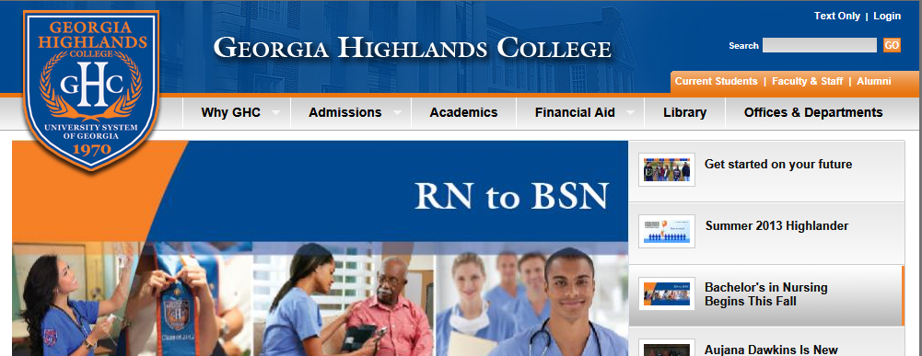
- Enter your Outlook User Name and Password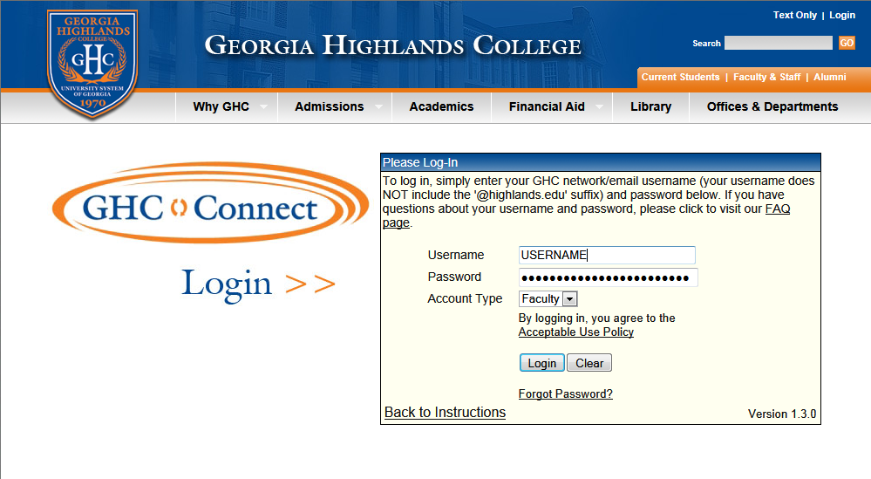
- Click on ADP and PeopleSoft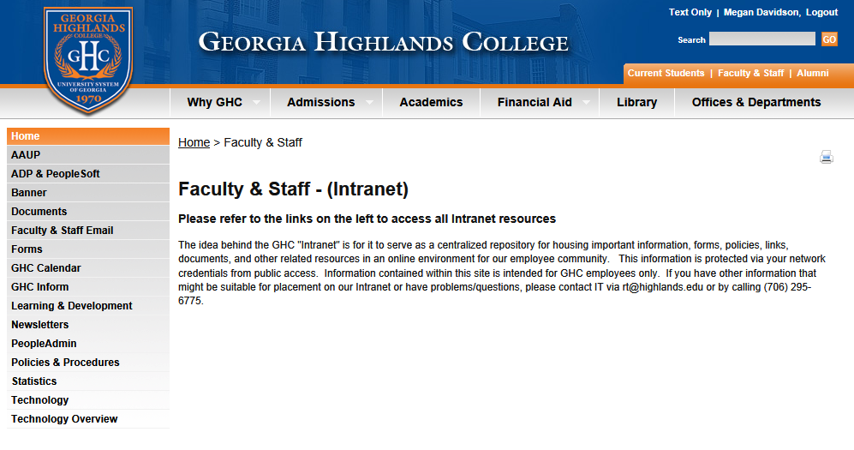
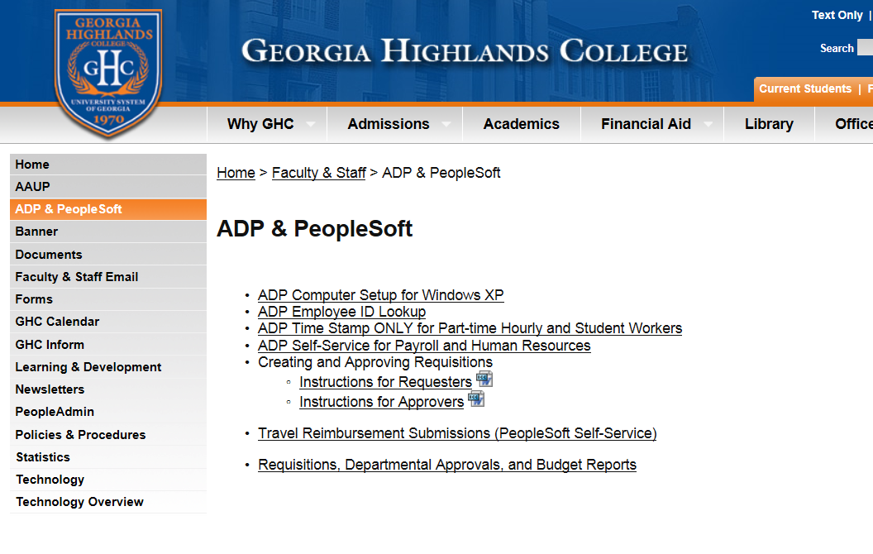
- Click on PeopleSoft- Department Requisitions and Approvals
- Log into PeopleSoft using the same User Name and Password you use to submit Travel (NOT YOUR ADP USER NAME AND PASSWORD) 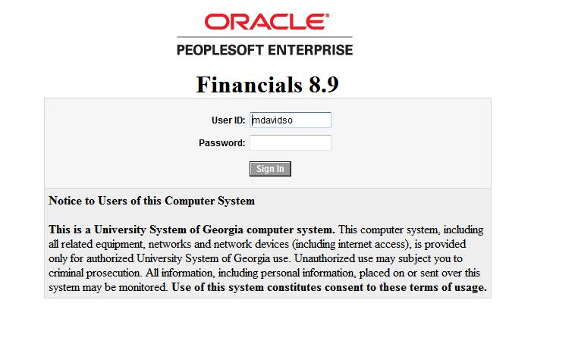
- Click on BOR Menus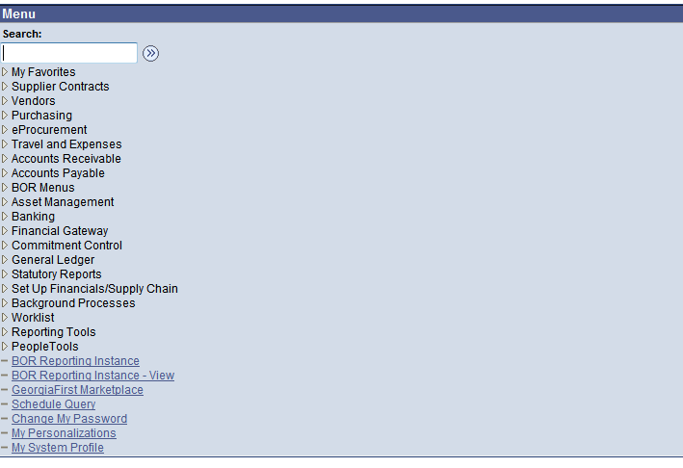
- Click on BOR General Ledger

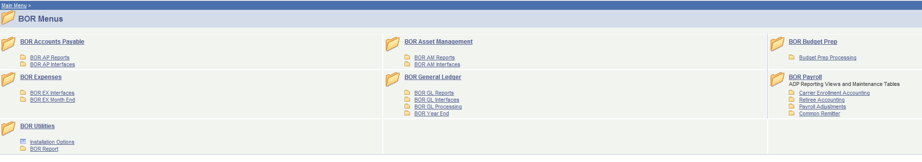
- Click on BOR GL Reports
- Click on Budget Activity Reports
- The following box will appear 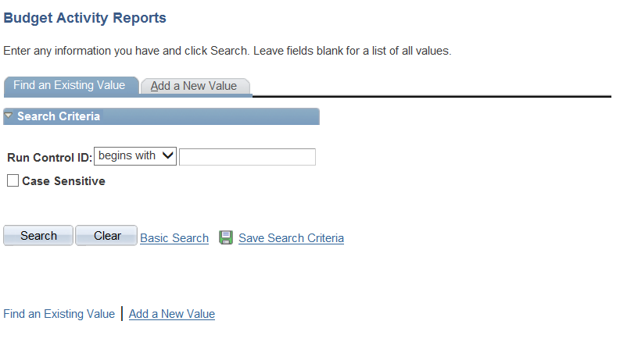
- Hit the search key
- Find the hyperlink that says Budget_Activity_Report and click on it 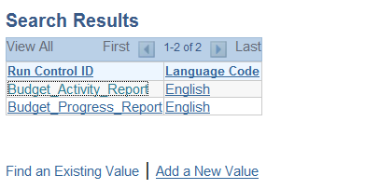
- Now it is time to add the detail to run your report.
  - Business Unit = 73000 Every time (this number is the number assigned to GHC)
  - Budget Period = This period corresponds to the FY you are attempting to get data for currently our FY is 2014
  - Accounting Period = Our Accounting Period starts in July (period 1) and ends in June (period 12) to get all data I recommend you run the report for periods 1 to 12
  - From Fiscal Year and To Fiscal Year = same Fiscal Year used for Budget Period
  - From Fund Code and To Fund Code = This is whatever fund code your department is assigned to. If you are unsure please let me know and I can tell you.
  - From Department and To Department = This is where you enter your department number (be sure the numbers match)
  - From Account and To Account = To get all data enter 500000 in the From and 999999 in the To
- Click Run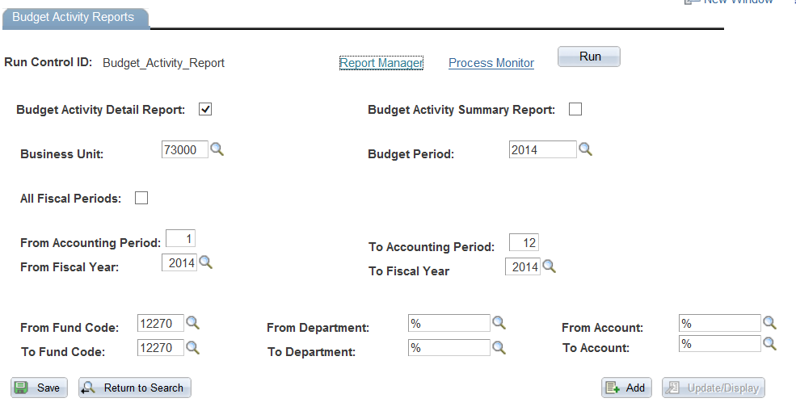
- You have 2 different options on which report type to run
  - Budget Activity Detail Report
  - Budget Activity Summary Report
- Choose either one depending on the amount of detail you would like to see on the report. We suggest you begin with Summary. Once you decide to view either Detail or Summary, check the appropriate box.
- Click Ok
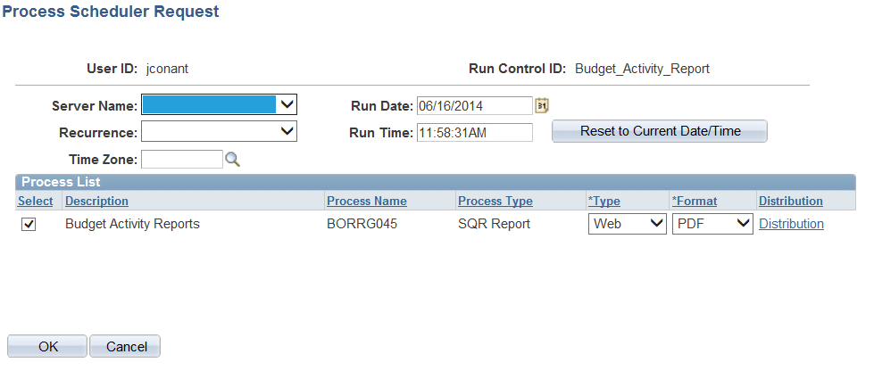

- Hit the Refresh Button until both the Run Status has run to Success and the Distribution Status has Posted. Click the Details hyperlink.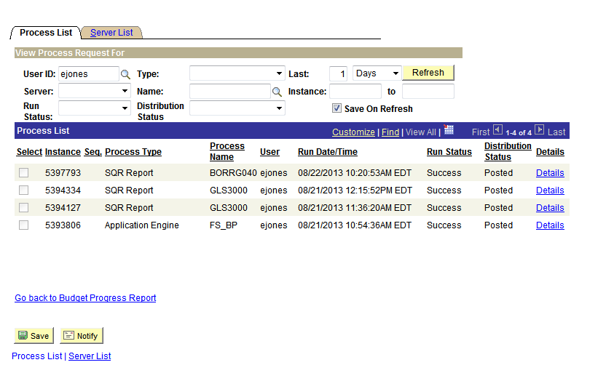
- Click on View Log Trace then click on ok 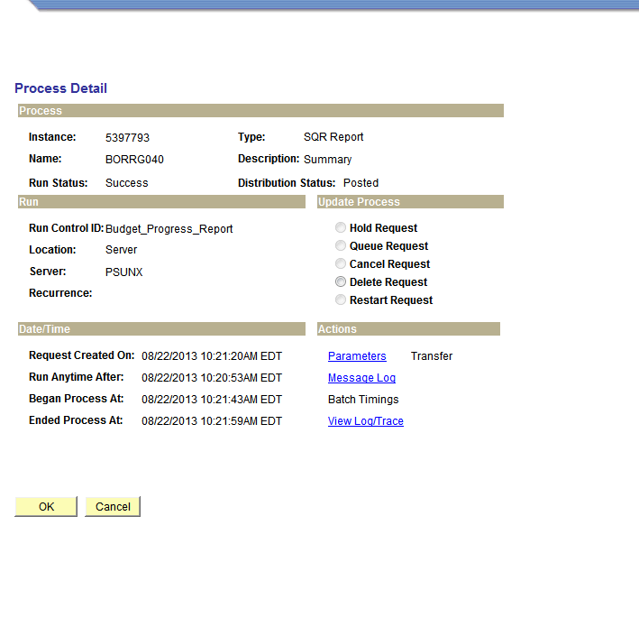
- Click on the PDF