

_{University System of Georgia}
eTIME_{® Employee User Guide}

Full-Time Staff Employees with Time Stamp and Hourly View Time Card

_{Contents}

log on 3
ETIME -MY TIMESTAMP, MY TIMECARD, MY REPORTS, MY ACTIONS 4
Comp Time 5
Transferring time in on a time card - this does not apply to everyone 6
Comments 7
sAVING THE TIME CARD 7
aPPROVING THE TIME CARD 8
REQUESTING TIME OFF - VACATION / COMP TIME 9
CANCELLING TIME OFF REQUEST - VACATION / COMP TIME 11
EXTENDED OF LEAVE TIME REQUEST - FMLA 13
CANCELLING EXTENDED LEAVE TIME OFF REQUEST - FMLA 15

CONTACTS 19

Glossary 20

Log On

Access the eTime Timestamp from the Employee Self Service Portal.

- Go to https://portal.adp.com

- Click ‘User Login’ button.

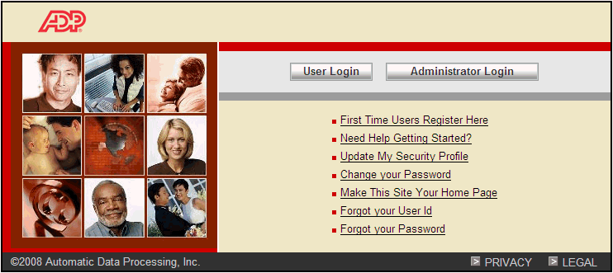

- Enter User Name and Password and click OK.

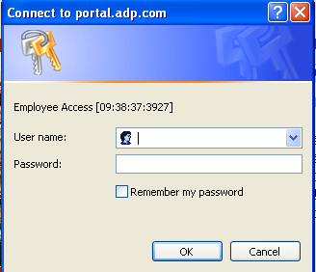

- The Netsecure Portal will appear. The application links allow you to enter into each application.

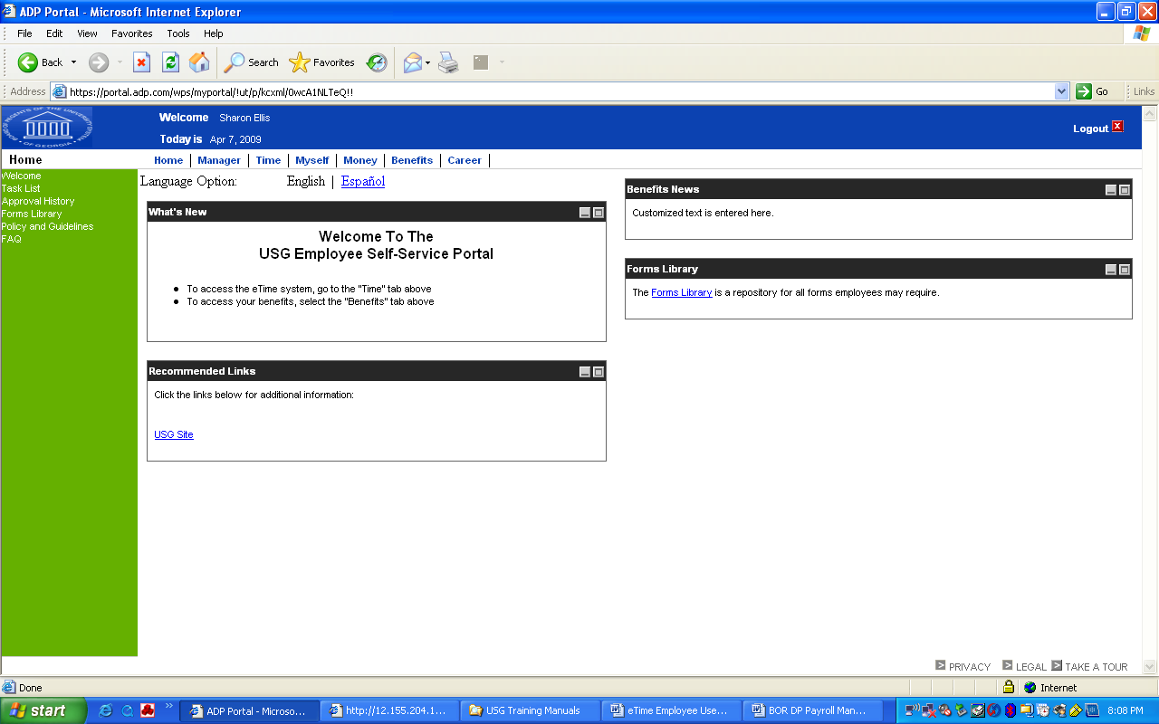
Application links

- Click the Time application link

- Click the Here link for All other employees if you are not a manager or approver of time cards.

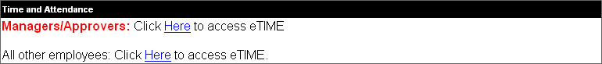

- Now you are in the eTime application
- The time stamp will appear as soon as you enter eTIME. Stamp in and select okay.
*Note – if you have already stamped in or out and you need to view and/or approve you time card then you will need to click on the HOME. This will take you to the home page where you will have the following options:
- You will click the various links – My Information
  - My Timecard: will take you into your time card to view, and approve.
  - My Reports: allows you to view you leave accruals and time card for printing.
  - My Actions: allows you to request time off if you are eligible for time off.
  - My Time Stamp: allows you to clock in and clock out daily.

My Time Stamp

The My Time stamp link is where you will access the time stamp feature to clock in and out daily.
- Click Record time stamp
- View the time and click okay to accept this time to record. You have clocked in.
- Repeat steps 1-2 above at the end of the day and you have clocked out.

My Time Card
The Hourly View timecard is where you will review, and approve your timecard at the end of a pay period. Your Manager/Supervisor will then review, edit, or approve the timecard and release the information to the payroll department.
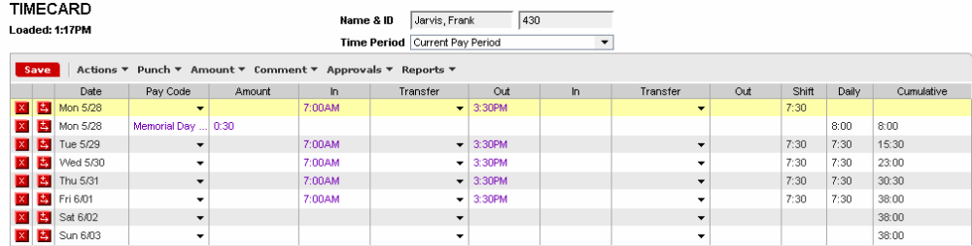

Your hours will already be entered for any of the following reasons:
You used the Time Stamp feature.
A holiday or scheduled time off was preloaded by ADP or your manager.

*Comp Time
The University System of Georgia will now track Comp Time earned and taken on the Time card. Comp Time will now be calculated and applied based on the Overtime rules where an employee must physically work 40 hours before Comp Time will be calculated at Time and a half. The Tuesday following the end of the Pay Period the Comp Time will appear in the Comp Time bucket for you to begin using. After 20 weeks from the Tuesday the Comp Time was placed in the bucket, if the Comp Time has not been used, eTime will process the Comp Time to be paid in the upcoming pay period.
For example, the Pay Period is April 4 – April 17. Comp Time is earned on April 7 of 2 hours. During the week of April 4 – April 10, you physically worked 40 hours; therefore, the 2 hours for April 7 will be calculated at Time and a half giving 3 hours to be placed in the Comp Time bucket for you. You will not be able to use this 3 hours until Tuesday April 21 (Tuesday after the pay period end date of April 17) when it will be placed in the Comp Time bucket.
*To receive comp time in lieu of overtime: You must complete the Comp Time in lieu of Overtime Form. If you select comp time is selected then it can only be changed annually during Open Enrollment.
Pay Code of Comp Time Off will be selected from this drop down.
Enter amount of time that was taken for Comp Time.

Transferring Time in a Timecard – You will be notified if you need to use this function. *If you have not been notified then this section will not apply to you.
Each employee is assigned a primary labor account, primary job, and default work rule. However, you may sometimes be asked to work at a different area or job and charge your hours there. This is referred to as a timecard transfer.
To perform a timecard transfer:
In the timecard grid, click the Transfer column on the row associated with the punch or amount that you want to transfer.
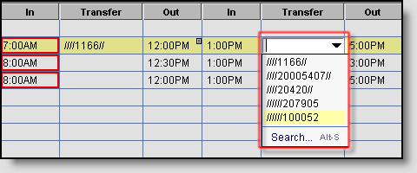
Select the transfer from the drop-down list of recent transfers.
Click the down arrow in the Transfer cell that you selected to show the list of most recent transfers. At the bottom of the list, click Search to access the Select Transfer dialog box.
The timecard grid supports up to two transfers in each row. To transfer your time more than twice in a given day, add a row under the day that you are currently editing and continue your entries.
Note: Transfers remain in effect on each day one is added, until you cancel them.

To report an absence not prior approved by your Manager/Supervisor:

Make sure that you call your manager/supervisor if you are out sick. Send a reminder email to your manager/supervisor as soon as you return to work. Include in the email the pay code that he/she should use to record on your time card for that day. Then your manager/supervisor will edit your time card.

Adding Comments
To add a comment to any cell, right-click in the cell and choose ‘Add Comment’, or Comment > Add.
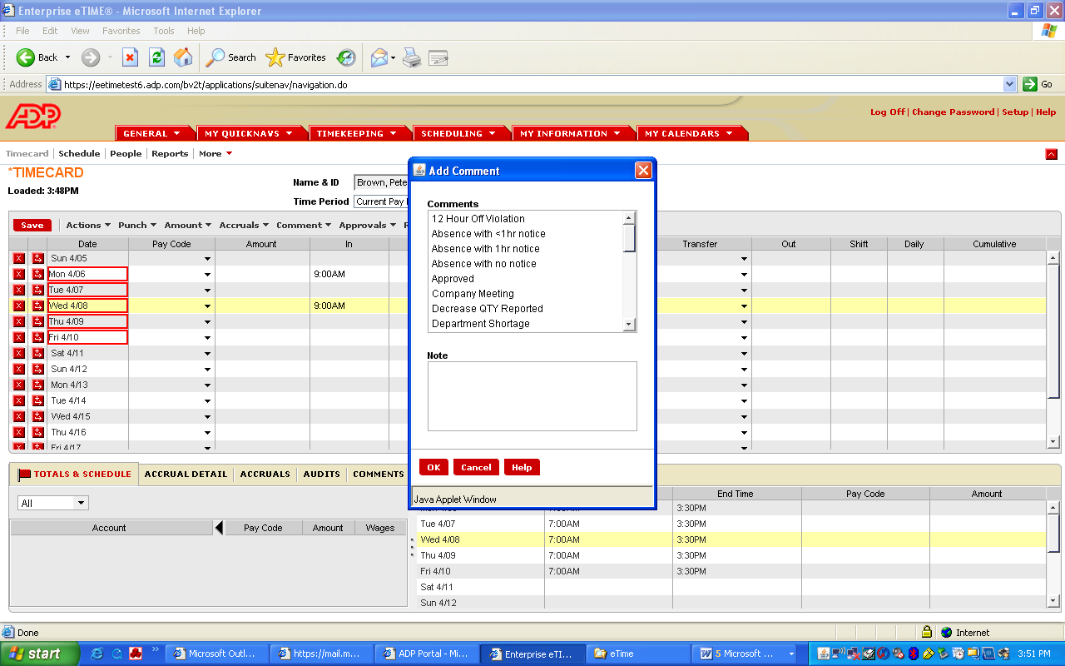
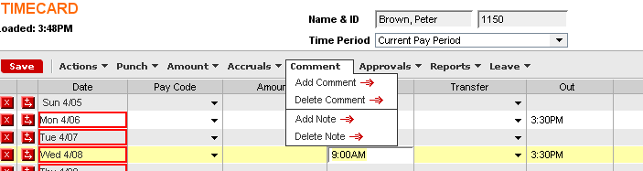

Saving the Time Card
You need to save your changes to your timecard. The word TIMECARD will be orange indicating changes had been made and saving is required. Click Save from the menu bar.
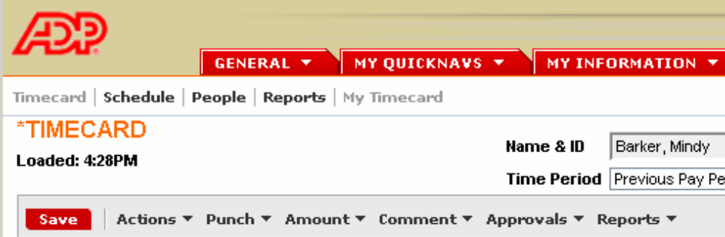

Approving the Timecard
Approving your timecard ‘submits’ your time card for manager approval. Approval lets a manager know that the timecard is accurate, complete and ready to be sent to payroll for processing.
Approval can be removed if a manager has not submitted the timecards to payroll.
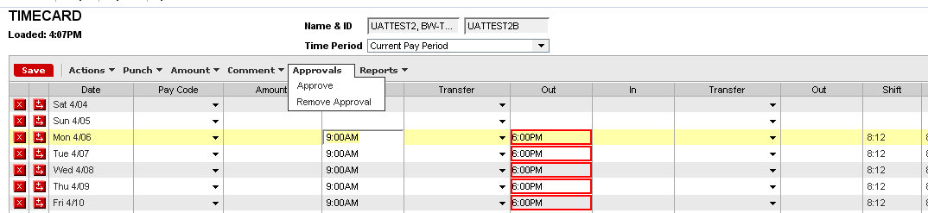
* Hint *
Make sure time is correct:

Don’t approve until any missed punches are reported to your manager/supervisor for them to correct. These are identified as a solid red box where the punch should be. Missed punches will cause the time card to not be paid if they are not corrected by the manager/supervisor.

Click on ‘Approvals’ then ‘Approve’

MY ACTIONS

Requesting Time Off – Vacation and/or Comp Time
Since Leave is managed and monitored in eTime®, the requesting for leave must be executed in eTime®.
After logging into eTime®, click My Actions.
To request Time Off, click the link for Request Time Off.
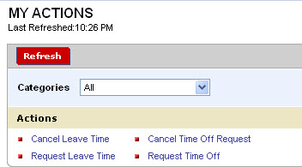
Use the  drop down for Request Type to select the Pay Code for the type of Leave you are requesting. Types of leave include Comp Time Off, Vacation, and Sick.
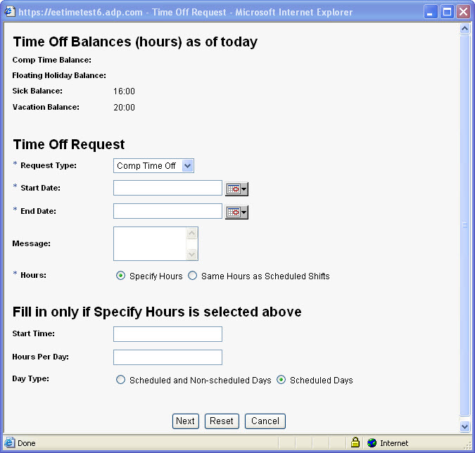
Enter the Date from or use the calendar icon to select the date.
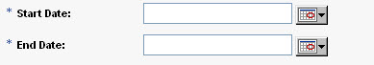
Enter the Date to or use the calendar icon to select the date.
In the Message field you can enter any information you wish to supply for the time off request.
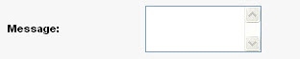
Click Specify Hours.
In the field of Start Time: enter the time your leave is to begin.
Enter the number of hours per day you will be requesting off.
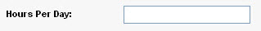
For Day Type click Scheduled and Non-scheduled Days
Click Next.
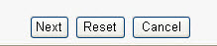
Click Save and Close. The request is routed to your Reports To Manager who will approve or reject your request.
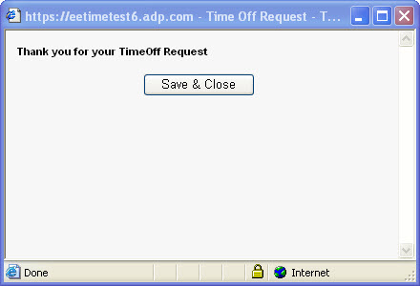
You will receive an email informing you that your request has been submitted.
You will receive an email informing you that your request has been approved or rejected by your manager.
Upon approval by your manager, the Pay Code for the type of leave you requested will now appear on your timecard for the date you requested.
You will also be able to check your Inbox in eTime® by clicking My Actions then Inbox.

Cancelling Time Off Request – Vacation and/or Comp Time
After logging into eTime®, click My Actions.
To cancel a request for Time Off that has been submitted, click the link for Cancel Time Off Request.
Use the drop down for Request Type to select the type of leave you wish to cancel.
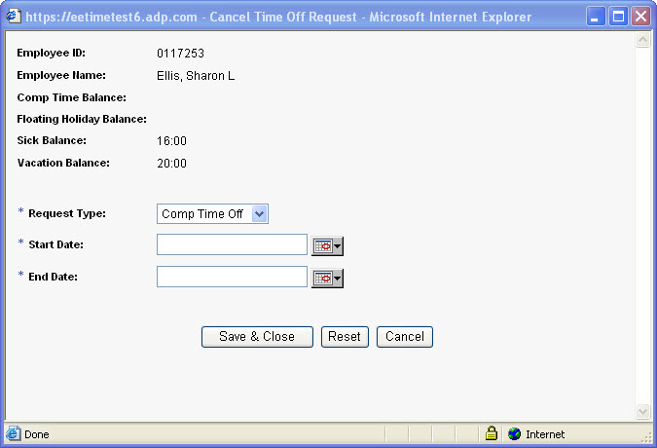
Enter the date for the time off you are canceling starts.
Enter the date for the time off you are canceling ends.
Click Save and Close. The request is routed to your Reports To Manager who will approve or reject your request.
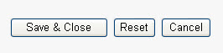
You will receive an email informing you that your request has been submitted.
You will receive an email informing you that your request has been approved or rejected by your manager.
Upon approval by your manager, the Pay Code for the type of leave you requested will be removed from your timecard.
You will also be able to check your Inbox in eTime® by clicking My Actions then Inbox.

Extended Leave Time Request (FMLA)
Extended lengths of leave time: Refers to leave that will apply to Family and Medical Leave Act (FMLA), Short Term Disability, Long Term Disability or Military Leave. You can request this type of leave from within eTime.

After logging into eTime®, click My Actions.
To request leave for an extended period of time, click the link for Request Leave Time.
Use the drop down for Leave Category to select the type of leave you wish to request.
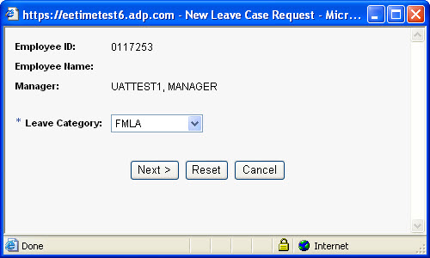
Click Next.
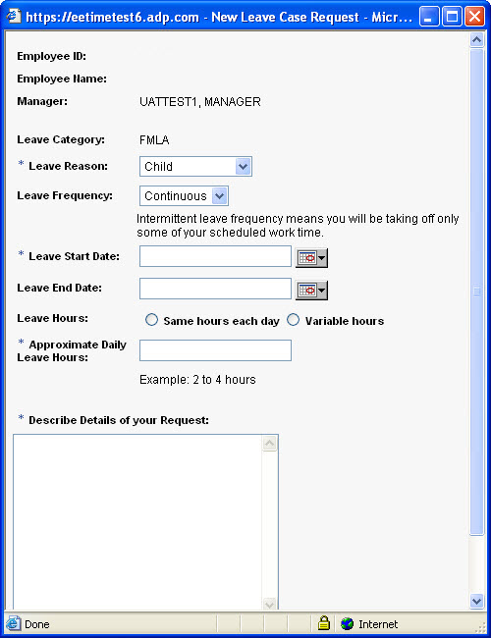
Use the drop down for Leave Reason to select the reason for leave you wish to request.
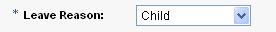
Use the drop down for Leave Frequency to state whether the leave is continuous or intermittent.
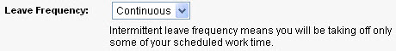
Enter the date for when the leave starts.
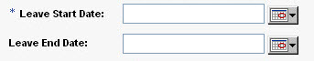
Enter the date for when the leave ends.

Select how the leave hours will be used.
Enter how many hours will be used each day.
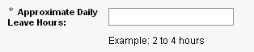
Describe why you need the leave in the description box.
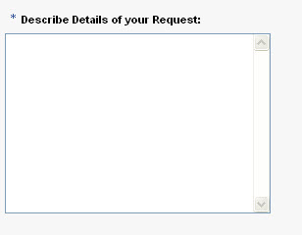
Click Send and Close. The request is routed to your Reports To Manager who will approve or reject your request.
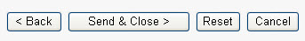
You will receive an email informing you that your request has been submitted.
Your Campus Leave Administrator will process your request, the Pay Code for the leave you requested will be recorded from your timecard.
You will also be able to check your Inbox in eTime® by clicking My Actions then Inbox.

Cancelling Extended Leave Time Request
After logging into eTime®, click My Actions.
To request leave for an extended period of time, click the link for Cancel Leave Time.
Use the drop down for Leave Category to select the type of leave you wish to cancel.
Click Next.
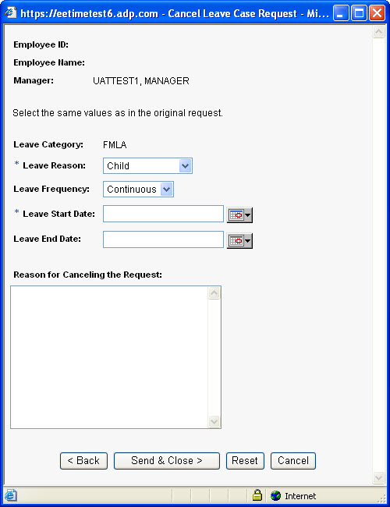
Use the drop down for Leave Reason to select the reason for leave you wish to cancel. This needs to be the same values as the original request.
Use the drop down for Leave Frequency to state whether the leave is continuous or intermittent.
Enter the date for when the leave starts.
Enter the date for when the leave ends.

Enter the reason why you are cancelling your original request.
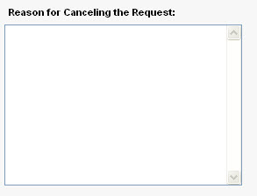
Click Send and Close. The request is routed to your Reports To Manager who will approve or reject your request.
You will receive an email informing you that your request has been submitted.
Your Campus Leave Administrator will process your request, the Pay Code for the leave you requested will be removed from your timecard.
You will also be able to check your Inbox in eTime® by clicking My Actions then Inbox.

Please contact the Payroll & Benefits Support Line if you have any questions regarding your pay or benefits.

Payroll & Benefits Support
Shared Services Center Phone: (855) 214-2644
Email: helpdesk@ssc.usg.edu

PAYROLL DEPARTMENT
Heather Underwood – Payroll Accountant Phone: (706) 802-5106
Email address: hunderwo@highlands.edu Fax: (706) 802-5296

Stephanie Loveless – Senior Accountant Phone: (706) 368-7346
Email address: sloveless@highlands.edu

Melissa Kirby – Assistant Director of Accounting Phone: (706) 295-6345
Email address: mkirby@highlands.edu

Human Resources Department
Ginni Siler – Chief Human Resources Officer Phone: (706) 802-5134 Fax: (706) 368-7723
Email address: gsiler@highlands.edu

Terri Cavender – Benefits Coordinator Phone: (706) 802-5195
Email address: tcavende@highlands.edu

Terri Kirby – HR Coordinator Phone: (706) 802-5136
Email address: tkirby@highlands.edu

Lauren Baus – HR Manager Phone: (706) 802-5479
Email address: lbaus@highlands.edu

GLOSSARY

Enterprise eTIME: Time keeping system. Timecard, time stamp, request time off or cancel time off request, request extended leave, cancel extended leave request, and reports are located in eTIME.
ESS: This is Employee Self Service where all HR/Payroll information can be viewed and/or changed by the employees. Such as Benefits (may only be changed during open enrollment), General Deductions, Withholding Taxes, Pay Statements, Direct Deposit information, Emergency contacts, Addresses, Phone Numbers, Leave Balances, etc.
Leave off: Refers to Family and Medical Leave Act (FMLA), Short Term Disability, Long Term Disability or Military Leave.
Pay Codes:
- Vacation
- Sick
- Jury Duty
- Comp Time
- Call in Pay – This only applies to maintenance employees in plant operations department.

Time off : Refers to vacation, sick, or comp time.

